Introduction 3
CR-05 Goals and Outcomes 9
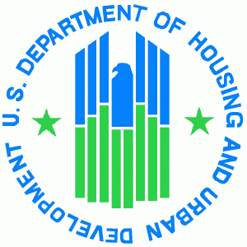
CR-10 Racial and Ethnic Composition of Families Assisted 15
CR-15 Resources and Investments 16
CR-20 Affordable Housing 21
CR-25 Homeless and Other Special Needs 26
CR-30 Public Housing 28
CR-35 Other Actions 29
CR-40 Monitoring 35
Citizen Participation Plan 91.105 37
CR-45 CDBG (CDBG grantees only) 42
Affirmatively Furthering Fair Housing within the City of Alliance 43
Point-In-Time 52
Self-Evaluation 53

Fifth Program Year CAPER

The CPMP fifth year Consolidated Annual Performance and Evaluation Report includes Narrative Responses to CAPER questions that CDBG, HOME, HOPWA, and ESG grantees must respond to each year in order to be compliant with the Consolidated Planning Regulations. The Executive Summary narratives are optional.

GENERAL
Section I: CR-00 Executive Summary Program Year 5 CAPER Executive Summary response:
Activity | Funds Committed | Funds Expended | Balance
Administration | $119,974.00 | $55,675.07 | $64,298.93
Housing Rehab & Repair | $183,972.00 | $133,211.00 | $50,761.00
Code Enforcement | $110,000.00 | $88,460.62 | $21,539.38
Demolition | $40,000.00 | $3,630.00 | $36,370.00
YWCA – Navigators After School | $12,459.50 | $12,459.50 | $0.00
YWCA – Employment | $3,000.00 | $3,000.00 | $0.00
ECEA – SPARK Alliance | $12,459.50 | $12,459.50 | $0.00
Domestic Violence Shelter (AADVS) | $12,459.50 | $12,459.50 | $0.00
Alliance Career Center | $12,459.50 | $12,459.50 | $0.00
Historic Preservation Capacity Building | $1,000.00 | $500.00 | $500.00
Alliance for Children and Families | $14,928.06 | $14,928.06 | $0.00
AFD Central Firestation Rehab Phase 1, 2, 3 | $40,018.94 | $0.00 | $40,018.94
Fair Housing | $8,000.00 | $4,000.00 | $4,000.00
Stark County CoC | $14,142.00 | $6,134.17 | $8,007.83
StarkFresh Mobile Grocery Market | $15,000.00 | $15,000.00 | $0.00
Union Avenue Corridor | $136,818.00 | $0.00 | $136,818.00
FY-2018 Totals | $736,691.00 | $374,376.92 | $362,314.08

SECTION I: INTRODUCTION

The overall purpose of the CAPER is to describe in detail all CDBG funded activities the City of Alliance undertook with FY-2018 funds for program year July 1, 2018 through June 30, 2019. It includes information on how the city addressed housing, homelessness, community, neighborhood public facilities, infrastructure, public social services, economic development, and elimination of slum, blight and fair housing issues. Housing rehabilitation, public facility assistance and demolition are some of the specific projects that were funded. Public Services include support for organizations serving adult and youth education, prescription assistance, domestic violence effected families, homelessness, and employment assistance.

The City of Alliance is an entitlement community under the HUD Community Development Block Grant (CDBG) Program. As an entitlement community the City of Alliance’s Department of Planning and Development, is awarded annual funding allocations from the Federal government to fund selected activities to address the HUD National Objectives. In addition, Alliance is a member of the HOME Consortium with Stark County and the City of Massillon. Through this membership, the city collaborates with these local government entities to perform a variety of tasks, including the Consortium’s Consolidated Plan.

As a recipient of federal funds the City of Alliance and the Consortium are required to submit to HUD each year an Annual Action Plan and at the conclusion of the year, a Consolidated Annual Performance Evaluation Report. These reports define the work that was accomplished during the program year and the end results the city utilized to address the national objectives in a manner that will produce the greatest measurable impact on our community. This CAPER provides an in-depth explanation of the projects and organizations which worked towards fulfilling the goals of the FY-2018 year.
FY-2018 CDBG Program
Funds Received $599,873.00
Program Income $0.00
Recaptured Funds $136,818.00
Total $736,691.00

NEIGHBORHOOD IMPROVEMENT PROJECTS

Housing Rehab - The City of Alliance utilized $150,000.00 in CDBG funding and additional funds from the HOME program to provide housing rehabilitation and emergency home repair through the Stark County Regional Planning Commission Housing Program.

Program Accomplishments: There were three contracts signed for housing rehab (CDBG Funds) through the Owner-Occupied Housing Rehab Program and twelve contracts were signed for emergency repairs (CDBG Funds) with a combined total of $158,836.00. Stark Regional Planning Commission completed three projects Home program in the amount of $65,497.50.

Code Enforcement - The City of Alliance utilized $88,460.62 in CDBG funds for city wide code enforcement to assist with property maintenance and zoning code related problems.

Program Accomplishments: During the period of July 1, 2017 through June 30, 2018, 1,350 properties were inspected. Of these properties, twelve had structural damage; 632 required re-inspections; 188 grass violations were cited, and 77 vacant properties were registered. In FY-2018, 89 property owners that were citied complied with the local code while seven were turned over to the City of Alliance Law Director’s Office. The Housing Specialist completed 128 first time city wide property maintenance inspections. In 2012, the Housing Specialist undertook the task of Grass/Weed inspections. Since then the housing specialist continues to be instrumental in bringing together all of the cities non-compliance mowing activities under one mowing program. In addition to the property inspections, the Housing Specialist continues to work with residents to educate them on proper housing maintenance.

In December of 2013, the Alliance City Council passed Ordinance 81-13s, a vacant property registration. This legislation is designed to clean up blighted neighborhoods by requiring all bank-owned, vacant, residential structures to be registered with the Department of Planning and Development, and to be bonded. The required bond is in the amount of $10,000.00 and can be utilized if the property is unsecured, needs maintained or demolished.

The city views this registration legislation as a highly successful tool and method which promotes and encourages property owners to maintain their properties. The City of Alliance administration strongly believes that while dilapidation can be contagious in a neighborhood, so too is increasing the overall appearance of a block by fighting blight. A successful strategy for building quality neighborhoods is to fix problems when they are small, to repair broken windows within a short time, to clean up sidewalks every day, and do not let problems escalate.

In addition, during the FY-2018 period the Planning and Development department continues to require a home owner to clean up their property of clutter both indoor and outdoor prior to signing a contract for either a home rehab or repair loan. This regulation allows the city to use the CDBG grants as just another tool in promoting economic development and enhancing the aid in the prevention or elimination of slums and blight. The Vacant Property Ordinance and the enforcement of the cleaning standards of the housing rehabilitation guidelines are prime examples of the Code Enforcement department working in conjunction with the Department of Planning and Development to create and maintain the city’s existing neighborhoods.

Demolition Program - The City of Alliance reserved $40,000.00 in FY–2018 CDBG funds for the demolition of vacant, dilapidated structures that blight high priority neighborhoods.

Program Accomplishments: The demolition program for the City of Alliance is spearheaded by the Alliance City Health Department and the Department of Planning and Development. During the FY-2018 the Alliance City Health Department condemned four structural demolitions and has six currently underway on properties in low/mod areas of the City from July 1, 2018 through June 30, 2019. At the present time, there are twenty-five condemned properties in the City.

PUBLIC FACILITIES ACTIVITIES

YWCA of Alliance Exterior Improvement Project – The City of Alliance allocated $24,000.00 in funds to the Alliance YWCA for exterior improvements. Currently no funds have been expended and project is still in progress. The YWCA is a historical landmark and because of the structural and historical integrity of the building, finding restoration companies to bid and take on the project was challenging and time consuming. Once the bid process was complete, the task of finding a vendor to supply the appropriate materials became another lengthy process. The windows took nearly three months before they were available once they were ordered. The project was completed in December of 2018.

Central Fire Station Project- The City of Alliance allocated $40,018.94 in funds the Alliance Central Fire Station Rehabilitation Project. The funds will be used to replace the leaking roof system at the Central Fire Station that is over 44 years old. There are numerous places in which the roof is leaking causing active mold growth in various locations inside the Fire Station.

Union Avenue Corridor Project- The Union Avenue Corridor Project connects the City of Alliance’s north and south corridor to historic downtown with the City’s current major commercial corridor at a critical juncture with Alliance Community Hospital, Akron Children’s Hospital, State State College, and the University of Mount Union. To date, no funds have been expensed on this project due to various other state and local funding to be used prior to CDBG funding.

PUBLIC SERVICE ACTIVITIES

YWCA (Navigators) Program - The City of Alliance allocated $12,459.50 in CDBG funds for the Navigators after School Program. The Navigator program for grades 6 through 8 and the Pilot program for grades 9 through 12. The mission of the after-school program is to provide enrichment activities which support the ideas and curriculum taught in the classroom. Student benefits from the program are seen in grade promotions and improved social interactions with parents, friends and community members. The after-school programs enjoy broad community support and receive additional funding from the Alliance school district by a 21st Century Community Learning Center Grant and donations from community organizations.

Program Accomplishments: The YWCA tracked the successes of 331 students in grades 6 through 8 who participated in the YWCA Navigators program. The navigator site provided thirty-nine days of afterschool care (M-TH) during this grant year to students in grades 6 through 8. Services included transportation, snacks, academic intervention, homework assistance and enrichment activities that built youth assets and competency in support of academic and life success.

YWCA (Employment) Program - The City of Alliance allocated $3,000 in CDBG funds for the Women off Welfare (WOW) program. This program is considered an effective program that meets the National Objectives for employment services.

Program Accomplishments: At the beginning of the program year, forty-six individuals were assisted with transitional housing, gas cards, and bus passes. These tools helped to aid in employment and pre-employment transportation costs, assistance with specific work related needs, and mentoring opportunities. 100% of recipients in FY-2018 identified transportation as their greatest barrier to work and 100% reported a recent crisis that impacted their income. Of the recipients, 100% were low income women.

Domestic Violence Educational Services Project - The City of Alliance allocated $12,459.50 in CDBG funds to provide victims of domestic violence with emergency shelter as well as education, teacher-tutor and abuse prevention community programs.

Program Accomplishments: During FY-2018, 301 women and 130 children were provided over 3,888 nights of shelter. Crisis counseling, support, information, and referrals were given through 2,973 crisis and support calls. The Education Services Coordinator assisted with child development, tutoring, and recreational activities. She acted as a liaison between shelter clients and the school systems. She held financial literacy classes and provided individual case management to assist clients with budgeting and reviewing their credit report and score. She represented the Shelter’s various events and implemented Teen Dating Violence Awareness Education at local schools and colleges. In addition, she assisted adults with finding and establishing employment as well with assistance in obtaining a GED. This program is of high importance because it is an unduplicated program within the City of Alliance.

SPARK Alliance – The City of Alliance allocated $12,459.50 in CDBG funds to help three and four year old children of low income families prepare for kindergarten.

Program Accomplishments: 217 children were assisted using FY-2018 CDBG funds. Services offered to the individuals and families include parent- partners meetings to assist in the enrollment of new students in kindergarten, home and group visits, developmental screenings, and various educational programs. When needed, the SPARK organization provides referrals to students’ families who show signs of learning disabilities. This is a service to the student and their families so the learning process does not become a struggle later in the child’s education. Services are advertised through word of mouth and publications through the Alliance school system.

StarkFresh Mobile Grocery – The City of Alliance allocated $15,000.00 in CDBG funds to focus on increasing access to healthy, affordable, locally raised, nutrient dense foods through equal food access to all residents. Their targeted audience is hose individuals with low to moderate incomes, residents of food desert areas, and senior living centers whose residents have mobility issues due to either health conditions or lack of transportation.

Program Accomplishments: StarkFresh provided delivery of fresh produce to the Alliance low to moderate income community between June and November of 2018. The five service stops include the Alliance Health Department on WIC days, Stark MHA, the Alliance Food Pantry and Senior Housing Centers. This market is designed to be healthy, affordable, locally raised, nutrient and dense foods for increased access to all residents. The program assisted a total of 474 residents of which 378 were low income and 96 were moderate income.

Alliance Career Centre – The City of Alliance allocated $12,459.50 in CDBG funds for tuition assistance for students seeking training and degree certification in a technology directed program geared to meet employer’s needs. The program served low to moderate income students within targeted geographic locations within the City of Alliance.

Program Accomplishments: In FY-2018 the Alliance Career Center assisted twenty-one applicants with tuition assistance in programs such as licensed practical nursing, cosmetology, and LPN training. This program allowed for job training skills and education for low to moderate income adults. Education access and assistance was utilized by twenty-one households of which three were of moderate income and eighteen were of low income. The direct benefit of persons assisted were seventeen white individuals and three black individuals. Monies for this program assisted with tuition, books or tools needed for the program. The program also assists with career passports and resumes.

Stark County Mental Health – The City of Alliance allocated $14,142.00 in CDBG funds to assist persons seeking assistance with housing and social service needs. This program will create a centralized intake and a coordinated assessment to assist in the support of rapid rehousing, emergency shelters, transitional housing and other housing programs.

Program Accomplishments: Homeless Navigation Specialists gather data from callers who are homeless or precariously housed, providing them referral and service information. This program works with area agencies to provide shelter. Specialists collect information during the initial contact utilizing a diversion tool which allows them to pre-screen callers to ascertain if additional assessment is needed. Data is then entered in the Homeless Management Information system (HMIS) for individuals who have not been diverted. All eligible individuals are placed on the Central Prioritization List for emergency shelter and/or housing (if not immediately available). CDBG funding for FY-2018 allowed the city to assist 173 families of which 170 were low income and three was moderate income. In FY-2018, there was $8,007.83 in funding recovered. The program year began late and other funds were used to pay invoices that CDBG money was to be used for.

Fair Housing Services – In FY-2018, $8,000.00 of CDBG funds was allocated to further engage the City of Alliance in fair housing activities. The fair housing practices include making individuals aware of the range of housing options, enforcement, education, and outreach, avoidance of concentrations of individuals with low to moderate income, testing, and any other appropriate activities deemed necessary to provide fair housing to residents in the City of Alliance.

Program Accomplishments: The figures on housing discrimination does not reflect the numerous calls received from persons who feel they have grounds to charge someone with discrimination. However, many of the calls are the result of landlord-tenant problems and are resolved through counseling and mediation.

During FY-2018, twenty-two property owners, managers, realtors, tenants and council persons were advised on the landlord-tenant law in the City of Alliance. Specifically, they were counseled in areas regarding evictions, security deposits, rent withholding, lease termination, retaliation and other areas that deal with residential landlords and tenants.

The Stark County Regional Planning Commission administers the City’s Fair Housing Program. Stark County Fair Housing Department work to secure the rights of individuals and to eliminate policies and practices that deny housing opportunity. The persistence of racial segregation, residential preferences in zoning, blatant discrimination against people of color, treating persons with disabilities differently, steering families with children to certain units, and sexual harassment continue to limit opportunities to fair and equal access to housing.

The Stark County Fair Housing Department will continue to root out discrimination and represent victims of housing discrimination. Necessary actions will be taken to ensure that the fair housing law is properly and fairly enforced throughout the City of Alliance. The Department Planning & Development will continue to take the appropriate steps necessary to eliminate the potential impediments and to set goals for improving fair housing choice and access to opportunity.

Alliance Fire Department – First Station No. 3 Rehabilitation Project – The City of Alliance allocated $29,226.00 of CDBG funds for the continued renovation of the Alliance Fire Department on Union Avenue. The funds are designated for the replacement of the roof, several bay windows and masonry repairs to the exterior of the structure. This Fire Station will provide immediate response to calls in target area 1. In addition, this building is a local landmark and labeled as a historic building in the City of Alliance.

Program Accomplishments: The Alliance Fire Station Rehab was completed in July of 2019. The Fire Station had new windows installed, the masonry work on the exterior of the building was repaired and the roof has been replaced.
Alliance Historic Preservation – The City of Alliance allocated $1,000.00 in FY-2018 of CDBG funds to the continued effort in preserving the City’s historic landmarks. The funds will be utilized for public education materials and consultation fees for a historic preservationist to develop a plan for a National Historic District. The goal would be for the Secretary of the Interior to establish a Historic District in on the Main Street Commercial Corridor in the city’s downtown area.

Program Accomplishments: During FY-2018, funds were used from the historical preservation allotment for a City of Alliance membership to Heritage Ohio. The Heritage Ohio membership allows for the City of Alliance to stay current on Historic Preservation guidelines, attend educational workshops and assist with consultations regarding historic preservations.
Program Administration and Other Activities

The City of Alliance CDBG Program Administration for the FY-2018 included: an allocation of $119,974.00 in CDBG funds for the planning, administration and overall management of the CDBG program. Of this $61,209.00 was allocated for payroll and $48,765.00 allocated for fringe benefits such as monies to be set aside for the Public Employees Retirement system, workers compensation, and other benefits. An additional $10,000.00 in funds were set aside to cover the cost of office, advertising, legal, and other incurred expenses.

Economic Development Activity

Alliance for Children and Families (ACES Program) – The City of Alliance allocated $14,928.06 in FY-2018 of CDBG funds to the ACES Program for the economic development program intended to help local businesses with employee retention. The program helps with the hiring, training and retention of quality employees.

Progam Accomplishments: During FY-2018, 160 employees went through the training, monitoring and assessment and all were able to maintain stable employment by overcoming the barriers that low to moderate income individuals face.

SECTION II: CR-05 - GOALS AND OUTCOMES – 91.520 (a)
Consolidated Plan 5- Year Goals (2014-2018)

In 2018 the Department of Planning and Development sponsored two public workshops held on December 11, 2018 and December 13, 2018 to solicit input for the upcoming five years. Each meeting consisted of a discussion on the development of the forthcoming Annual Action Plan and the Five Year Consolidated Plan and potential funding priorities to carry out those goals. In addition, along with greater communication and contact with sub recipient organizations. Additionally, a meeting of the Community Planning and Development Committee took place on January 28, 2019 to review the allocation of funds to meet the goals and outcomes of the Annual Action Plan. Based on community participation, surveys, and analysis of the SP-45 Goals as defined in the 2014 – 2018 Consolidated Plan, 91.415, 91.215(a)(4) the housing and community development goals the City of Alliance pursued in program year two and will continue to pursue over the next two years can be identified below:

Priority Goal 1. Increase Affordable Housing
Priority Goal 2. Improve Living Condition of Distressed Neighborhoods
Priority Goal 3. Improve Coordination of Services
Priority Goal 4. Create and Preserve Economic Opportunities
Priority Goal 5. Strengthen Neighborhoods

Section 91.520(a) provides an overview that includes a comparison of the major initiatives and highlights for each of the measures that were proposed in the consolidated plan and how those measures were executed by the City of Alliance throughout the program year. The section will conclude with explanation of why progress was, or was not, made toward meeting goals and objectives. 91.520(g)

Progress the jurisdiction has made in carrying out its strategic plan and its action plan. 91.520(a)
This could be an overview that includes major initiatives and highlights that were proposed and executed throughout the program year.
Priority Goal 1: Increase Affordable Housing: Currently, the City has made progress in carrying out this portion of the strategic plan and towards meeting the identified five year goal by providing safe and decent affordable housing through the owner-occupied housing rehab program. In FY-2018 CDBG funds were used to completed two full rehabs and twelve emergency housing rehabs. The number of emergency rehabs increased do to the need of immediate repairs by qualifying applicants.
Priority Goal 2: Improve Living Conditions of Distressed Neighborhoods: The City’s Code Enforcement Official and the Housing Specialist continue to work with property maintenance issues throughout the community. Target areas were developed by the City for the housing rehabilitation program. These are located in areas with the greatest amount of low/mod individuals. The City's housing strategy includes elimination of the most blighted structures in the target areas.
Priority Goal 3: Fair Housing Education and Outreach: The City of Alliance funded activities, programs, and public marketing that raised awareness and knowledge of fair housing rights. The city established an Affirmative Marketing Policy in which the staff monitors its progress. The Fair Housing office continued to accomplish the goal of fair housing education and outreach by sponsoring trainings, presentations, and workshops. In addition, the staff continued to counsel tenants, landlords, students, and representatives from social service agencies to increase their knowledge on the fair housing and landlord-tenant laws. The City of Alliance working in conjunction with the City of Massillon and the Stark Regional Planning Commission completed a revised Analysis of Impediments.
Priority Goal 4: Create and Preserve Economic Opportunities: Several programs continued to be sponsored by the City through its CDBG program that work towards creating and preserving Economic Opportunities. The Alliance Career Center assist students with obtaining training in several mechanical and medical fields; the YWCA assists dislocated workers with transportation and other assistance; the Educational Services project at the Domestic Violence Shelter works with victims of domestic violence through outreach programs which offer counseling, GED preparation training, and lifestyle classes including financial literacy, employment training and how to disengage from the cycle of long-term abuse.
Priority Goal 5: Strengthen Neighborhoods: Full and emergency rehabilitations provided safe, affordable, and decent living conditions for low to moderate income households within the City’s specified target areas. The HOME Program brought qualified home owners into code enforcement compliance in the target area. Demolitions and greening have reduced the number of blighted structures and raised property values of contiguious structures.

Comparison of the proposed versus actual outcomes for each outcome measure submitted with the consolidated plan and explain, if applicable, why progress was not made toward meeting goals and objectives. 91.520(g)

Categories, priority levels, funding sources and amounts, outcomes/objectives, goal outcome indicators, units of measure, targets, actual outcomes/outputs, and percentage completed for each of the grantee’s program year goals.

Table 1 - Accomplishments – Program Year & Strategic Plan to Date
Goal | Category | Source / Amount | Indicator | Unit of Measure | Expected – Strategic Plan | Actual – Strategic Plan | Percent Complete | Expected – Program Year | Actual – Program Year | Percent Complete
Affordable Housing | Affordable Housing | CDBG: $ | Homeowner Housing Rehabilitated | Household Housing Unit | 5 | 12 | 240.00% | 5 | 12 | 240.00%
Economic Development | Non-Housing Community Development | CDBG: $ | Public Service activities other than Low/Moderate Income Housing Benefit | Persons Assisted | 2500 | 3000 | 120.00% | 2500 | 2700 | 108.00%
Economic Development | Non-Housing Community Development | CDBG: $ | Jobs created/retained | Jobs | 160 | 160 | 100.00% | 160 | 160 | 100.00%
Infrastructure Improvements | Non-Housing Community Development | CDBG: $ | Public Facility or Infrastructure Activities other than Low/Moderate Income Housing Benefit | Persons Assisted | 1 | 2 | 200.00% | 22,000 | 22,000 | 100.00%
Infrastructure Improvements | Non-Housing Community Development | CDBG: $ | Buildings Demolished | Buildings | 0 | 0 | 0.00% | 3 | 6 | 200.00%
Planning and Administration | Non-Housing Community Development | CDBG: $ | Housing Code Enforcement/Foreclosed Property Care | Household Housing Unit | 1000 | 1200 | 120.00% | 0 | 1 | 100.00%
Planning and Administration | Non-Housing Community Development | CDBG: $ | Other | Other | 4 | 4 | 100.00% | 500 | 0 | 0.00%
Public Services | Non-Housing Community Development | CDBG: $ | Public service activities other than Low/Moderate Income Housing Benefit | Persons Assisted | 3000 | 3000 | 100.00% | 2500 | 3000 | 120.00%
Public Services | Non-Housing Community Development | CDBG: $ | Homeless Person Overnight Shelter | Persons Assisted | 0 | 173 | 0.00% | 150 | 173 | 115.33%

Assess how the jurisdiction’s use of funds, particularly CDBG, addresses the priorities and specific objectives identified in the plan, giving special attention to the highest priority activities identified.

1. Describe the manner in which the recipient would change its program as a result of its experiences. To date, there have been no changes to program objectives in the planning and administration of the City of Alliance’s Consolidated Plan and CDBG program. The city will continue to provide decent housing, safe living environments and help provide jobs for low/mod individuals. Alliance will continue to find ways and increase awareness of the issues and programs that are offered to serve the needy as it begins focusing on a more aggressive public participation program.

2. Describe Other Actions in Strategic Plan or Action Plan taken to address obstacles to meeting underserved needs. The Domestic Violence Shelter located within the City of Alliance has assisted victims of domestic violence and their families who may find themselves without a place of residence, funds and the skills necessary to change their lives for the better. Through the use of additional City funding, Alliance has assisted adults in receiving necessary work skills and training needed to find gainful employment through the Alliance High School’s partnership with the Alliance Career Centre. Also, the City of Alliance has provided required employment materials and shelter through the YWCA Employment Assistance Program and transitional housing.

Intro to the jurisdiction's use of funds
The City of Alliance has made prgress toward meeting its goals and objectives. Each CDBG funded project is geared towards meeting one or more of the HUD national objectives. FY-2018 projects were largely successful due to the fact that City administrators and CDBG funded organizations worked in conjunction to ensure the overall benefit requirement were met and exceeded. However, due to lack of applications and the rejection of non-qualifying applicants, no progress was made by the City in its goals towards creating and preserving economic opportunities from the business sector using FY-2018 monies. The City did make a significant effort to accomplish this goal using UDAG funds.
Consolidated Plan 5- Year Goals (2014-2018)

In FY-2018, the Department of Planning and Development sponsored a series of two public workshops held in December of 2018 to solicit input into the implementation of its consolidated five year Strategic Plan. Each meeting consisted of a discussion on the development of the forthcoming Annual Action Plan and potential funding priorities to carry out those goals. The Annual meeting of the Community Planning and Development Committee was held in January of 2019 to review the allocation of funds to meet the goals and outcomes of the Annual Action Plan. Based on community participation and analysis of the SP-45 Goals as defined in the 2014 - 2018 Consolidated Plan, 91.415, 91.215(a)(4) the housing and community development goals the City of Alliance pursued in program year two are identified as follows: Priority Goal 1: Increase Affordable Housing; Priority Goal 2: Improve Living Condition of Distressed Neighborhoods; Priority Goal 3: Improve Coordination of Services; Priority Goal 4: Create and Preserve Economic Opportunities; Priority Goal 5: Strengthen Neighborhoods. The section 91.520(a) shows progress the jurisdiction has made in carrying out its strategic plan and its action plan towards meeting its identified five year goals and objectives. This section provides an overview that includes a comparison of the major initiatives and highlights for each of the measures that were proposed in the consolidated plan and how those measures were executed by the City of Alliance throughout the program year, and will conclude with explanation of why progress was, or was not, made toward meeting goals and objectives. 91.520(g)
Activity | Funds Committed | Funds Expended | Balance
Administration | $109,522.00 | $113,834.55 | $(4,312.55)
Housing Rehab & Repair | $150,000.00 | $139,065.75 | $10,934.25
Code Enforcement | $132,940.00 | $92,088.81 | $40,851.19
Demolition | $32,148.00 | $41,810.00 | $(9,662.00)
Alliance Community Pantry (ACP) | $9,000.00 | $9,000.00 | $0.00
Prescription Access Network (PAN) | $4,642.00 | $4,642.00 | $0.00
YWCA-Navigators After School | $9,000.00 | $9,000.00 | $0.00
YWCA - Employment | $3,000.00 | $3,000.00 | $0.00
ECEA-SPARK Alliance | $9,500.00 | $9,500.00 | $0.00
Domestic Violence Shelter (AADVS) | $9,500.00 | $9,499.99 | $0.01
Alliance Career Center | $9,500.00 | $9,500.00 | $0.00
YWCA Exterior Improvements | $24,000.00 | $12,590.00 | $11,410.00
Fair Housing Consultation | $14,545.00 | $5,179.17 | $9,365.83
Historic Preservation Capacity Building | $2,000.00 | $500.00 | $1,500.00
Alliance for Children and Families | $36,200.00 | $36,200.00 | $0.00
Alliance Fire Department | $29,226.00 | $19,501.00 | $9,725.00
Fair Housing | $8,000.00 | $6,000.00 | $2,000.00
Stark County Mental Health | $20,000.00 | $4,006.29 | $15,993.71
FY-2017 Totals | $612,723.00 | $524,917.56 | $87,805.44
FY-2017 Activity Funding Table
CR-10 - Racial and Ethnic composition of families assisted
Describe the families assisted (including the racial and ethnic status of families assisted). 91.520(a)
Table 2 – Table of assistance to racial and ethnic populations by source of funds

 | CDBG
White | 864
Black or African American | 281
Asian | 13
Black or African American & White | 74
Other | 61
American Indian & White | 1

Total | 1,294

Hispanic | 18
Not Hispanic | 1,312

Narrative
Problems continue to occur with the sub-recipient’s duplicating population numbers for clients who return more than once and failure to track client racial data. Within FY-2018, the implementation of reporting racial data was not addressed by the Planning and Development staff, and believes that this is an error that must be addressed over the upcoming FY-2018. It is anticipated in late 2018 the staff of the City of Alliance Planning and Development will be working closely together and with stakeholders, community groups, and other programs to implement an improved system of recording information. The key to the success of this effort will be the utilization of a variety of dissemination resources that are utilized by all age, social, and ethnic groups throughout the city. At this point, only the Alliance Community Pantry seems to have successfully developed a tracking method for client racial profiles as requested by the Department of Housing and Urban Development.

CR-15 - Resources and Investments 91.520(a)
Identify the resources made available

Table 3 - Resources Made Available
Source of Funds | Source | Resources Made Available | Amount Expended During Program Year
CDBG | CDBG | $736,691.00 | $374,376.92
HOME | HOME | 0 | 0
HOPWA | HOPWA | 0 | 0
ESG | ESG | 0 | 0
Other | Other | 0 | 0

Narrative
The total amount of HUD CDBG funding allocated during FY-2018 was $599,873.00. CDBG revenue and program income information can also be found in the Revenue/Program Income Report, located in the Appendix.
The City of Alliance has developed priority areas for allocation of CDBG funds. The rationale for the creation of the boundaries was based on the percentage of low/moderate income individuals in each area, the age and condition of housing structures and the age and condition of the public infrastructure. The goal was to coordinate funds into planned areas to match housing rehabilitation with street improvements in an effort to build viable neighborhoods. Recipients of CDBG funds should provide benefits to residents of at least one of the four priority/target areas in the City of Alliance.
Applications from sub-recipients are scored on a diversity of measures and assigned numerical values. If the project is not located in one of the priority areas it receives a zero in the geographic location category. The City of Alliance would estimate that approximately 80 percent of CDBG funds will be dedicated to the target areas. The remaining balance, but not more than the 20% of the cap, will be used for administrative purposes.

Identify the geographic distribution and location of investments

Narrative
The majority of the City's minority and low income households are clustered in the priority or target areas. Some of the individual census tracts in these target areas exceed the 75 percent low-moderate income levels. All CDBG funding received for FY-2018 is used in the designated target areas. Funding was not broke down by percentages for the individual areas because all of the designated areas qualify.
Target Area 1: Target Area Number 1 is an 73 percent low-moderate income area which is bound on the north by East Broadway, on the south by South Street, on the west by South Union and on the east by Mahoning Avenue. Census Tracts 7104 and 7105 are the foundations of this target area. Projects in this target area receive 20 points.

Target Area 2: Target Area Number 2 is an 84 percent low-moderate income area which is bound on the north by a rail line, on the south by East Broadway, on the west by East Union and on the east by Mahoning Avenue. Census Tracts 7014 and 7105 are the foundations of this target area. Projects in this target area receive 15 points.
Target Area 3: Target Area Number 3 is an 86 percent low-moderate income area which is bound on the north by Vine Street and the City border, on the south by a rail line, on the west by North Union Avenue and on the east by Mahoning Avenue. This target area is the eastern section of Census Tract 7102. Projects in this target area receive 10 points.
Target Area 4: Target Area Number 4 is a 63 percent low-moderate income area which is bound on the north by West Vine Street, on the south by West Main Street, on the west by Klinger Avenue and Lexington Township and on the east by North Union Avenue. This target area is the central and western portion of Census Tract 7102. Projects in this target area receive 5 points.

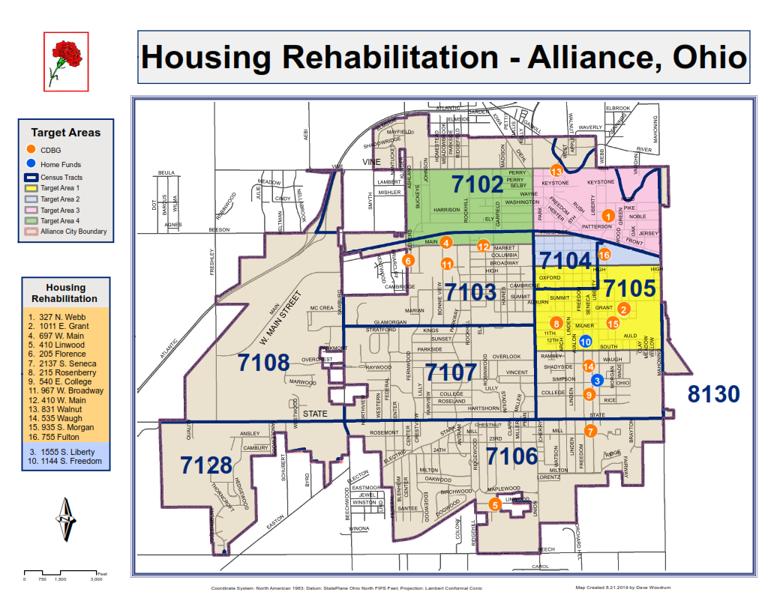
Leveraging
Explain how federal funds leveraged additional resources (private, state and local funds), including a description of how matching requirements were satisfied, as well as how any publicly owned land or property located within the jurisdiction that were used to address the needs identified in the plan.
The City of Alliance utilizes CDBG entitlement funds which it receives directly from HUD and HOME funding, made possible through participation in the Stark County Consortium. To ensure that the projects funded with CDBG funds are eligible, the project applications are ranked and scored on a variety of topics. One of those topics is the availability of matching/leveraging funds.
Federal CDBG resources from HUD permitted local non-profit organizations and other service providers to leverage with other public and private partners to better utilize a variety of federal, state and local funding to carry out their activities can be seen as follows:
Alliance Area Domestic Violence Shelter- Funding sources include VOCA which is the federal Victims of Crime Act in the amount of $29,020.00, as well as private contributions and year-round fundraising.
Alliance Career Center - Funding sources include the ACC Scholarship Committee in the amount of $30,000.00 along with $50,000.00 from the Ohio Department of Education for recognition as a Full-Service Adult Career Center and the Award of Federal Perkins Grant fund.
YWCA of Alliance Navigators Program - Funding sources include Alliance City Schools of $46,000.00, Ohio Department of Education of $17,600.00, United Way og Greater Stark County of $50,000.00, individual contributions, and membership fees.
YWCA of Alliance Employment Program- Funding sources include local contributions of $7,500.00; Non-local committed to this project $370.00 and $16,000.00 from the Alliance Family Services.
SPARK Alliance – Funding sources include Alliance City Schools, Greater Alliance Foundation, United Way of Greater Stark County, Sisters of Charity Foundation, University of Mount Union, Wal-Mart, community sponsorships and fundraisers that total $187,000.00.
Stark County CoC – Funding sources include United Way of Stark County, Stark County Regional Planning, City of Canton and City of Massillon CDBG programs.
StarkFresh Mobile Grocery Market – Funding sources include City of Canton CDBG, Creating Health Communities, and the Austin Baily Health and Wellness Foundation.
How matching requirements were satisfied:
Public service projects and housing needs projects funded by CDBG during FY-2018 are all able to provide additional services to the Alliance community due to the fact they are recipients of these federal funds. The City of Alliance along with the sub recipients work cohesively to ensure all federal regulations and guidelines are observed with the hopes that the funding will remain constant for the dignity and future of the populations served.
Publicly Owned Land or Property:
No publicly owned land or property located within the jurisdiction was used to address the needs identified in the plan.

CR-20 - Affordable Housing 91.520(b)
Evaluation of the jurisdiction's progress in providing affordable housing, including the number and types of families served, the number of extremely low-income, low-income, moderate-income, and middle-income persons served.

Table 4 – Number of Households
 | One-Year Goal | Actual
Number of Homeless households to be provided affordable housing units | 0 | 0
Number of Non-Homeless households to be provided affordable housing units | 0 | 0
Number of Special-Needs households to be provided affordable housing units | 0 | 0
Total | 0 | 0

Table 5 – Number of Households Supported
 | One-Year Goal | Actual
Number of households supported through Rental Assistance | 0 | 0
Number of households supported through The Production of New Units | 0 | 0
Number of households supported through Rehab of Existing Units | 12 | 12
Number of households supported through Acquisition of Existing Units | 0 | 0
Total | 12 | 12

Discuss the difference between goals and outcomes and problems encountered in meeting these goals.
- Preserve Existing Housing Stock (Single Family Home Repair): During FY-2018 no CDBG funds were used to construct permanent affordable housing for special needs and homeless households. However, activities that were supported with CDBG funds included the rehab of owner occupied single family housing of low to moderate incomes. The three major goals and objectives of the program are: neighborhood revitalization, decent, safe and sanitary housing, and being in compliance with the property maintenance code of Alliance. Improvements to low or moderate neighborhoods continue to be made that will result in the provision of quality affordable housing as homeowners take more pride and interest in their properties and surroundings. Rehabs included three homes in Priority Target Area 1, one home in Priority area 2, two homes in Priority Target Area 3, one home in Priority Target Area 4, three homes within census tract 7103 , two homes within census tract 8130 and the final two homes within census tract 7106 and the demolition of vacant and abandoned blighted properties.
- Rehabilitation Relocation Assistance Programming: For the FY-2018 program, relocation was not being funded, impacting progress towards this goal. The City currently has more than adequate affordable housing stock and will work with collaborators to relocate homeless residents into rehabbed affordable transitional housing when needed.
Discuss how these outcomes will impact future annual action plans.
Preserve Existing Housing Stock (Single Family Home Repair): The City will continue the funding for programs such as Alliance for Children and Families, and with the single family rehab program which not only assist low to moderate families with maintaining affordable housing but also work to improve the conditions of the housing stock for all of Alliance’s residents. Future Annual Action Plans will update on program changes that are currently in development. The City of Alliance Department of Planning and Development has maximized all available funding for the benefit of low to moderate income persons and has worked to increase the supply of, or access to, affordable housing. The affordable housing activity assisted 14 families with the Single Family Emergency Home Rehabilitation and Repair Program. Homebuyer Assistance and Multifamily Housing Programs are on the horizon to be developed into active programs. The number of residents provided housing related assistance through CDBG funded Public Service Activities can be found in the accomplishment tables in CR05.
Include the number of extremely low-income, low-income, and moderate-income persons served by each activity where information on income by family size is required to determine the eligibility of the activity.
Table 6 – Number of Households Served

Number of Households Served | CDBG Actual | HOME Actual
Extremely Low-income | 5 | 0
Low-income | 2 | 0
Moderate-income | 7 | 0
Total | 14 | 0

Narrative Information
- Rehab: CDBG and HOME funds are being used for the Owner-Occupied Housing Rehab Program for qualifying single family residents. The CRA (Community Reinvestment Area) enables property owners to rehab or build additions to existing units without real estate taxes increasing. The three main goals and objectives of the program are neighborhood revitalization, decent, safe and sanitary housing and remaining in compliance with the property maintenance codes for the City of Alliance.
- Housing: The Alliance Domestic Violence Shelter provided affordable, safe, transitional housing to low/moderate income residents suffering from acts of domestic violence.

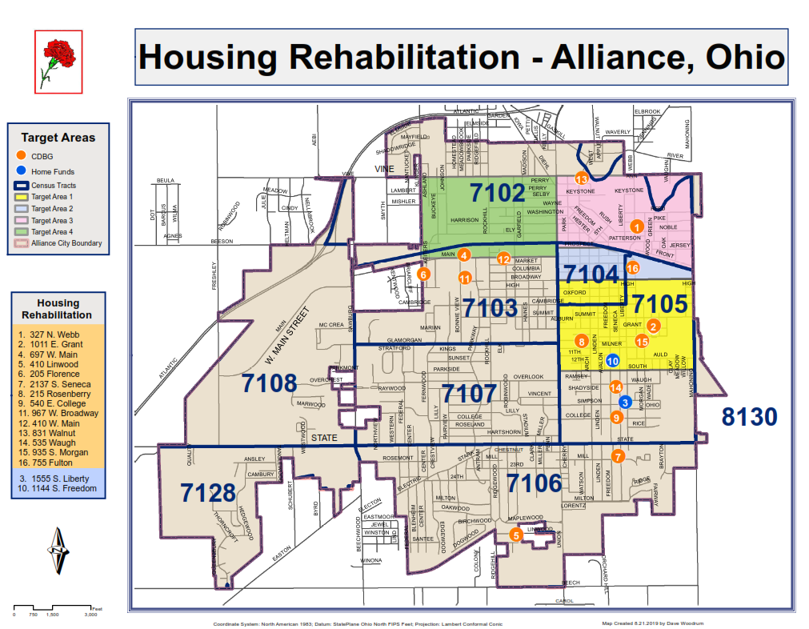

CR-25 - Homeless and Other Special Needs 91.220(d,e); 91.320(d,e); 91.520(c)
Evaluate the jurisdiction’s progress in meeting its specific objectives for reducing and ending homelessness through:
Reaching out to homeless persons (especially unsheltered persons) and assessing their individual needs.

The City of Alliance has a domestic violence shelter for those in need. The domestic violence shelter has been in operation since January 1989 and in FY-2018 $12,459.50 in CDBG funds were allocated to the shelter. During the period from 7/1/18 to 6/30/19, there were 301 women and 130 children served. Often, the shelter can reduce the impact of possible temporary housing displacement for many individuals in the City and surrounding areas by providing them with multiple nights of shelter.
Homeless activities for the City of Alliance and Stark County are handled through the Continuum of Care (CoC). The CoC is housed at the Stark County Resource Planning Commission (SCRPC). In FY-2018, the City of Alliance will partner with the CoC to sponsor a new nonprofit to provide services for homeless residents.
Total Households Served Actual Goal
Domestic Violence Shelter 431 225
Alliance for Children and Families 0 1

Addressing the emergency shelter and transitional housing needs of homeless persons.
The City of Alliance is a member of the Stark County Interagency Council on Homelessness. Its purpose is to develop and implement strategies and solutions to address the problem of homelessness to include the development of supportive housing options. Goals are to prevent and end chronic homelessness in Stark County, ensure a coordinated safety net of emergency services for those in short term housing crisis and coordinate and consolidate local efforts to provide a cost effective and streamlined system for addressing homelessness.

Helping low-income individuals and families avoid becoming homeless, especially extremely low-income individuals and families and those who are: likely to become homeless after being discharged from publicly funded institutions and systems of care (such as health care facilities, mental health facilities, foster care and other youth facilities, and corrections programs and institutions); and receiving assistance from public or private agencies that address housing, health, social services, employment, education, or youth needs.
The City of Alliance continues to watch for opportunities for establishing activities that promote job training and education programs and homeless services that offer transportation, expanded outreach, and shelter. In FY-2018, the City continued to support agencies such as the YWCA and the Alliance Career Center to provide low to moderate income persons with job training and education and to provide other homeless services programs. The City’s Department of Development will continue to support and partner with organizations that provide education, job training and placement, supported employment, transportation, and day shelter for persons with and without disabilities.
Helping homeless persons (especially chronically homeless individuals and families, families with children, veterans and their families, and unaccompanied youth) make the transition to permanent housing and independent living, including shortening the period of time that individuals and families experience homelessness, facilitating access for homeless individuals and families to affordable housing units, and preventing individuals and families who were recently homeless from becoming homeless again.
The City's Mayor attended meetings for the Homeless Continuum of Care of Stark County (HCCSC) interagency council. This membership allowed the Mayor to assist in the creation of innovative strategies and solutions to address the problem of homelessness and the development of supportive housing options. The HCCSC's goals are to prevent and end chronic homelessness in Stark County to ensure a coordinated safety net of emergency services for individuals in short term and chronic housing crisis and to coordinate and consolidate local efforts to provide a cost effective and streamlined system for addressing homelessness. With each meeting the City comes closer to the end goal as the Mayor stays informed on the topics of homelessness and housing opportunities for at risk Alliance residents. Working with sub-recipients the City is in a position to help minimize the trauma and dislocation that homelessness causes to individuals, families, and communities.

CR-30 - Public Housing 91.220(h); 91.320(j)
Actions taken to address the needs of public housing.
The City of Alliance Administration and Planning and Development Department does not operate a public housing program. This is operated by the Stark County Metropolitan Housing Authority.
Actions taken to encourage public housing residents to become more involved in management and participate in homeownership.
The City of Alliance CDBG Program does not operate the local public housing program and its resident's initiatives. This is administered by the Stark Metropolitan Housing Authority (SMHA), the local public housing authority.
Actions taken to provide assistance to troubled PHAs.
The Stark Metropolitan Housing Authority has not been designated as a troubled PHA.

CR-35 - Other Actions 91.220(j)-(k); 91.320(i)-(j)
Actions taken to remove or ameliorate the negative effects of public policies that serve as barriers to affordable housing such as land use controls, tax policies affecting land, zoning ordinances, building codes, fees and charges, growth limitations, and policies affecting the return on residential investment. 91.220 (j); 91.320 (i).
The City of Alliance's Housing Specialist and Zoning Inspector attend the Zoning Inspectors Task Force meetings. This is a group comprised of local zoning inspectors, code enforcement officials and housing specialists. These individuals have been educated on how the effects of zoning ordinances may affect fair housing in a negative manner. City of Alliance representatives have made presentations to the Zoning Inspectors Task Force.
The City of Alliance Zoning Inspector works partially under CDBG funding in our target areas. Therefore, the inspector works directly with the staff who develop the Annual Action Plans and Consolidated Plans. The inspector makes recommendations to the City's Board of Zoning Appeals and the committee that makes recommendations for the zoning regulations. In FY-2018, the Zoning Review Plan Committee completed revisions to the Zoning Book which is done every five years. The zoning inspector sits on this committee and advocates for furthering Fair Housing.

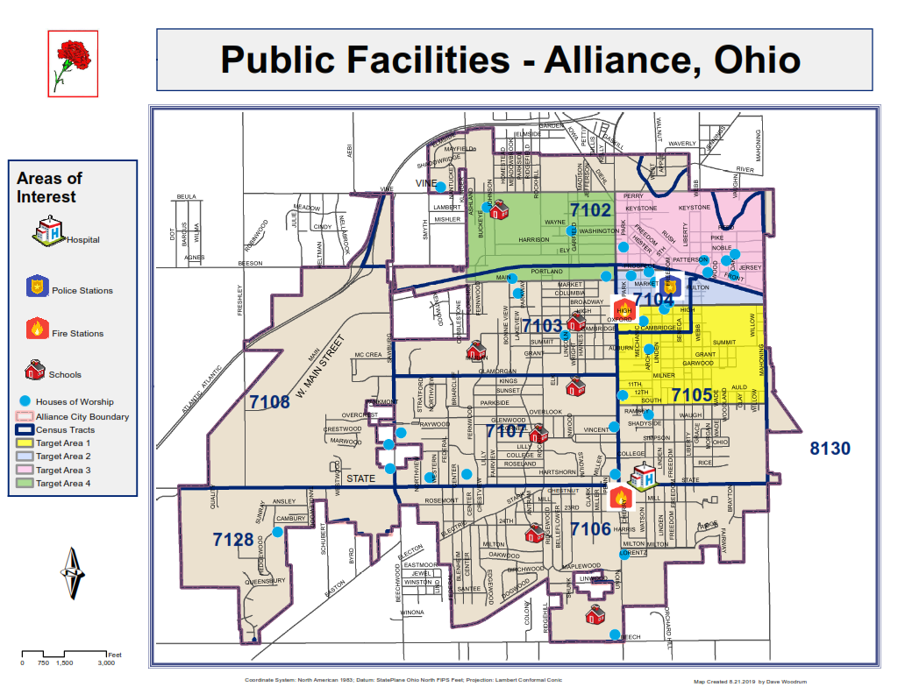
Map of Public Facilities by Target Area
Actions taken to address obstacles to meeting underserved needs. 91.220(k); 91.320(j)
All of the objectives set forth in the Consolidated Plan and the Annual Action Plans are designed to address the needs of the underserved in the City of Alliance. Actions can be identified with both the City’s and the sub recipients CDBG activities which include housing rehabilitation (both CDBG & HOME) which assist homeowners in improving their homes by making them safe, sanitary and cost effective. The CDBG funds provided to the City's sub recipients provide public services that are geared toward low-moderate income residents within the City of Alliance.
Actions taken to reduce lead-based paint hazards. 91.220(k); 91.320(j)
The age and condition of the housing stock in the City of Alliance is a matter of concern in regard to lead-based paint. Most homes built before 1980 are at risk for lead contamination. Because of age and the poor condition of the housing stock the City of Alliance Health Department conducts environmental assessments on all children reported with elevated blood lead levels in the City of Alliance. This program is coordinated with the nursing division of the health department. The nurses conduct home visits to assess the environment. During the visits they provide information for preventative measures regarding proper cleaning of surfaces or abatement procedures and other helpful information to assist in lowering exposure to lead. The Health Department has educational information available to the clients that they serve and to the public.
Actions taken to reduce the number of poverty-level families. 91.220(k); 91.320(j)
In order to reduce the number of poverty level families within the City of Alliance the YWCA Employment Assistance Program assisted low to moderate income women by eliminating barriers to work through assistance with transportation, clothing, personal care and other work related items. FY-2018 assisted 46 women, of which 22 were White, 19 were Black/African American, 4 were Black/African American & White and 1 was from other racial backgrounds.
In FY-2018 the City of Alliance assisted 21 low to moderate individuals with tuition assistance while attending the Alliance Career Center. Assistance provided individuals the ability to overcome obstacles that would have prevented them from continuing their academic goals.
The Alliance Area Domestic Violence Shelter provided outreach and educational services to victims of domestic violence. The total number of recipients’ assisted was 323. Of the recipients’ assisted, 202 were White, 86 Black/African American, 3 were American Indian/Alaskan Native, 1 was Asian & White, and 31 was Black/African American & White. The Alliance Area Domestic Violence Shelter is an advocate to those who fear homelessness and the ability to start or maintain employment. This program is necessary to reduce the number of poverty-level families.
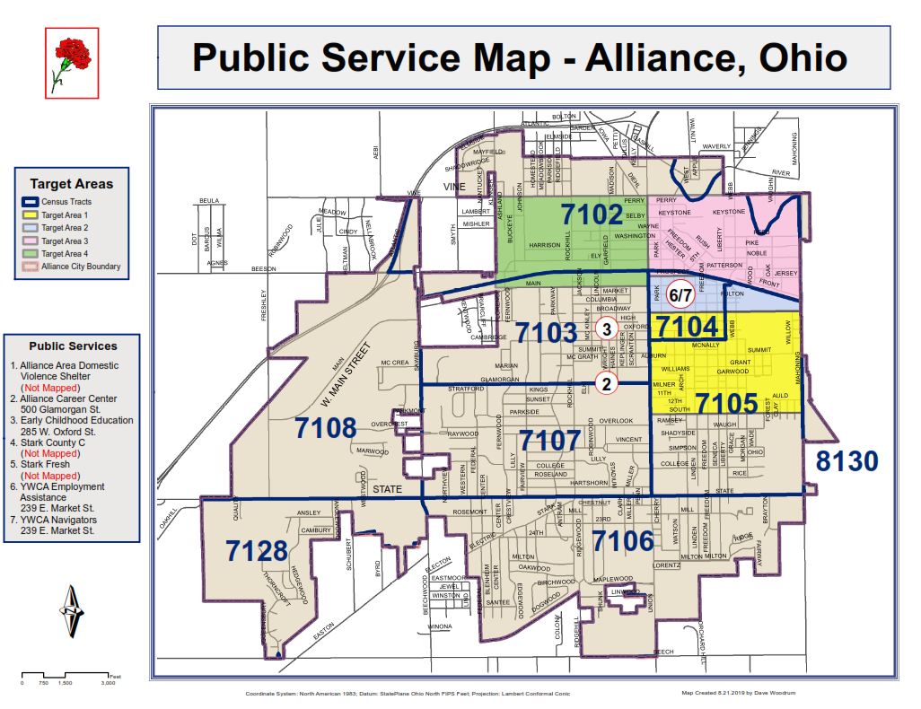
Public Service Map
Actions taken to develop institutional structure. 91.220(k); 91.320(j)
The City of Alliance works directly with City departments, county and state agencies, local business partners, public service agencies and faith based organizations to carry out the objectives in the strategic plan. Below is the list of institutional structures that the City collaborates with:
- The Homeless CoC of Stark County
- The Stark County Regional Planning Commission
- The Planning & Development Committee
- Alliance for Children & Families
- The Alliance Area Domestic Violence Shelter
- Beacon Pharmacy
- The YWCA of Alliance
- Ohio Means Jobs
- Stark County Board of Developmental Disabilities
- SARTA
- The Alliance Area Chamber of Commerce
- The Alliance Career Center
- Ohio Housing Finance Agency
- The Alliance Mission Encounter
- Hammer & Nails
- StarkFresh Mobile Grocery
The City of Alliance’s Mayor has been an active member of the Homeless CoC of Stark County for the past four years. The Homeless CoC of Stark County has been in operation since 2013. The Director of Planning & Development is on the Stark County Network Board which is a part of the Homeless CoC of Stark County.
In the future, the City of Alliance and The Stark County Regional Planning Commission will look for efficient ways to acquire properties for low to moderate income family housing with less delays of time so that projects like the Alliance for Children and Families are completed within the fiscal program year.
Actions taken to enhance coordination between public and private housing and social service agencies. 91.220(k); 91.320(j)
In the future, the City of Alliance and The Stark County Regional Planning Commission will look for efficient ways to acquire properties for low to moderate income family housing and minimize delays so that projects like the Alliance for Children and Families are completed within the fiscal program year.
Identify actions taken to overcome the effects of any impediments identified in the jurisdictions analysis of impediments to fair housing choice. 91.520(a)
Please note the section on action plans and subsequent actions undertaken for the City of Alliance for the response to 91.520(a).

CR-40 - Monitoring 91.220 and 91.230
Describe the standards and procedures used to monitor activities carried out in furtherance of the plan and used to ensure long-term compliance with requirements of the programs involved, including minority business outreach and the comprehensive planning requirements.
Monitoring: Programs and projects have direct oversight by the Department of Planning and Development. Compliance with federal guidelines, achievement of goals and objectives and the collection of data is completed by the department.
To ensure compliance with timeliness for the CDBG program, the City of Alliance Department of Planning and Development followed these actions:
- Screening and selecting sub recipients and activities that will meet timeliness standards.
- Incorporating project mile stones and drawdown schedules into sub recipient contracts.
- Implementing sanctions for untimely sub recipients.
- Reallocating funds for untimely sub recipients.

Funding provided to sub-recipients require a per month based activity monitoring form. The activity monitoring form must report how CDBG funds were expended and how many clients benefited from the use of these funds. The Planning and Development Department does not release funding until it is verified that the expenditure meets all requirements included in the contract including the budget line items between the City of Alliance and the sub-recipient. The Department of Planning and Development’s Community Development Planner along with the City of Alliance Auditor, Deputy Auditor, or Planner’s assistant perform onsite visits to review work performed during the elapsed time period.
Informal and formal monitoring visits were conducted to ensure compliance with program requirements. Risk assessments and in-house desk audits were also performed for three funded agencies. These agencies included: The Stark County Mental Health Program, the Alliance Area Domestic Violence Shelter and the StarkFresh Mobile Grocery all of which there were no findings. The agencies were in compliance with HUD regulations.
The purpose of this monitoring plan is to provide an internal control mechanism to review performance over a period of time and to evaluate compliance of non-profit sub recipients funded with Community Development Block Grant (CDBG) funds pursuant to 24 CFR 570.502, Applicability of uniform administrative requirement, (a) (14) and with 24 CRF Section 5, Uniform Administrative Requirements for Grants and Cooperative Agreements to states and local governments, 24 CFR Section 85.40 “monitoring and reporting program performance”, and other laws and regulations based on the funding source.
The monitoring plan positions the City of Alliance, Planning & Development Department to make informed judgments about sub recipient’s program effectiveness, efficiency, ability to prevent fraud, and waste and abuse of public funds. Monitoring also allows the City of Alliance to provide technical assistance to help sub recipients comply with applicable laws and regulations, improve technical skills, increase and stay updated on regulations relevant to CDBG or other funding agencies. Additionally, monitoring helps to identify deficiencies, and highlight accomplishments and best practices that can be duplicated.
In addition, the housing inspector completes inspections on work being done by contractors who are contracted for homes for the Owner-Occupied Housing Rehab Program. A “Work Progress Report” is completed for each inspection visit. Communication is consistent with the homeowner and housing inspector.
Citizen Participation Plan 91.105(d); 91.115(d)
Describe the efforts to provide citizens with reasonable notice and an opportunity to comment on performance reports.
The Public Notice for the City of Alliance’s FY-2018 C.A.P.E.R. was published in the Alliance Review on August 28, 2019. A copy was made available at the Rodman Public Library, the Office of Planning and Development and on the City's website at www.cityofalliance.com. Currently, the City has not received any public comments on the FY-2018 C.A.P.E.R. In addition, the performance report provided to citizens must identify the federal funds made available for furthering the objectives of the Consolidated Plan. For each formula grant program, the grantee shall identify the total amount of funds available (including estimated program income), the total amount of funds committed during the reporting period, the total amount expended during the reporting period, and the geographic distribution and location of expenditures. Jurisdictions are encouraged to include maps in describing the geographic distribution and location of investment (including areas of minority concentration). The geographic distribution and expenditure requirement may also be satisfied by specifying the census tracts where expenditures were concentrated.

Citizen Participation Plan
PROPOSED CITIZEN PARTICIPATION PLAN
The Department of Planning & Development is the responsible entity in the City of Alliance to administer the HUD funded Community Block Grant Program (CDBG).
Citizen Participation Plan Development Process
Prior to the adoption of the Community Development Department’s Citizen Participation Plan, citizens are given the opportunity to comment. The draft plan is presented to the Community Development Committee at its March meeting at the same time as the CDBG proposed program. The plan is then made accessible to the residents of the City of Alliance through its website and a copy is available in the Rodman Public Library for a 30 day citizen comment period. As needed, the plan can be made into a format accessible to persons with disabilities, upon request. Any comments made by the public during the 30 comment period will be addressed by staff prior to the adoption of the final citizen participation plan. Furthermore, comments made may not always result in changes in the plan.
Community Development
Public Participation General Information
One of the main goals of the City of Alliance’s Planning & Development Department is to provide the community an opportunity to participate in an advisory role in the planning, implementation and assessment of its programs and projects. There are four main programs or plans that the Community Development Department undertakes and two main programs that the Stark County Regional Planning Commission’s Community Development Department administers for the City. These programs are the Community Development Block Grant Program, the Consolidated Plan (5- Year Plan), the Annual Action Plan, the Consolidated Annual Performance Plan (CAPER), and the HOME Investment Partnership Program (HOME), and the Assessment of Fair Housing (AFH), respectively. Please see the list below outlining basic practices and policies utilized by the City of Alliance to ensure the public has access and knowledge to programs in their community:

Holding a “public meeting” entails:
- Not being required by law.
- Not making the discussion between the interested parties and comments public record.
- Attendees being able to ask questions and make comments, with the aid of a moderator to keep the meeting focused.
All meetings held by the Community Development Department are normally during the day and held at the City Administration Office located at 504 E. Main Street, Alliance, Ohio 44601. If necessary, meetings may be held in the evening. By holding meetings or hearings at the City Administration office building, they are accessible to the community through the following ways:
- The City Administration Building is ADA accessible.
- The City Administration Building is accessible to public transportation, including the location of a SARTA bus stop directly in front of the Administration Building.
- Meetings or hearings being held are advertised in the local newspaper and the City of Alliance’s website, when applicable.
- Any documents created by the Department of Community Planning & Development that require public comment are made available on the City’s website as well as a copy being available at the office.
- If a non-English speaking community member attends a meeting, they are encouraged to bring a translator (1.08% non-English speaking households in Stark County, Ohio, according to the 2013 American Community Survey). If an interpreter is needed, advance arrangements will need to be made. The plan is intended to facilitate persons with mobility, visual or that are hearing impaired.
Community Development Programs / Plans
- Community Development Block Grant Program
The City of Alliance is the recipient of the federally funded CDBG program of the U.S. Department of Housing and Urban Development (HUD). The Department of Planning and Development does all of the overall planning and administration of the CDBG Program. The CDBG Program aims at developing viable communities by providing decent housing and a suitable living environment, along with expanding economic opportunities, for persons of low-and moderate incomes.
Citizen participation is a vital role in the CDBG Program process. As established by Section 104(a)(2) of the Housing and Community Development Act and by the regulations at 24 CFR 570.486, there are key actions that need to be taken to ensure that citizens of a community where CDBG funded activities will take place, have an opportunity to participate in an advisory role in the planning, implementation and assessment of the program and projects. Therefore, the City of Alliance’s Planning & Development Department includes the local community in the CDBG Program implementation by taking the following actions:
- Providing 2 public meetings, each at different stages of the program. The first being held for the CAPER to be presented, and the second during the 30 day public comment period of the Annual Action Plan.
- Providing citizens with reasonable advance notice of and opportunity to comment on proposed activities.
- Providing citizens contact information for submitting complaints and then responding to complaints in a timely manner.
Each program year the Planning & Development Department is responsible for:
- Publishing notices for the CDBG application workshop in the local newspaper.
- Sending invitations to non-profit agencies that have applied in the past, or expressed an interest in applying.
- Posting notices on the City of Alliance’s website.
A public meeting is held to present the upcoming proposed funding plan and encourage discussion with attendees. The funding plan is also presented at the March CDBG Committee meeting for voting approval and updates to the Citizen Participation Plan. Once the Plan is approved by the CDBG Committee the public comment period commences on the proposed program.
At the end of the comment period and after the comments have been reviewed and considered by the Department of Planning & Development staff, the Plan is presented to City Council for final approval. The final CDBG Funding Program is sent for submission to HUD no later than 45 days prior to the start of the City’s federal fiscal year (July 1).
CDBG Substantial Amendments:
An amendment is deemed “substantial” when:
- A program is added or cancelled; or
- A considerable amount of money is being reallocated from one project to another, as determined by the Community Development Department; or
- There is a change to the purpose, scope, location, or beneficiaries of an activity (24 CFR Part 91.505).
Public participation is required when a substantial amendment is needed. The proposed substantial amendment is presented to the Community Development Committee at an emergency meeting. A public notice of the proposed amendment is published allowing for a 30 comment period. If comments are received by citizens, they will be considered prior to finalizing the amendment. The Planning & Development Committee votes to approve the amendment which is then published as the final amendment. Then the amendment is presented to City Council for approval. In cases where urgency is a consideration, the comment period may be reduced to 15 days or less.
- Consolidated 5 Year Plan (CP) and Annual Action Plan (AAP)
The consolidated plan is a five year plan, updated every five years, in accordance with HUD regulations. The plan provides an assessment of needs in the community, including housing and homeless needs, a housing market analysis, and a strategic plan for the allocation of housing resources. The plan also includes the City’s priority community development needs that qualify under the CDBG program. Additionally, there is an assessment of the needs for infrastructure improvement, public facilities, public services, accessibility, economic development, fair housing and planning needs.
The submission of the CP also contains the first year AAP. During the next four years only the AAP is submitted.
The Citizen Participation for the AAP is as outlined in the CDBG section of this document. The AAP summarizes the activities that the City will undertake utilizing CDBG funding during the fiscal year.
Citizen participation is critical during the preparation of the CP. Residents are encouraged to participate through the following ways:
- Completing a survey that is made available to groups targeted as able to provide input in terms of homeless, housing, planning, and non-housing community development needs to gather information and comments.
- Attendance at public meetings.
- Public comments are received at public meetings held throughout the preparation of the CP.
- All comments and views are considered prior to submission of the CP.
As a result of the public meetings held, objectives and goals of the community are established and public comments are accepted. The CP is presented to the Community Development Committee and then there is a 30 day public comment period. Any comments or views taken into consideration by the staff and are made note of in the final CP. The Plan is then presented to City Council for approval and sent to HUD.
Consolidated Plan and Action Plan “Substantial” Amendments:
An amendment is deemed “substantial” when:
- There is a change to the allocation priorities or a change in the method of distribution of funds; or
- To carry out an activity, using funds from any program covered by the CP not previously described in the action plan; or
- To change the purpose, scope, location, or beneficiaries of an activity (24 CFR Part 91.505).
Public participation is required when a substantial amendment is needed. The proposed substantial amendment is presented to the Community Development Committee in a special meeting. A public notice of the proposed amendment is published allowing for a 30 day comment period. If comments are received by the citizens, they will be considered prior to finalizing the amendment. In cases where urgency is a consideration, the comment period may be reduced to 15 days or less. The Plan is then presented to City Council for approval and sent to HUD and published as the final Plan.
Consolidated Annual Performance Evaluation Report (CAPER)
The Consolidated Annual Performance Evaluation Report (CAPER), is completed annually by the Community Development Department staff and submitted to HUD within 90 days after the end of the City’s program year (June 30). Once the draft is completed the actions are as follows to encourage citizen participation:
- The draft CAPER is made available on the City’s website and the Rodman Public Library for a 15 day comment period.
- A copy is available at the Department of Planning & Development
- All comments are reviewed by the staff of Planning & Development and included in the final CAPER.
At the end of the comment period, the CAPER is submitted to HUD.
HOME Program and Fair Housing Program
The Home and Fair Housing Program are administrated by Stark County Regional Planning Commission for the City of Alliance. All public meetings and hearings for these programs are held by the County and information for these meetings is available on the Commissions website at http://www.starkcountyohio.gov/regional-planning. Information on both of these programs can be found on their website as well. For more information on the processes and procedures please visit their website or call the Stark County Community Development Department at (330) 451-7389.

CR-45 - CDBG 91.520(c)
Specify the nature of and reasons for, any changes in the jurisdiction’s program objectives and indications of how the jurisdiction would change its programs as a result of its experiences.
In FY-2017 Historic Preservation as economic development was added as a high priority goal. This goal was not part of the 2014-2018 Consolidated Plan. After FY-2018, the City of Alliance decided to remove this goal after review of the original goals. The City of Alliance considers this to be a need but not a prioity.
The City of Alliance continues to review the reporting process for the sub-recipients to ensure the most accurate demographic information.
Does this Jurisdiction have any open Brownfields Economic Development Initiative (BEDI) grants?
No
[BEDI grantees] Describe accomplishments and program outcomes during the last year.

Affirmatively Furthering Fair Housing
City of Alliance
July 1, 2018 – June 30, 2019 (FY 2018)

On April 11, 1968, Title VIII of the Civil Rights Act of 1968, commonly known as the Fair Housing Act, was signed into law. The federal Fair Housing Act was passed one week after the assassination of the Rev. Dr. Martin Luther King, Jr. as a tribute to him and the work he did to challenge residential segregation. The Civil Rights Act of 1968 prohibits discrimination based on race, color, religion, and national origin. Fair housing advocates fought for added protections and the law was amended making housing discrimination against women illegal in 1974, and families with children and persons with disabilities illegal in 1988.
The goals of the Civil Rights Act of 1968 were to eliminate housing discrimination and promote residential integration. Additionally, the law was passed to provide a place of opportunity in every neighborhood regardless of the race, color or national origin of its residents. Every person should have a right to live in neighborhoods rich with opportunity including affordable housing, fair credit, good schools, fresh food and much more. Since the passage of the law, we have made great strides in combating discrimination. However, the struggle continues for African Americans, Latinos, women, people with disabilities, and other minorities. More than 50 years later, many of the pressing issues that existed in 1968 are still in the forefront.
The Stark County Regional Planning Commission’s Fair Housing Department serves to protect fair housing rights of residents in Stark County and the City of Alliance. The department is committed to equality and opportunity for everyone. This report outline key obstacles, through impediments, to achieving the goals of the Fair Housing Act, while providing an action plan to combat such barriers.
As recipients of Community Development Block Grant (CDBG) and HOME funds, the City of Alliance is legally obligated to Affirmatively Further Fair Housing. Entitlement communities receiving HUD funds are required to examine and attempt to alleviate housing discrimination within their jurisdiction, promote fair housing choice for all persons, provide opportunities for all persons to reside in any given housing development regardless of race, color, religion, sex, national origin, disability or familial status, promote housing that is accessible to and usable by persons with disabilities and comply with the non-discrimination requirements of the Fair Housing Act. To satisfy the requirements of the Housing and Community Development Act of 1974, as amended, and to affirmatively further fair housing, the cities of Alliance, Canton and Massillon, and Stark County, for the Board of Stark County Commissioners, agreed to collaborate and prepare a Regional Analysis of Impediments to Fair Housing Choice. The Analysis of Impediments to Fair Housing Choice (AI) is a review of a jurisdiction’s laws, regulations, policies, procedures, and practices affecting the location, availability and accessibility of housing, as well as an assessment of conditions, both public and private, affecting fair housing choice.
The 2018 Regional AI evaluates population, household income, and housing characteristics by protected classes in each of the jurisdictions; evaluates public and private sector policies that impact fair housing choice; identifies blatant impediments to fair housing choice; and recommends specific strategies to overcome the effects of any impediments identified.
Below are the Potential Impediments, Recommended Action Plans and Subsequent Actions Undertaken for the City of Alliance:
- Potential Impediment: The City's regulation of group homes places restrictions that are not consistent with fair housing standards.
Recommended Action Plan: Amend the ordinance to allow group homes in the same residential districts as single-family dwelling units for non-disabled persons and permit them by right without any conditions.
Action Undertaken: The staff plans to speak with city officials in order to amend the ordinance to allow group homes in the same residential districts as single-family dwelling units and not solely through conditional use.

- Potential Impediment: The City’s definition of family is narrow and could discriminate against a variety of nontraditional family types.
Recommended Action Plan: Amend the definition of family so that it does not have a numerical limit and instead emphasizes the functioning of the individuals as a single housekeeping unit.
Action Undertaken: The staff plans to speak with city officials to broaden the definition of family in order to include groups of individuals functioning as a single housekeeping unit.
- Potential Impediment: The City’s appointed public boards relating to housing issues are not demographically representative of the community at large.
Recommended Action Plan: Consider the composition of race, gender, and disability when appointing new members to the City's boards and commissions that could influence housing issues.
Action Undertaken: The staff plans to speak with city administration in regards to actively seeking qualified members of protected classes to sit on the Zoning Board and other housing-related boards and committees so they may be better equipped to represent and serve the community at large.

- Potential Impediment: The Comprehensive Land Use Plan and the City’s zoning ordinance discourage the development of multi-family rental housing.

Recommended Action Plan: Update the City’s land use plan to include a statement to encompass its fair housing aims and ensure that the intent and effect of the housing policies established are consistent with that statement.
Action Undertaken: Staff plans to initiate a review of the zoning ordinance and Comprehensive Land Use Plan with the goal of amending statements that do not discourage the development of multi-family rental housing and with the goal of removing obstacles to the creation of affordable housing.

- Potential Impediment: The City has no Language Access Plan.
Recommended Action Plan: Conduct a four factor analysis and create a Language Access Plan.
Action Undertaken: The staff plans to speak with City Administration to conduct the four-factor analysis to determine the extent to which the translation of vital documents is necessary to assist persons with limited English proficiency in accessing city programs and services.

- Potential Impediment: Some landlords are not making investments to improve and maintain their properties, leaving low-income tenants living in unhealthy environments.
Recommended Action Plan: Create a landlord registry that includes unit inspections and fair housing training.
Recommended Action Plan: Create a database of complaints against landlords. Share database with SCRPC in order to fight noncompliance with fair housing across the County.
Action Undertaken: The staff plans to speak with City Administration to encourage a landlord registry and rental unit inspections in order for landlords to maintain such units in a healthy and safe place for tenants to live. Thereafter, the staff will create a data base of complaints against landlords in the city.
Action Undertaken: The staff plans to conduct additional fair housing workshops to increase the awareness of tenant’s rights and landlords knowledge of the law.

- Potential Impediment: The City has areas consisting of concentrated LMI persons and racial and ethnic minorities.
Recommended Action Plan: Allocate CDBG funding to enhance and revitalize LMI areas and improve the existing housing stock.
Action Undertaken: In the past, the city allocated CDBG funding to a non-profit organization to rehab a unit for an eligible residence in order to improve the quality of life of residents. The staff will encourage City Administration to continue such efforts, as well as other things, in order to improve the existing housing stock.

Potential impediments were identified in the AI for the entire Region/County. Below are the Potential Impediments, Recommended Action Plans and Subsequent Actions Undertaken for the Region:

- Potential Impediment: Coordination between SARTA and local development departments could be improved from a fair housing standpoint.
Recommended Action Plan: Add a review by SARTA to SCRPC’s review process for new development projects.
Recommended Action Plan: Incorporate public transportation staff in the development planning process through periodic group meetings with County and local planning staff and SARTA officials.
Recommended Action Plan: Add language to future comprehensive plans that describes how current and future public transportation projects will affect impacted areas.
Action Undertaken: The staff plans to speak with the county planning department to see how to incorporate the recommended action plans to improve coordination between SARTA.

Strategies for Affirmatively Furthering Fair Housing
The following section addresses the efforts to further fair housing for all Alliance residents.

Housing Discrimination Highlights

Thousands of cases have been filed around the country to address discriminatory practices and policies that violate the federal Fair Housing Act. The cases have challenged discrimination in every type of housing transaction - rental, sales, lending, homeowner’s insurance, appraisal, advertising, sexual harassment, zoning, and more. Identifying issues and solutions can be extremely complex and a huge obstacle for many. Discrimination against persons in a protected class is often intertwined with other seemingly economic and social issues. According to the Housing Research and Advocacy Center, more than 33,000 instances of housing discrimination occur in Northeast Ohio annually, particularly against African Americans, Hispanics/Latinos, Asian Americans, and Pacific Islanders. On the national level, the National Fair Housing Alliance (NFHA) estimates that 4 million acts of housing discrimination occur per year in the rental market alone. The actual numbers reported are much smaller because housing discrimination often goes undetected and unreported. While occasionally housing discrimination is blatant and obvious, it is increasingly subtle, and it can be disguised by discriminatory pricing, terms, false information, and other factors that influence housing choice. It is estimated that less than one percent of housing discrimination complaints are reported.

The Stark County Fair Housing Department (SCFHD) operates at the forefront of the housing crisis by educating the community and the housing industry and by enforcing the laws intended to protect all against housing discrimination. The SCFHD receives, processes, tests, investigates, and files complaints of housing discrimination with the Ohio Civil Rights Commission. In Ohio, residential property is also covered by state law governing fair housing through the Ohio Revised Code, Section 4112.02(H). The Ohio statute is broader than the federal Fair Housing Act in several important respects. While Ohio law prohibits discrimination based on all of the classes protected by federal law, it also prohibits discrimination based on two additional grounds, ancestry and military status. Second, while federal law contains several provisions that exempt certain residential property from coverage, Ohio’s statute does not include these exemptions, making Ohio’s fair housing law applicable to almost all housing in the state. In an effort to enforce fair housing laws, SCFHD assists those who experience discrimination. The staff files administrative complaints, resolve complaints through conciliation, and litigate fair housing cases, where necessary. Below highlights the most notable cases during this reporting period:

Alliance: In June 2019, the staff assisted a bariatric disabled tenant. Due to the tenant’s disability, she would often need emergency transportation to a hospital. EMS providers could not transport the tenant in a cot because it would not fit in the building’s elevator. The patient had to be moved on a tarp. The staff believed management needed to reasonably accommodate this tenant by transferring her to a 1st floor unit. Since there were no units available on the 1st floor, staff requested a transfer to another building where the elevator could accommodate the tenant and a cot. As a result of the staff’s intervention, management agreed to transfer the tenant to a building where she could live and enjoy her dwelling, as well as be transported by EMS providers on a cot and down an elevator in case of emergencies.

As previously mentioned, housing discrimination often goes undetected and unreported. It is common for victims of discrimination not to report it because it is difficult to identify, prove, and document. In addition, victims of housing discrimination often feel that nothing can or will be done about the discrimination that they experience. Frequently, they feel that they might be subject to retaliation by their housing provider, landlord, or even their neighbors. Housing discrimination affects us all, preventing the City of Alliance, Stark County and the U.S. from living up to equitable opportunities.

Education, Workshops, Trainings and Outreach

The staff continues its ongoing process to educate the public on the fair housing law through workshops, presentations, and training in an attempt to increase the awareness of discrimination. The following events and activities were conducted by the department to educate and reach out to the community:
August 2018
- Staff conducted a training to Stark Metropolitan Housing Authority staff. The staff engaged all participants in dialogue on different fair housing scenarios. Approximately 110 people were in attendance.

September 2018
- Staff gave a presentation to landlords at the Real Estate Investor’s Association Expo that was held at Kent Stark State University Conference Center. Staff trained landlords from around the county on various discriminatory scenarios including, “What Would You Do” questions. Approximately 25 persons were in attendance.

- Staff had a display booth at the Real Estate Investor’s Association Expo that was
held at Kent Stark State University Conference Center.
October 2018

Staff was interviewed on News Talk 1480 WHBC Radio. The discussion was on the Fair Housing Luncheon and guest speaker, Dr. Bernice King.

- Staff was interviewed on Q-92 WDJQ Radio. The discussion was on housing discrimination, the Fair Housing Luncheon and guest speaker, Dr. Bernice King.

- Staff conducted a training to Section 8 landlords. Staff gave an overview of the fair housing law and costly fines. Approximately 76 people were in attendance.

- Staff sponsored a countywide Fair Housing Luncheon in celebration of the 50th Anniversary of the Fair Housing Act. Featured speaker was Dr. Bernice King. The event was held at Kent Stark State University. Three hundred fifty (350) people were in attendance.

November 2018
- Staff conducted a presentation to the Hoarding Coalition for Stark County Mental Health & Addiction Recovery. Staff gave an overview on fair housing and how disability relates to hoarding. Approximately 15 persons were in attendance.

April 2019
- Staff gave a presentation to the RPC staff and Commission on the 51st Anniversary of the Fair Housing Act.

- Staff provided news releases in the Alliance Review (local newspaper) to commemorate the passage of the Fair Housing Law.

Staff attended Alliance Council Meeting for the AI Consultant’s presentation on the Analysis of Impediment Study findings.

Educational materials were provided to all participants who attended the above listed presentations, workshops, trainings, etc.

SMHA Grievance Hearings

In addition to the above activities, the Fair Housing Manger conducted 2 Informal and Formal Grievance Hearings for Stark Metropolitan Housing Authority. SMHA entered into an agreement, and later renewed, with the Stark County Regional Planning Commission for the Fair Housing Manager to conduct hearings as the Hearing Appeals Officer. The purpose of the hearings is to resolve applicant or tenant disputes with the Housing Authority without legal action and to correct PHA errors that may occur in the decision-making process. The following lists the basic responsibilities of the Hearing Officer:

Assist with the coordination and the scheduling of all hearings;

Hear appeals by applicants of public housing and the housing choice voucher program regarding determination of ineligibility or denial of admission;

Hear appeals from housing choice voucher participants in regards to adverse decisions in their certification and/or tenancies;

Hear appeals from public housing tenants in regards to termination of assistance, PHA requirements related to the tenancy of the resident, or PHA failure to act related to the tenancy of the resident;

Hear appeals from public housing tenants and housing choice voucher participants in regards to a reasonable accommodation request denial;
- Research federal regulations and review SMHA’s Administrative Plan and Admissions and Continued Occupancy Policy;

Issue written decisions on each hearing.

Monitoring
During this period, 3 housing providers were monitored. The owners and managers were monitored on a quarterly basis due to some questionable illegal rental practices in the past in regards to race, color, disability and familial status.

Advertising and Promotion

The staff continues to educate the public on the fair housing law in an attempt to increase the awareness of discrimination. Educational materials are distributed to various agencies and Alliance residents. The staff distributed five hundred and eighty-nine (589) brochures to property owners, managers, tenants, Alliance Municipal Court, City of Alliance Community Development Department, Realtors, Stark Metropolitan Housing Authority, Stark County Mental Health & Addiction Recovery Board, Community Services of Stark County, and Stark Regional Planning Commission.

Landlord and Tenant Relations

In addition to counseling home seekers on the laws that govern discrimination, the staff counsels on landlord and tenant issues to the citizens of Alliance and Stark County. Property owners, managers, tenants and representatives from social service agencies are counseled on their rights, obligations, and responsibilities under the Ohio Landlord Tenant Law. The figures on housing discrimination does not reflect the calls received from persons who feel they have grounds to charge someone with discrimination. However, many of the calls are the result of a landlord-tenant issue and resolved through counseling and mediation.

During this period, 22 property owners, managers, Realtors and tenants were counseled on the landlord-tenant law in the city of Alliance. Specifically, they were counseled in areas regarding evictions, security deposits, rent withholding, lease termination, retaliation and other areas that deal with residential landlords and tenants.

Conclusion

Fifty-one years after the Fair Housing Act made housing discrimination illegal, acts of discrimination in housing still occur every day. While often undetected and unreported, housing discrimination is still a huge obstacle for many. We still have much work to do. We still have housing providers giving false information about the availability of housing because the person inquiring over the telephone sounds black. We still have landlords refusing to rent to persons with disabilities. We still have housing providers lying that a complex qualifies for Housing for Older Persons just because they do not want children on the property. We still have hate or bias-related incidents occurring across the country. We still have racial segregation, residential preferences in zoning, steering, sexual harassment and blatant discrimination against people of color and persons with disabilities. In many ways, we are still separate and unequal!! The fight for fair housing continues, but together we can make a difference. We must continue our efforts to address discrimination as we undertake the next 50 years of the Fair Housing Act.

The Fair Housing Department for the City of Alliance will continue to root out discrimination and represent victims of housing discrimination. Necessary actions will be taken to ensure that the fair housing law is properly and fairly enforced in the City. The fair housing department will continue to take the appropriate steps necessary to eliminate the potential impediments listed in the Analysis of Impediments to Fair Housing Choice.

SELF EVALUATION

- Describe the effect programs have in solving neighborhood and community problems.
- Describe progress in meeting priority needs and specific objectives and help make community’s vision of the future a reality.
- Describe how you provided decent housing and a suitable living environment and expanded economic opportunity principally for low and moderate-income persons.
- Indicate any activities falling behind schedule.
- Describe how activities and strategies made an impact on identified needs.
- Identify indicators that would best describe the results.
- Identify the barriers that had a negative impact on fulfilling the strategies and overall vision.
- Identify whether major goals are on target and discuss reasons for those that are not on target.
- Identify any adjustments or improvements to strategies and activities that might meet your needs more effectively.

- FY-2018 projects had quantifiable effects on neighborhood and community issues. The City of Alliance returned 89 housing violations back to property maintenance code compliance. The City resolved 188 nuisance complaints for trash and/or tall grass.
- All activities funded during FY-2018 made an impact on the needs and objectives identified in the Consolidated Plan as measured by the number of persons and households directly and indirectly benefitting from the activities.
- In FY-2018, the City provided decent, safe and affordable housing through a variety of housing rehab projects funded through CDBG as well as code enforcement initiatives. The City utilized HOME funds to assist three low-moderate income families by bringing these three homes up to code. CDBG funds were used to do emergency repairs to twelve low to moderate income owner occupied homes and three full rehabs for owner- occupied, low to moderate income households.
- The Central Fire Station Rehabilitation was granted an extension for FY-2018 due to the contractor running behind schedule. The other activity granted an extension in FY-2018 was the Union Avenue Corridor. Due to funding from various state and federal funding, the project is still in the environmental review process.
- The demolition of dilapidated and abandoned housing continues to be a priority for the City of Alliance. Demolition, the Neighborhood Initiative Program (NIP), housing rehab and aggressive code enforcement have produced noticeable, visual revitalization progress in the target neighborhoods. The City continues to aggressively pursue irresponsible home owners and landlords that contribute to the decay of the housing stock in the City of Alliance. The City has also utilized UDAG funds to assist in the demolition of vacant, dilapidated, commercial buildings in the downtown area that have jeopardized public health and safety.
- Success is measured by the number of properties inspected and found to have code violations compared to the number of violating properties inspected and found to have code violations compared to the number of violating properties that were resolved. Success is also measured by comparing the total number of blighted/vacant properties against the total number that were demolished and removed from the City’s housing stock.
- The largest barrier to meeting community needs is ongoing sufficient funding. Programs like NIP has helped significantly, more long-term sustainable funding is needed to ensure revitalization efforts keep moving forward. As of June 30, 2019 the City has demolished 161 blighted structures through this program.
- Intentionally Left Blank
- The City of Alliance is in process of undertaking the potential impediments listed in the latest analysis of Impediments for Fair Housing. Currently the City is looking working on a project to make certain the Spanish speaking population has adequate access to city programs and services which are HUD funded. The City has moved forward in promoting Affordable Multi Family Housing with the Nantucket Circle Project and has completed a senior housing renovation at the Newsome Towers. The City does infact have a draft of their Affirmative Marketing Plan in place; this was an oversight in the latest Analisis of Impediments. The Affirmative Marketing Plan was included in the FY-2018 Annual Action Plan.

AA) Funds were not expended for acquisition, rehabilitation, or demolition of occupied real property in FY-2018.

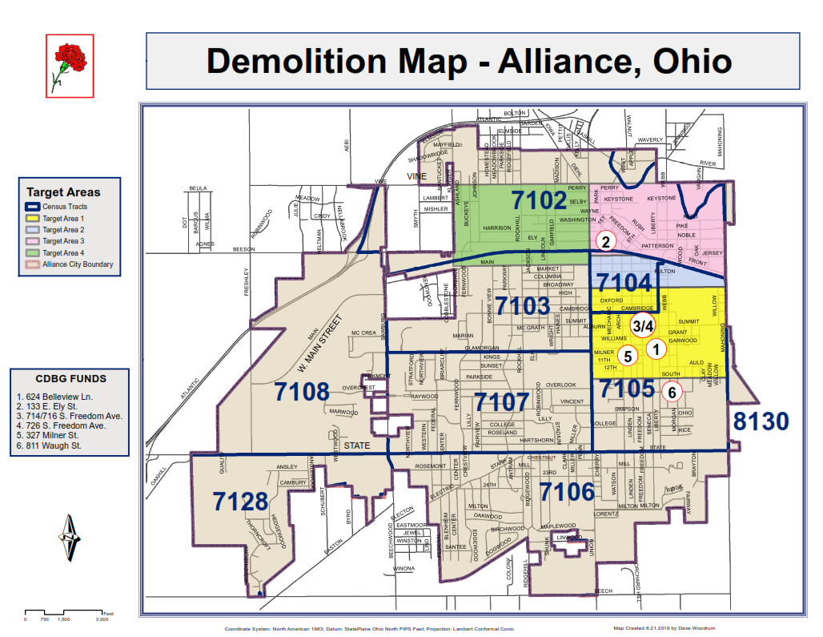
Demolition Map

