Introduction 3
CR-05 Goals and Outcomes 12
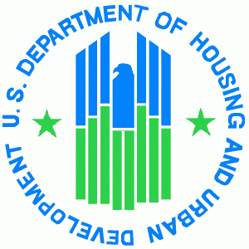
CR-10 Racial and Ethnic Composition of Families Assisted 19
CR-15 Resources and Investments 20
CR-20 Affordable Housing 25
CR-25 Homeless and Other Special Needs 30
CR-30 Public Housing 32
CR-35 Other Actions 33
CR-40 Monitoring 40
Citizen Participation Plan 91.105 42
CR-45 CDBG (CDBG grantees only) 47
Affirmatively Furthering Fair Housing within the City of Alliance 49
Point-In-Time 58
Self-Evaluation 59
Public Service Monitoring 61
Fair Housing Seminar 63
Public Notices 64

Fifth Program Year CAPER

The CPMP fourth Consolidated Annual Performance and Evaluation Report includes Narrative Responses to CAPER questions that CDBG, HOME, HOPWA, and ESG grantees must respond to each year in order to be compliant with the Consolidated Planning Regulations. The Executive Summary narratives are optional.

GENERAL
Section I: CR-00 Executive Summary Program Year 5 CAPER Executive Summary response:
Activity | Funds Committed | Funds Expended | Balance
Administration | $109,522.00 | $91,639.19 | $17,882.81
Housing Rehab & Repair | $150,000.00 | $150,000.00 | $0.00
Code Enforcement | $132,940.00 | $90,583.39 | $42,356.61
Demolition | $32,148.00 | $18,994.51 | $13,153.49
Alliance Community Pantry (ACP) | $9,000.00 | $9,000.00 | $0.00
Prescription Access Network (PAN) | $4,642.00 | $4,642.00 | $0.00
YWCA-Navigators After School | $9,000.00 | $9,000.00 | $0.00
YWCA - Employment | $3,000.00 | $3,000.00 | $0.00
ECEA-SPARK Alliance | $9,500.00 | $9,500.00 | $0.00
Domestic Violence Shelter (AADVS) | $9,500.00 | $9,499.99 | $0.01
Alliance Career Center | $9,500.00 | $9,500.00 | $0.00
YWCA Exterior Improvements | $24,000.00 | $0.00 | $24,000.00
Fair Housing Consultation | $14,545.00 | $3,179.17 | $11,365.83
Historic Preservation Capacity Building | $2,000.00 | $500.00 | $1,500.00
Alliance for Children and Families | $36,200.00 | $36,200.00 | $0.00
Alliance Fire Department | $29,226.00 | $3,746.00 | $25,480.00
Fair Housing | $8,000.00 | $4,000.00 | $4,000.00
Stark County Mental Health | $20,000.00 | $4,006.29 | $15,993.71
FY-17 Totals | $612,723.00 | $456,990.54 | $155,732.46
SECTION I: INTRODUCTION

The overall purpose of the CAPER is to describe in detail all CDBG funded activities the City of Alliance undertook with FY-17 funds for program year July 1, 2017 through June 30, 2018. It includes information on how the city addressed housing, homelessness, community, neighborhood public facilities, infrastructure, public social services, economic development, and elimination of slum, blight and fair housing issues. Housing rehabilitation, public facility assistance and demolition are some of the specific projects that were funded. Public Services include support for organizations serving adult and youth education, prescription assistance, domestic violence effected families, homelessness, and employment assistance.

The City of Alliance is an entitlement community under the HUD Community Development Block Grant (CDBG) Program. As an entitlement community the City of Alliance’s Department of Planning and Development, is awarded annual funding allocations from the Federal government to fund selected activities to address the HUD National Objectives. In addition, Alliance is a member of the HOME Consortium with Stark County and the City of Massillon. Through this membership, the city collaborates with these local government entities to perform a variety of tasks, including the Consortium’s Consolidated Plan.

As a recipient of federal funds the City of Alliance and the Consortium are required to submit to HUD each year an Annual Action Plan and at the conclusion of the year, a Consolidated Annual Performance Evaluation Report. These reports define the work that was accomplished during the program year and the end results the city utilized to address the national objectives in a manner that will produce the greatest measurable impact on our community. This CAPER provides an in-depth explanation of the projects and organizations which worked towards fulfilling the goals of the FY-17 year.
FY-2017 CDBG Program
Funds Received $547,611.00
Program Income $0.00
Recaptured Funds $65,112.00
Total $612,723.00

NEIGHBORHOOD IMPROVEMENT PROJECTS

Housing Rehab - The City of Alliance utilized $150,000.00 in CDBG funding and additional funds from the HOME program to provide housing rehabilitation and emergency home repair through the Stark County Regional Planning Commission Housing Program.

Program Accomplishments: There were three contracts signed for housing rehab (CDBG Funds) through the Owner-Occupied Housing Rehab Program and seven contracts were signed for emergency repairs (CDBG Funds) with a combined total of $98,200.75. As of September 25, 2018 CDBG rehab contract is still in process under the FY-2017 funding. Stark Regional Planning Commission completed eight projects Home program in the amount of $174,762.25.

Code Enforcement - The City of Alliance utilized $50,585.00 in CDBG funds for city wide code enforcement to assist with property maintenance and zoning code related problems.

Program Accomplishments: During the period of July 1, 2017 through June 30, 2018, 1777 properties were inspected. Of these properties, sixteen had structural damage; 821 required re-inspections; 232 grass violations were cited, and 109 vacant properties were registered. This number increased from last year due to the checks and balances with our new trash ordinance in conjunction with the city taking on the billing for residential trash services. In FY-17, 121 property owners that were citied complied with the local code while five were turned over to the City of Alliance Law Director’s Office. The Housing Specialist completed 122 first time city wide property maintenance inspections. In 2012, the Housing Specialist undertook the task of Grass/Weed inspections. Since then the housing specialist continues to be instrumental in bringing together all of the cities non-compliance mowing activities under one mowing program. In addition to the property inspections, the Housing Specialist continues to work with residents to educate them on proper housing maintenance.

In December of 2013, the Alliance City Council passed Ordinance 81-13s, a vacant property registration. This legislation is designed to clean up blighted neighborhoods by requiring all bank-owned, vacant, residential structures to be registered with the Department of Planning and Development, and to be bonded. The required bond is in the amount of $10,000.00 and can be utilized if the property is unsecured, needs maintained or demolished. In FY-2017 some seventy-seven new units were added to the vacancy registration.

The city views this registration legislation as a highly successful tool and method which promotes and encourages property owners to maintain their properties. The City of Alliance administration strongly believes that while dilapidation can be contagious in a neighborhood, so too is increasing the overall appearance of a block by fighting blight. A successful strategy for building quality neighborhoods is to fix problems when they are small, to repair broken windows within a short time, to clean up sidewalks every day, and do not let problems escalate.

In addition, during the FY-17 period the Planning and Development department continues to require a home owner to clean up their property of clutter both indoor and outdoor prior to signing a contract for either a home rehab or repair loan. This regulation allows the city to use the CDBG grants as just another tool in promoting economic development and enhancing the aid in the prevention or elimination of slums and blight. The Vacant Property Ordinance and the enforcement of the cleaning standards of the housing rehabilitation guidelines are prime examples of the Code Enforcement department working in conjunction with the Department of Planning and Development to create and maintain the city’s existing neighborhoods.

Demolition Program - The City of Alliance reserved $32,148.00 in FY–17 CDBG funds for the demolition of vacant, dilapidated structures that blight high priority neighborhoods.

Program Accomplishments: The demolition program for the City of Alliance is spearheaded by the Alliance City Health Department and the Department of Planning and Development. During the FY-17 the Alliance City Health Department condemned four structural demolitions on properties in low/mod areas of the City from July 1, 2017 through June 30, 2018. At the present time, there are twenty condemned properties in the City.

Alliance for Children and Families - The City of Alliance allocated $36,200.00 in funding for the purchase and rehabilitation of a single family residential unit which will be provided as a safe, affordable housing for a formerly homeless family. This program aides in addressing the vacancy and blight issues that plague this and other target areas within the City of Alliance. Funding for this project was allocated from FY-2016 funds. Delays occurred early on beginning with acquisition of the project. Once the issues were resolved, the project moved forward without any further complications. The project was completed in July of 2018.

Program Accomplishments: A local 501c (3) that provides permanent and affordable rental housing for homeless families. FY-2016 funds were allocated for the purpose of purchasing a single family home in a low to moderate income area. The goal of the project was to provide safe, affordable housing to one low/moderate income family annually. This family has completed ACH’s program and has moved on from a single unit supportive family unit and transitioned into a single family residence. Services will still be provided through ACF to assist the families on track success. As of the move in date (6/30/16) this goal has been achieved and it is the goal of the organization along with the City of Alliance to ensure this stays true.

PUBLIC FACILITIES ACTIVITIES

YWCA of Alliance Exterior Improvement Project – The City of Alliance allocated $24,000.00 in funds to the Alliance YWCA for exterior improvements. Currently no funds have been expended and project is still in progress. The YWCA is a historical landmark and because of the structural and historical integrity of the building, finding restoration companies to bid and take on the project was challenging and time consuming. Once the bid process was complete, the task of finding a vendor to supply the appropriate materials became another lengthy process. The windows will take nearly three months before they are available once they have been ordered. The anticipated deadline, weather permitting will be December of 2018.

PUBLIC SERVICE ACTIVITIES

YWCA (Navigators) Program - The City of Alliance allocated $9,000.00 in CDBG funds for the Navigators after School Program. The Navigator program for grades 6 through 8 and the Pilot program for grades 9 through 12. The mission of the after-school program is to provide enrichment activities which support the ideas and curriculum taught in the classroom. Student benefits from the program are seen in grade promotions and improved social interactions with parents, friends and community members. The after-school programs enjoy broad community support and receive additional funding from the Alliance school district by a 21st Century Community Learning Center Grant and donations from community organizations.

Program Accomplishments: The YWCA tracked the successes of 230 students in grades 6 through 8 who participated in the YWCA Navigators program. The navigator site provided eighty-nine days of afterschool care (M-TH) during this grant year to students in grades 6 through 8. Services included transportation, snacks, academic intervention, homework assistance and enrichment activities that built youth assets and competency in support of academic and life success.

YWCA (Employment) Program - The City of Alliance allocated $3,000 in CDBG funds for the Women off Welfare (WOW) program. This program is considered an effective program that meets the National Objectives for employment services.

Program Accomplishments: At the beginning of the program year, fifty-seven individuals were assisted with transitional housing, gas cards, and bus passes. These tools helped to aid in employment and pre-employment transportation costs, assistance with specific work related needs, and mentoring opportunities. 100% of recipients in FY-17 identified transportation as their greatest barrier to work and 100% reported a recent crisis that impacted their income. Of the recipients, 100% were low to moderate income women.

Prescription Access & Assistance Project – The City of Alliance allocated $4,642.00 in CDBG funding to provide prescription access assistance to low/mod income individuals with no prescription insurance. This program is considered to be effective and throughout FY-17 tracking for persons assisted continued to be above average.

Program Accomplishments: During FY-17, there were twenty-seven individuals assisted with acquiring free and low-cost prescription medications that may otherwise have had to go without due to the high cost of these products. CDBG funds were used exclusively to pay for prescription medications for Alliance residents which are dispensed at two convenient locations and administered by a licensed pharmacist. Prescription Access Network (PAN) is a facility similar to a real world pharmacy where prescriptions are administered by a licensed pharmacist who is available to answer questions or address concerns from persons assisted. The total dollar amount provided to these twenty-seven low to moderate income individuals was $50,291.00, and covered the cost of 406 medications. Without access to this program these low to moderate income individuals may not have received their needed medications due to lack of access, funds, treatment and support.

Domestic Violence Educational Services Project - The City of Alliance allocated $9,500.00 in CDBG funds to provide victims of domestic violence with emergency shelter as well as education, teacher-tutor and abuse prevention community programs.

Program Accomplishments: During FY-17, 301 women, children and men were provided over 1,172 nights of shelter. Crisis counseling, support, information, and referrals were given through 3,522 crisis and support calls. The Education Services Coordinator assisted with child development, tutoring, and recreational activities. She acted as a liaison between shelter clients and the school systems. She held financial literacy classes and provided individual case management to assist clients with budgeting and reviewing their credit report and score. She represented the Shelter’s various events and implemented Teen Dating Violence Awareness Education at local schools and colleges. In addition, she assisted adults with finding and establishing employment as well with assistance in obtaining a GED. This program is of high importance because it is an unduplicated program within the City of Alliance.

Alliance Community Food Pantry - The City of Alliance allocated $9,000.00 in CDBG funds to provide food to low/mod income residents of Alliance through the Alliance Community Pantry. Operating since November of 2010, the pantry has become a major source of food for those with hunger needs in Alliance. This program is considered an effective program and throughout FY-17 their tracking for persons assisted continued to be above average.

Program Accomplishment: During FY-17 approximately 7,492 low to moderate income residents were assisted with more than 674,556 meals with assistance from the $9,000.00 CDBG award. All funds were expended on the purchase of food to stock the pantry. The pantry is in operation as a “choice” pantry which means that clients select what food items they want from the items that are available. The Alliance Community Pantry has broad based community support from churches, service organizations, corporations, and individuals. The pantry receives many donations of food and financial assistance from the community support groups which help to ensure enough food is able to provide for the City of Alliance’s low to moderate income residents who require their services. Clients can visit the pantry every two weeks.

SPARK Alliance – The City of Alliance allocated $9,500.00 in CDBG funds to help three and four year old children of low income families prepare for kindergarten.

Program Accomplishments: 756 children were assisted using FY-17 CDBG funds. Services offered to the individuals and families include parent- partners meetings to assist in the enrollment of new students in kindergarten, home and group visits, developmental screenings, and various educational programs. When needed, the SPARK organization provides referrals to students’ families who show signs of learning disabilities. This is a service to the student and their families so the learning process does not become a struggle later in the child’s education. Services are advertised through word of mouth and publications through the Alliance school system.

Alliance Career Centre – The City of Alliance allocated $9,500.00 in CDBG funds for tuition assistance for students seeking training and degree certification in a technology directed program geared to meet employer’s needs. The program served low to moderate income students within targeted geographic locations within the City of Alliance.

Program Accomplishments: In FY-17 the Alliance Career Center assisted eighteen applicants with tuition assistance in programs such as licensed practical nursing, cosmetology, and LPN training. This program allowed for job training skills and education for low to moderate income adults. Education access and assistance was utilized by eighteen households of which two were of moderate income and sixteen were of low income. The direct benefit of persons assisted were thirteen white individuals and five black individuals. Of the total eighteen applicants, six were female head of households. Monies for this program assisted with tuition, books or tools needed for the program. The program also assists with career passports and resumes.

Stark County Mental Health – The City of Alliance allocated $20,000.00 in CDBG funds to assist persons seeking assistance with housing and social service needs. This program will create a centralized intake and a coordinated assessment to assist in the support of rapid rehousing, emergency shelters, transitional housing and other housing programs.

Program Accomplishments: Homeless Navigation Specialists gather data from callers who are homeless or precariously housed, providing them referral and service information. This program works with area agencies to provide shelter. Specialists collect information during the initial contact utilizing a diversion tool which allows them to pre-screen callers to ascertain if additional assessment is needed. Data is then entered in the Homeless Management Information system (HMIS) for individuals who have not been diverted. All eligible individuals are placed on the Central Prioritization List for emergency shelter and/or housing (if not immediately available). CDBG funding for FY-17 allowed the city to assist 113 families of which 112 were low income and one was moderate income.

Fair Housing Services – In FY-17, $8,000.00 of CDBG funds was allocated to further engage the City of Alliance in fair housing activities. The fair housing practices include making individuals aware of the range of housing options, enforcement, education, and outreach, avoidance of concentrations of individuals with low to moderate income, testing, and any other appropriate activities deemed necessary to provide fair housing to residents in the City of Alliance.

Program Accomplishments: The figures on housing discrimination does not reflect the numerous calls received from persons who feel they have grounds to charge someone with discrimination. However, many of the calls are the result of landlord-tenant problems and are resolved through counseling and mediation.

During FY-17, sixty property owners, managers, realtors, tenants and council persons were advised on the landlord-tenant law in the City of Alliance. Specifically, they were counseled in areas regarding evictions, security deposits, rent withholding, lease termination, retaliation and other areas that deal with residential landlords and tenants. The following chart contains a breakdown on the number of households counseled by category and by fiscal years:

 | TOTAL LANDLORD-TENANT INQUIRIES
Category |  | FY 2014-2015 | FY 2015-2016 | FY 2016-2017 | FY 2017-2018
Evictions |  | 8 | 8 | 7 | 8
Escrow |  | 9 | 9 | 5 | 4
Rent Increase |  | 0 | 0 | 1 | 0
Utilities |  | 2 | 6 | 3 | 4
Miscellaneous |  | 17 | 12 | 10 | 15
Repairs |  | 15 | 9 | 6 | 8
Security Deposits |  | 3 | 3 | 5 | 6
Illegal Entry |  | 4 | 0 | 0 | 0
Lease Termination |  | 5 | 11 | 11 | 9
Referrals |  | 20 | 18 | 12 | 19
TOTAL INQUIRIES BY HOUSEHOLDS |  | 86 | 72 | 60 | 73

The Stark County Regional Planning Commission administers the City’s Fair Housing Program. In 2017, there were 115 complaints of housing discrimination filed in Northeast Ohio with the U.S. Department of Housing and Urban Development. The most common bases of discrimination alleged in the complaints were disability followed by familial status and race. Stark County Fair Housing Department work to secure the rights of individuals and to eliminate policies and practices that deny housing opportunity. The persistence of racial segregation, residential preferences in zoning, blatant discrimination against people of color, treating persons with disabilities differently, steering families with children to certain units, and sexual harassment continue to limit opportunities to fair and equal access to housing.

The Stark County Fair Housing Department will continue to root out discrimination and represent victims of housing discrimination. Necessary actions will be taken to ensure that the fair housing law is properly and fairly enforced throughout the City of Alliance. The Department Planning & Development will continue to take the appropriate steps necessary to eliminate the potential impediments and to set goals for improving fair housing choice and access to opportunity.

Alliance Fire Department – First Station No. 3 Rehabilitation Project – The City of Alliance allocated $29,226.00 of CDBG funds for the continued renovation of the Alliance Fire Department on Union Avenue. The funds are designated for the replacement of the roof, several bay windows and masonry repairs to the exterior of the structure. This Fire Station will provide immediate response to calls in target area 1. In addition, this building is a local landmark and labeled as a historic building in the City of Alliance.

Program Accomplishments: The Alliance Fire Station Rehab is still under construction. To date, new windows have been installed, the masonry work is near completion and the repairs to the roof is scheduled to begin the second week in November. Delays for this project included finding contractors to bid work on the historic building and finding materials appropriate to maintain the historic integrity of the building.
Alliance Historic Preservation – The City of Alliance allocated $2,000.00 in FY-17 of CDBG funds to the continued effort in preserving the City’s historic landmarks. The funds will be utilized for public education materials and consultation fees for a historic preservationist to develop a plan for a National Historic District. The goal would be for the Secretary of the Interior to establish a Historic District in on the Main Street Commercial Corridor in the city’s downtown area.

Program Accomplishments: During FY-17, funds were used from the historical preservation allotment for a City of Alliance membership to Heritage Ohio. The Heritage Ohio membership allows for the City of Alliance to stay current on Historic Preservation guidelines, attend educational workshops and assist with consultations regarding historic preservations.
Fair Housing Consultation – The City of Alliance allocated $14,545.00 in CDBG funds for the planning and analysis of fair housing standards within the city’s jurisdiction. The project is intended to help identify impediments of fair housing and work to ensure efforts are being make to help individuals with low or moderate income levels overcome any effects of the identified impediments.

Program Accomplishments: A new Stark County Analysis of Impediments was completed. This project was a collaboration of the Stark County HOME Consortium which includes the City of Alliance, City of Massillon, the City of Canton, and the consulting firm Mullin & Lonergan Associates. The analysis includes demographic trends, racial composition, residential segregation patterns, race/ethnicity and income, disability and income, familial status and income, ancestry and income housing market, review of public and private sector policies, a review of the Stark Metropolitan Housing Authority, regional considerations and potential impediments and recommendations. The City will now begin the process of making adjustments based on the recommendations of the analysis so that they will be in full compliance with the Fair Housing standards.

Program Administration and Other Activities

The City of Alliance CDBG Program Administration for the FY-17 included: an allocation of $109,522.00 in CDBG funds for the planning, administration and overall management of the CDBG program. Of this $51,000.00 was allocated for payroll and $48,765.00 allocated for fringe benefits such as monies to be set aside for the Public Employees Retirement system, workers compensation, and other benefits. An additional $9,757.00 in funds were set aside to cover the cost of office, advertising, legal, and other incurred expenses. Additionally, a total of $132,940.00 in CDBG funds were set aside for the cost of operations and running the code enforcement program in the targeted areas within the City of Alliance. The use of these funds were vital in the fight against blight and urban decay, the promotion of economic development, and the improvement of affordable housing for the cities low to moderate income residents.

SECTION II: CR-05 - GOALS AND OUTCOMES – 91.520 (a)
Consolidated Plan 5- Year Goals (2014-2018)
An open meeting to introduce a proposed Citizen Participation Plan and any other business to come before the Community Development Committee was held on Monday, October 25, 2017 in the 2nd Floor Conference Room of the City Administration Building located at 504 E. Main Street, Alliance, Ohio at 10:00 am. The proposed plan was available online at www.cityofalliance.com and copies were available at the meeting and in the Office of Community Development.

In 2017-2018 the Department of Planning and Development sponsored two public workshops held on November 28, 2017 at 9:30 a.m. and November 29, 2017 at 4:00 p.m. to solicit input into the implementation of its consolidated five year Strategic Plan. Each meeting consisted of a discussion on the development of the forthcoming Annual Action Plan and potential funding priorities to carry out those goals. In addition, along with greater communication and contact with sub recipient organizations, a web based survey of community residents and other stakeholders was also conducted. Additionally, yearly meetings of the Community Planning and Development Committee are held in February to review the allocation of funds to meet the goals and outcomes of the Annual Action Plan. Based on community participation, surveys, and analysis of the SP-45 Goals as defined in the 2014 – 2018 Consolidated Plan, 91.415, 91.215(a)(4) the housing and community development goals the City of Alliance pursued in program year two and will continue to pursue over the next two years can be identified below:

Priority Goal 1. Increase Affordable Housing
Priority Goal 2. Improve Living Condition of Distressed Neighborhoods
Priority Goal 3. Improve Coordination of Services
Priority Goal 4. Create and Preserve Economic Opportunities
Priority Goal 5. Strengthen Neighborhoods

Section 91.520(a) provides an overview that includes a comparison of the major initiatives and highlights for each of the measures that were proposed in the consolidated plan and how those measures were executed by the City of Alliance throughout the program year. The section will conclude with explanation of why progress was, or was not, made toward meeting goals and objectives. 91.520(g)

Progress the jurisdiction has made in carrying out its strategic plan and its action plan. 91.520(a)
This could be an overview that includes major initiatives and highlights that were proposed and executed throughout the program year.
Priority Goal 1: Increase Affordable Housing: Currently, the City has made progress in carrying out this portion of the strategic plan and towards meeting the identified five year goal by providing safe and decent affordable housing through the owner-occupied housing rehab program. In FY-17 CDBG funds were used to completed three full rehabs and seven emergency housing rehabs including one full rehab pending completion. The number of emergencies decreased due to the five percent increase in full rehabilitations completed.
Priority Goal 2: Improve Living Conditions of Distressed Neighborhoods: The city’s Code Enforcement Official and the Housing Specialist continue to work with property maintenance issues throughout the community. Target areas were developed by the city for the housing rehabilitation program. These are located in areas with the greatest amount of low/mod individuals. The city's housing strategy includes elimination of the most blighted structures in the target areas.
Priority Goal 3: Fair Housing Education and Outreach: The City of Alliance funded activities, programs, and public marketing that raised awareness and knowledge of fair housing rights. The city established an Affirmative Marketing Policy in which the staff monitors its progress. The fair housing office continued to accomplish the goal of fair housing education and outreach by sponsoring trainings, presentations, and workshops. In addition, the staff continued to counsel tenants, landlords, students, and representatives from social service agencies to increase their knowledge on the fair housing and landlord-tenant laws. The City of Alliance is in the process of working in conjunction with the City of Massillon and the Stark Regional Planning Commission to complete a revised Analysis of Impediments. Various staff members, City Council, other elected officials and CDBG sub recipients met with consultants from Mullin & Lonergan for interviews regarding Fair Housing practices. The City of Alliance participated in the Fair Housing seminar held in Alliance on April 24, 2018 at the Hampton Inn & Suites located at 1831 W. State Street. City of Alliance representation included the Director of Planning & Development and City Council members of the Community Development Committee. Darlene Sweeney- Newbern, Director of Regional Operations for the Ohio Civil Rights Commission was the guest speaker.
Priority Goal 4: Create and Preserve Economic Opportunities: Several programs continued to be sponsored by the City through its CDBG program that work towards creating and preserving Economic Opportunities. The Alliance Career Center assist students with obtaining training in several mechanical and medical fields; the YWCA assists dislocated workers with transportation and other assistance; the Educational Services project at the Domestic Violence Shelter works with victims of domestic violence through outreach programs which offer counseling, GED preparation training, and lifestyle classes including financial literacy, employment training and how to disengage from the cycle of long-term abuse.
Priority Goal 5: Strengthen Neighborhoods: Full and emergency rehabilitations provided safe, affordable, and decent living conditions for low to moderate income households within the city’s specified target areas. The HOME Program brought qualified home owners into code enforcement compliance in the target area. Demolitions and greening have reduced the number of blighted structures and raised property values of contagious structures.

Comparison of the proposed versus actual outcomes for each outcome measure submitted with the consolidated plan and explain, if applicable, why progress was not made toward meeting goals and objectives. 91.520(g)

Categories, priority levels, funding sources and amounts, outcomes/objectives, goal outcome indicators, units of measure, targets, actual outcomes/outputs, and percentage completed for each of the grantee’s program year goals.

Table 1 - Accomplishments – Program Year & Strategic Plan to Date
Goal | Category | Source / Amount | Indicator | Unit of Measure | Expected – Strategic Plan | Actual – Strategic Plan | Percent Complete | Expected – Program Year | Actual – Program Year | Percent Complete
Affordable Housing | Affordable Housing | CDBG: $ | Rental units rehabilitated | Household Housing Unit | 1 | 0 | 0.00% | 1 | 0 | 0.00%
Affordable Housing | Affordable Housing | CDBG: $ | Homeowner Housing Rehabilitated | Household Housing Unit | 30 | 10 | 33.33% | 7 | 8 | 114.29%
Affordable Housing | Affordable Housing | CDBG: $ | Housing Code Enforcement/Foreclosed Property Care | Household Housing Unit | 1000 | 1777 | 177.70% | 0 | 0 | 0.00%
Economic Development | Non-Housing Community Development | CDBG: $ | Facade treatment/business building rehabilitation | Business | 10 | 0 | 0.00% | 1 | 0 | 0.00%
Economic Development | Non-Housing Community Development | CDBG: $ | Businesses assisted | Businesses Assisted | 5 | 0 | 0.00% | 0 | 0 | 0.00%
Economic Development | Non-Housing Community Development | CDBG: $ | Buildings Demolished | Buildings | 0 | 1 | 100.00% | 0 | 1 | 100.00%
Economic Development | Non-Housing Community Development | CDBG: $ | Other | Other | 203 | 203 | 100.00% | 203 | 0 | 0.00%
Infrastructure Improvements | Non-Housing Community Development | CDBG: $ | Public Facility or Infrastructure Activities other than Low/Moderate Income Housing Benefit | Persons Assisted | 1 | 4140 | 414,000.00% | 3 | 4140 | 138,000.00%
Infrastructure Improvements | Non-Housing Community Development | CDBG: $ | Public service activities other than Low/Moderate Income Housing Benefit | Persons Assisted | 0 | 39 | 0.00% | 0 | 39 | 100.00%
Infrastructure Improvements | Non-Housing Community Development | CDBG: $ | Facade treatment/business building rehabilitation | Business | 0 | 0 | 0.00% | 1 | 0 | 0.00%
Infrastructure Improvements | Non-Housing Community Development | CDBG: $ | Buildings Demolished | Buildings | 0 | 0 | 0.00% | 1 | 0 | 0.00%
Infrastructure Improvements | Non-Housing Community Development | CDBG: $ | Housing Code Enforcement/Foreclosed Property Care | Household Housing Unit | 0 | 0 | 0.00% | 80 | 0 | 0.00%
Planning and Administration | Non-Housing Community Development | CDBG: $ | Housing Code Enforcement/Foreclosed Property Care | Household Housing Unit | 0 | 1 | 100.00% | 0 | 1 | 100.00%
Planning and Administration | Non-Housing Community Development | CDBG: $ | Other | Other | 4 | 0 | 0.00% | 500 | 0 | 0.00%
Public Services | Non-Housing Community Development | CDBG: $ | Public service activities other than Low/Moderate Income Housing Benefit | Persons Assisted | 3000 | 26677 | 889.23% | 0 | 26677 | 100.00%
Public Services | Non-Housing Community Development | CDBG: $ | Other | Other | 0 | 0 | 0.00% | 500 | 0 | 0.00%

Assess how the jurisdiction’s use of funds, particularly CDBG, addresses the priorities and specific objectives identified in the plan, giving special attention to the highest priority activities identified.

1. Describe the manner in which the recipient would change its program as a result of its experiences. To date, there have been no changes to program objectives in the planning and administration of the City of Alliance’s Consolidated Plan and CDBG program. The city will continue to provide decent housing, safe living environments and help provide jobs for low/mod individuals. Alliance will continue to find ways and increase awareness of the issues and programs that are offered to serve the needy as it begins focusing on a more aggressive public participation program.

2. Describe Other Actions in Strategic Plan or Action Plan taken to address obstacles to meeting underserved needs. The City of Alliance has provided funds for assisting individuals in receiving prescriptions for illness. Without the Prescription Access and Assistance program a large portion of the local underserved population would be without proper prescription medications. Through the Domestic Violence Shelter, the City of Alliance has assisted victims of domestic violence and their families who may find themselves without a place of residence, funds and the skills necessary to change their lives for the better. Through the use of additional city funding, the city has assisted adults in receiving necessary work skills and training needed to find gainful employment through the Alliance High School’s partnership with the Alliance Career Centre. Also, the City of Alliance has provided required employment materials and shelter through the YWCA Employment Assistance Program and transitional housing.

Intro to the jurisdiction's use of funds
The City of Alliance feels great progress has been made towards meeting its goals and objectives. Each CDBG funded project is geared towards meeting one or more of the HUD national objectives. FY-17 projects were largely successful due to the fact that City administrators and CDBG funded organizations worked in conjunction to ensure the overall benefit requirement were met and exceeded. However, due to lack of applications and the rejection of non-qualifying applicants, no progress was made by the City in its goals towards creating and preserving economic opportunities from the business sector using FY-17 monies. The City did make a significant effort to accomplish this goal using UDAG funds.
Consolidated Plan 5- Year Goals (2014-2018)

In 2017-2018, the Department of Planning and Development sponsored a series of two public workshops held in November of 2017 to solicit input into the implementation of its consolidated five year Strategic Plan. Each meeting consisted of a discussion on the development of the forthcoming Annual Action Plan and potential funding priorities to carry out those goals. The Annual meeting of the Community Planning and Development Committee was held in April to review the allocation of funds to meet the goals and outcomes of the Annual Action Plan. Based on community participation, surveys, and analysis of the SP-45 Goals as defined in the 2014 - 2018 Consolidated Plan, 91.415, 91.215(a)(4) the housing and community development goals the City of Alliance pursued in program year two and will continue to pursue over the next two years can be identified as follows: Priority Goal 1: Increase Affordable Housing; Priority Goal 2: Improve Living Condition of Distressed Neighborhoods; Priority Goal 3: Improve Coordination of Services; Priority Goal 4: Create and Preserve Economic Opportunities; Priority Goal 5: Strengthen Neighborhoods. The section 91.520(a) shows progress the jurisdiction has made in carrying out its strategic plan and its action plan towards meeting its identified five year goals and objectives. This section provides an overview that includes a comparison of the major initiatives and highlights for each of the measures that were proposed in the consolidated plan and how those measures were executed by the City of Alliance throughout the program year, and will conclude with explanation of why progress was, or was not, made toward meeting goals and objectives. 91.520(g)

Activity | Funds Committed | Funds Expended | Balance
Administration | $110,559.00 | $87,919.91 | $22,639.09
Early Hill Playground | $22,759.10 | $22,759.10 | $0.00
Housing Rehab & Repair  ACF-Vacant Housing Acquisition & Rehab | $190,354.94 | $60,504.12 | $129,850.82
Code Enforcement | $83,842.85 | $49,039.26 | $34,803.59*
Demolition | $47,922.64 | $28,775.25 | $19,147.39
Alliance Community Pantry (ACP) | $14,000.00 | $14,000.00 | $0.00*
Prescription Access Network (PAN) | $6,919.00 | $6,919.00 | $0.00
YWCA-Navigators After School | $13,123.38 | $13,123.38 | $0.00
YWCA - Employment | $3,000.00 | $300,00.00 | $0.00
ECEA-SPARK Alliance | $15,000.00 | $15,000.00 | $0.00
Domestic Violence Shelter (AADVS) | $14,000.00 | $14,000.00 | $0.00
Alliance Career Center | $16,873.00 | $16,873.00 | $0.00
YWCA Exterior Improvements | $18,000.00 | $7,500.00 | $10,500.00
FY-16 Totals | $689,735.15 | $339,913.10 | $349,822.05
FY-16 Activity Funding Table
CR-10 - Racial and Ethnic composition of families assisted
Describe the families assisted (including the racial and ethnic status of families assisted). 91.520(a)
Table 2 – Table of assistance to racial and ethnic populations by source of funds

 | CDBG
White | 20,197
Black or African American | 5,419
Asian | 71
American Indian or American Native | 125
Native Hawaiian or Other Pacific Islander | 3

Total | 25,815

Hispanic | 109
Not Hispanic | 25,706

Narrative
Problems continue to occur with the sub-recipient’s duplicating population numbers for clients who return more than once and failure to track client racial data. Within FY-17, the implementation of reporting racial data was not addressed by the Planning and Development staff, and believes that this is an error that must be addressed over the upcoming FY-18. It is anticipated in late 2018 the staff of the City of Alliance Planning and Development will be working closely together and with stakeholders, community groups, and other programs to implement an improved system of recording information. The key to the success of this effort will be the utilization of a variety of dissemination resources that are utilized by all age, social, and ethnic groups throughout the city. At this point, only the Alliance Community Pantry seems to have successfully developed a tracking method for client racial profiles as requested by the Department of Housing and Urban Development.

CR-15 - Resources and Investments 91.520(a)
Identify the resources made available

Table 3 - Resources Made Available
Source of Funds | Source | Resources Made Available | Amount Expended During Program Year
CDBG | CDBG | $612,723.00 | $456,990.54
HOME | HOME | 0 | 0
HOPWA | HOPWA | 0 | 0
ESG | ESG | 0 | 0
Other | Other | 0 | 0

Narrative
The actual total amount of HUD CDBG funding allocated during FY-17 was $547,611.00, a slight decrease than the amount received in FY-16 of HUD Allocation funding. CDBG revenue and program income information can also be found in the Revenue/Program Income Report, located in the Appendix.
The City of Alliance has developed priority areas for allocation of CDBG funds. The rationale for the creation of the boundaries was based on the percentage of low/moderate income individuals in each area, the age and condition of housing structures and the age and condition of the public infrastructure. The goal was to coordinate funds into planned areas to match housing rehabilitation with street improvements in an effort to build viable neighborhoods. Recipients of CDBG funds should provide benefits to residents of at least one of the four priority/target areas in the City of Alliance.
Applications from sub-recipients are scored on a diversity of measures and assigned numerical values. If the project is not located in one of the priority areas it receives a zero in the geographic location category. The City of Alliance would estimate that approximately 80 percent of CDBG funds will be dedicated to the target areas. The remaining balance, but not more than the 20% of the cap, will be used for administrative purposes.

Identify the geographic distribution and location of investments

Narrative
The majority of the city's minority and low income households are clustered in the priority or target areas. Some of the individual census tracts in these target areas exceed the 75 percent low-moderate income levels. All CDBG funding received for FY-17 is used in the designated target areas. Funding was not broke down by percentages for the individual areas because all of the designated areas qualify.
Target Area 1: Target Area Number 1 is a 60 percent low-moderate income area which is bound on the north by East Broadway, on the south by South Street, on the west by South Union and on the east by Mahoning Avenue. Census Tracts 7104 and 7105 are the foundations of this target area. Projects in this target area receive 20 points.

Target Area 2: Target Area Number 2 is an 84 percent low-moderate income area which is bound on the north by a rail line, on the south by East Broadway, on the west by East Union and on the east by Mahoning Avenue. Census Tracts 7014 and 7105 are the foundations of this target area. Projects in this target area receive 15 points.
Target Area 3: Target Area Number 3 is a 74 percent low-moderate income area which is bound on the north by Vine Street and the City border, on the south by a rail line, on the west by North Union Avenue and on the east by Mahoning Avenue. This target area is the eastern section of Census Tract 7102. Projects in this target area receive 10 points.
Target Area 4: Target Area Number 4 is a 63 percent low-moderate income area which is bound on the north by West Vine Street, on the south by West Main Street, on the west by Klinger Avenue and Lexington Township and on the east by North Union Avenue. This target area is the central and western portion of Census Tract 7102. Projects in this target area receive 5 points.
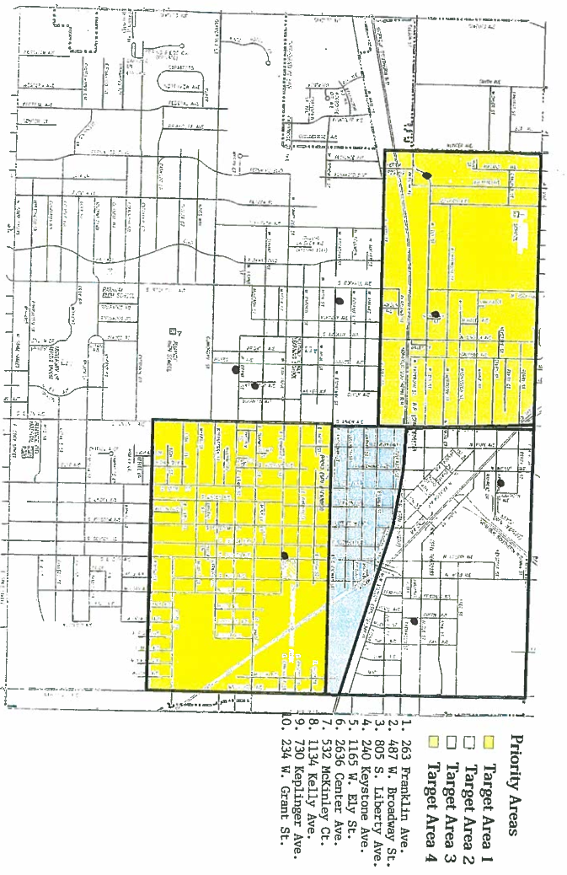
Leveraging
Explain how federal funds leveraged additional resources (private, state and local funds), including a description of how matching requirements were satisfied, as well as how any publicly owned land or property located within the jurisdiction that were used to address the needs identified in the plan.
The City of Alliance utilizes CDBG entitlement funds which it receives directly from HUD and HOME funding, made possible through participation in the Stark County Consortium. To ensure that the projects funded with CDBG funds are eligible, the project applications are ranked and scored on a variety of topics. One of those topics is the availability of matching/leveraging funds.
Federal CDBG resources from HUD permitted local non-profit organizations and other service providers to leverage with other public and private partners to better utilize a variety of federal, state and local funding to carry out their activities can be seen as follows:
Prescription Access - uses CDBG funding from the City of Alliance. Other funding sources include $15,000 from local sources to the project, $75,000 from non-local sources to the project and $50,000 of additional funding from sources like the Austin Bailey Health & Wellness Foundation.
Domestic Violence Educational Services- uses CDBG funding from the City of Alliance. Other funding sources include State of Ohio Marriage License Fee portions, VOCA funds which is the federal Victims of Crime Act in the amount of $22,045.00, as well as private contributions and year-round fundraising.
Alliance for Children and Families - uses CDBG funding from the City of Alliance. Other funding sources include Corporation for Support of Housing, Stark County Foundation, ODOD, HUD, Altman Foundation, Greater Alliance Foundation, Stark County Regional Planning through the Stark County Commissioners, Sisters of Charity Foundation, direct private pledges from United Way affiliates, and individual contributions.
YWCA of Alliance - uses CDBG funding from the City of Alliance. Other funding sources include programming fees, contributions, United Way, endowment funds and membership fees.
SPARK Alliance - uses CDBG funding from the City of Alliance. Other funding sources include Greater Alliance Foundation, the State of Ohio, United Way, Stuckey Fund, Rotary and Kiwanis.
How matching requirements were satisfied:
Public service projects and housing needs projects funded by CDBG during FY-17 are all able to provide additional services to the Alliance community due to the fact they are recipients of these federal funds. Without the CDBG funds and additional leveraged/matching funds the services would not be able to provide services to the level that they do. Because of this, the City of Alliance along with the sub recipients work cohesively to ensure all federal regulations and guidelines are observed with the hopes that the funding will remain constant for the dignity and future of the populations served.
Publicly Owned Land or Property:
No publicly owned land or property located within the jurisdiction was used to address the needs identified in the plan.

CR-20 - Affordable Housing 91.520(b)
Evaluation of the jurisdiction's progress in providing affordable housing, including the number and types of families served, the number of extremely low-income, low-income, moderate-income, and middle-income persons served.

Table 4 – Number of Households
 | One-Year Goal | Actual
Number of Homeless households to be provided affordable housing units | 1 | 0
Number of Non-Homeless households to be provided affordable housing units | 1 | 0
Number of Special-Needs households to be provided affordable housing units | 1 | 1
Total | 3 | 1

Table 5 – Number of Households Supported
 | One-Year Goal | Actual
Number of households supported through Rental Assistance | 0 | 0
Number of households supported through The Production of New Units | 0 | 0
Number of households supported through Rehab of Existing Units | 6 | 9
Number of households supported through Acquisition of Existing Units | 0 | 0
Total | 6 | 9

Discuss the difference between goals and outcomes and problems encountered in meeting these goals.
- Preserve Existing Housing Stock (Single Family Home Repair): During FY-17 no CDBG funds were used to construct permanent affordable housing for special needs and homeless households. However, activities that were supported with CDBG funds included the rehab of owner occupied single family housing of low to moderate incomes. The three major goals and objectives of the program are: neighborhood revitalization, decent, safe and sanitary housing, and being in compliance with the property maintenance code of Alliance. Improvements to low or moderate neighborhoods continue to be made that will result in the provision of quality affordable housing as homeowners take more pride and interest in their properties and surroundings. Rehabs included one home in Priority Target Area 1, two homes in Priority Target Area 3, two homes in Priority Target Area 4, three homes within census tracts 7103 and 7104, and the final two homes within census tracts 7106 and 7108 and the demolition of vacant and abandoned blighted properties.
- Rehabilitation Relocation Assistance Programming: For the FY-17 program, relocation was not being funded, impacting progress towards this goal. The City currently has more than adequate affordable housing stock and will work with collaborators to relocate homeless residents into rehabbed affordable transitional housing when needed.
Discuss how these outcomes will impact future annual action plans.
Preserve Existing Housing Stock (Single Family Home Repair): The City will continue the funding for programs such as Alliance for Children and Families, and with the single family rehab program which not only assist low to moderate families with maintaining affordable housing but also work to improve the conditions of the housing stock for all of Alliance’s residents. Future Annual Action Plans will update on program changes that are currently in development. The City of Alliance Department of Planning and Development has maximized all available funding for the benefit of low to moderate income persons and has worked to increase the supply of, or access to, affordable housing. The affordable housing activity assisted 9 families with the Single Family Emergency Home Rehabilitation and Repair Program. Homebuyer Assistance and Multifamily Housing Programs are on the horizon to be developed into active programs. The number of residents provided housing related assistance through CDBG funded Public Service Activities can be found in the accomplishment tables in CR05.
Include the number of extremely low-income, low-income, and moderate-income persons served by each activity where information on income by family size is required to determine the eligibility of the activity.
Table 6 – Number of Households Served

Number of Households Served | CDBG Actual | HOME Actual
Extremely Low-income | 5 | 0
Low-income | 5 | 0
Moderate-income | 2 | 0
Total | 12 | 0

Narrative Information
- Rehab: CDBG and HOME funds are being used for the Owner-Occupied Housing Rehab Program for qualifying single family residents. The CRA (Community Reinvestment Area) enables property owners to rehab or build additions to existing units without real estate taxes increasing. The three main goals and objectives of the program are neighborhood revitalization, decent, safe and sanitary housing and remaining in compliance with the property maintenance codes for the City of Alliance.
- Housing: The Alliance Domestic Violence Shelter provided affordable, safe, transitional housing to low/moderate income residents suffering from acts of domestic violence.

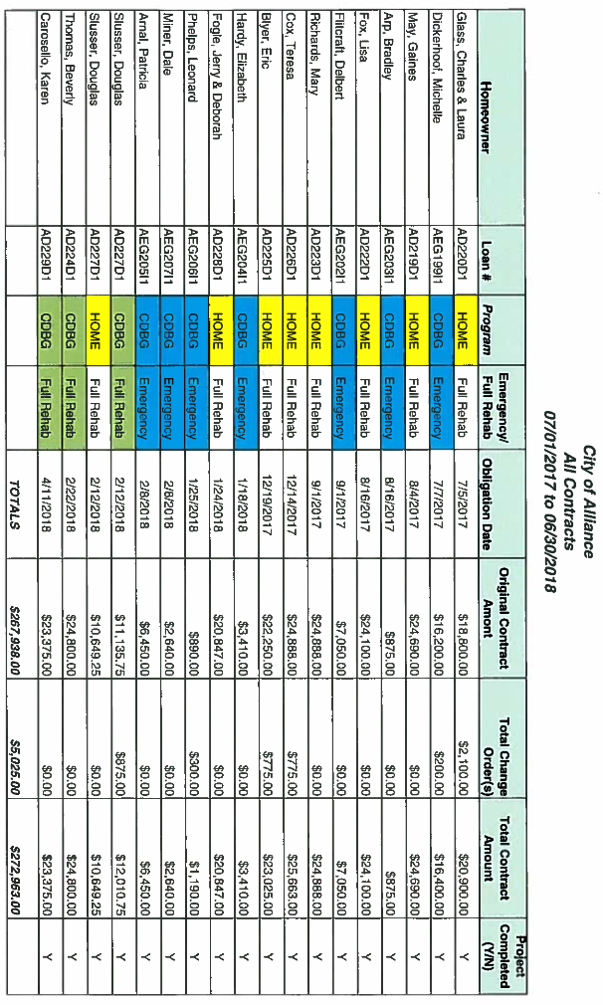

CR-25 - Homeless and Other Special Needs 91.220(d,e); 91.320(d,e); 91.520(c)
Evaluate the jurisdiction’s progress in meeting its specific objectives for reducing and ending homelessness through:
Reaching out to homeless persons (especially unsheltered persons) and assessing their individual needs.

The City of Alliance has a domestic violence shelter for those in need. The domestic violence shelter has been in operation since January 1989 and in FY-17 $9,500 in CDBG funds was allocated to the shelter. During the period from 7/1/17 to 6/30/18, there were 300 persons served. Often, the shelter can reduce the impact of possible temporary housing displacement for many individuals in the city and surrounding areas by providing them with multiple nights of shelter.
Homeless activities for the City of Alliance and Stark County are handled through the Continuum of Care (CoC). The CoC is housed at the Stark County Resource Planning Commission (SCRPC), with Natalie McClesky as the CoC Planner. In FY-18 the City of Alliance will partner with the CoC to sponsor a new nonprofit to provide services for homeless residents.
Total Households Served Actual Goal
Domestic Violence Shelter 300 225
Alliance for Children and Families 0 1
Addressing the emergency shelter and transitional housing needs of homeless persons.
The City of Alliance is a member of the Stark County Interagency Council on Homelessness. Its purpose is to develop and implement strategies and solutions to address the problem of homelessness to include the development of supportive housing options. Goals are to prevent and end chronic homelessness in Stark County, ensure a coordinated safety net of emergency services for those in short term housing crisis and coordinate and consolidate local efforts to provide a cost effective and streamlined system for addressing homelessness.

Helping low-income individuals and families avoid becoming homeless, especially extremely low-income individuals and families and those who are: likely to become homeless after being discharged from publicly funded institutions and systems of care (such as health care facilities, mental health facilities, foster care and other youth facilities, and corrections programs and institutions); and receiving assistance from public or private agencies that address housing, health, social services, employment, education, or youth needs.
The City of Alliance continues to watch for opportunities for establishing activities that promote job training and education programs and homeless services that offer transportation, expanded outreach, and shelter. In FY-17 the City is continued to support agencies such as the YWCA and the Alliance Career Center to provide low to moderate income persons with job training and education and to provide other homeless services programs. The city’s Department of Development will continue to support and partner with organizations that provide education, job training and placement, supported employment, transportation, and day shelter for persons with and without disabilities.
Helping homeless persons (especially chronically homeless individuals and families, families with children, veterans and their families, and unaccompanied youth) make the transition to permanent housing and independent living, including shortening the period of time that individuals and families experience homelessness, facilitating access for homeless individuals and families to affordable housing units, and preventing individuals and families who were recently homeless from becoming homeless again.
The city's Mayor attended meetings for the Homeless Continuum of Care of Stark County (HCCSC) interagency council. This membership allowed the Mayor to assist in the creation of innovative strategies and solutions to address the problem of homelessness and the development of supportive housing options. The HCCSC's goals are to prevent and end chronic homelessness in Stark County to ensure a coordinated safety net of emergency services for individuals in short term and chronic housing crisis and to coordinate and consolidate local efforts to provide a cost effective and streamlined system for addressing homelessness. With each meeting the city comes closer to the end goal as the Mayor stays informed on the topics of homelessness and housing opportunities for at risk Alliance residents. Working with sub-recipients the city is in a position to help minimize the trauma and dislocation that homelessness causes to individuals, families, and communities.

CR-30 - Public Housing 91.220(h); 91.320(j)
Actions taken to address the needs of public housing.
The City of Alliance Administration and Planning and Development Department does not operate a public housing program. This is operated by the Stark County Metropolitan Housing Authority.
Actions taken to encourage public housing residents to become more involved in management and participate in homeownership.
The City of Alliance CDBG Program does not operate the local public housing program and its resident's initiatives. This is administered by the Stark Metropolitan Housing Authority (SMHA), the local public housing authority.
Actions taken to provide assistance to troubled PHAs.
The Stark Metropolitan Housing Authority has not been designated as a troubled PHA.

CR-35 - Other Actions 91.220(j)-(k); 91.320(i)-(j)
Actions taken to remove or ameliorate the negative effects of public policies that serve as barriers to affordable housing such as land use controls, tax policies affecting land, zoning ordinances, building codes, fees and charges, growth limitations, and policies affecting the return on residential investment. 91.220 (j); 91.320 (i).
The City of Alliance's Housing Specialist and Zoning Inspector attend the Zoning Inspectors Task Force meetings. This is a group comprised of local zoning inspectors, code enforcement officials and housing specialists. These individuals have been educated on how the effects of zoning ordinances may affect fair housing in a negative manner. City of Alliance representatives have made presentations to the Zoning Inspectors Task Force.
The City of Alliance Zoning Inspector works partially under CDBG funding in our target areas. Therefore, the inspector works directly with the staff who develop the Annual Action Plans and Consolidated Plans. The inspector makes recommendations to the City's Board of Zoning Appeals and the committee that makes recommendations for the zoning regulations. In FY-17, the Zoning Review Plan Committee will be meeting to discuss and make revisions to the Zoning Book which is done every five years. The zoning inspector sits on this committee and advocates for furthering Fair Housing.
Map of Public Facilities by Target Area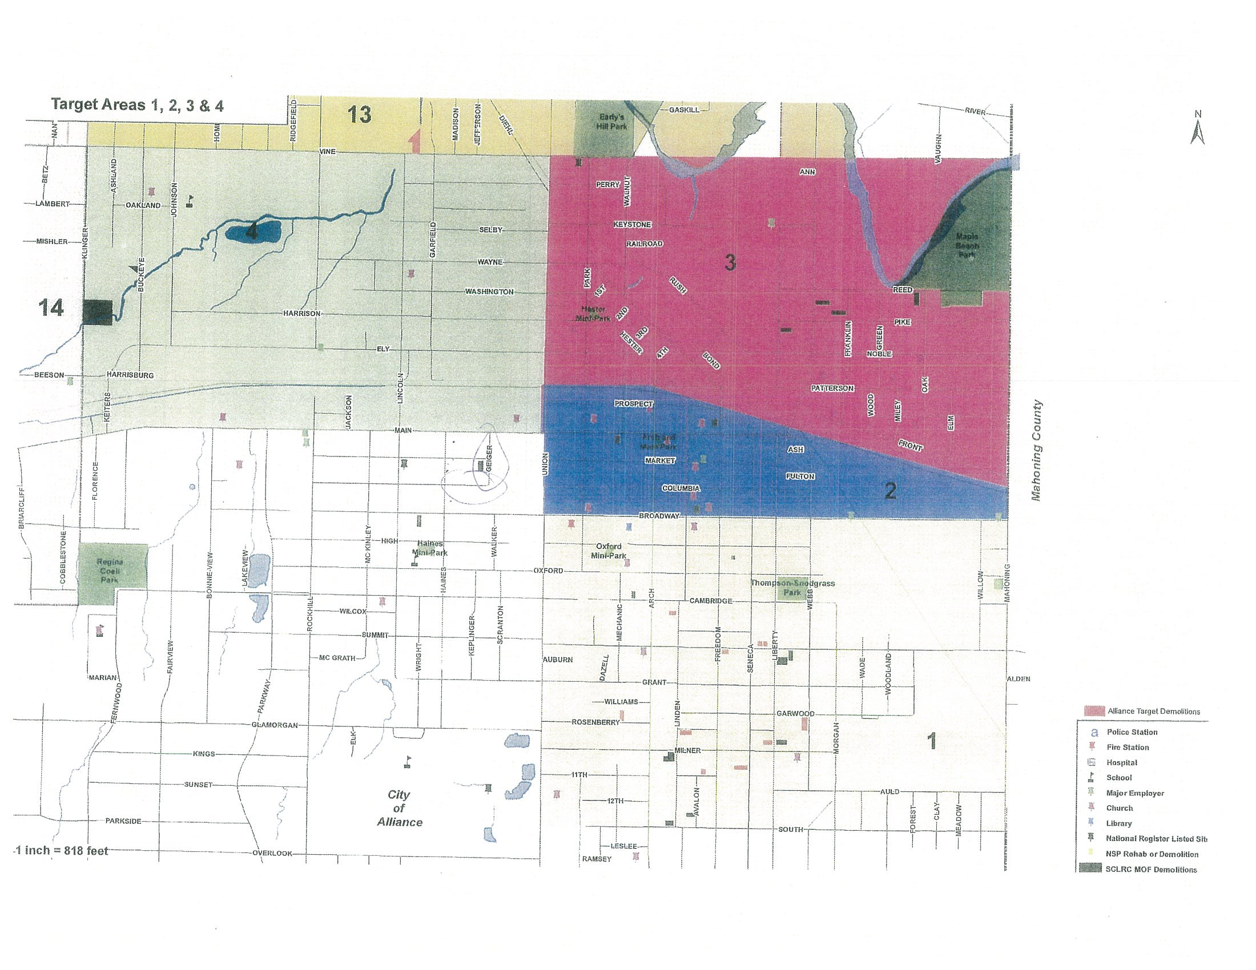
Target Area Map
Actions taken to address obstacles to meeting underserved needs. 91.220(k); 91.320(j)
All of the objectives set forth in the Consolidated Plan and the Annual Action Plans are designed to address the needs of the underserved in the City of Alliance. Actions can be identified with both the city’s and the sub recipients CDBG activities which include housing rehabilitation (both CDBG & HOME) which assist homeowners in improving their homes by making them safe, sanitary and cost effective. The CDBG funds provided to the City's sub recipients provide public services that are geared toward low-moderate income residents within the City of Alliance.
Actions taken to reduce lead-based paint hazards. 91.220(k); 91.320(j)
The age and condition of the housing stock in the City of Alliance is a matter of concern in regard to lead-based paint. Most homes built before 1980 are at risk for lead contamination. Because of age and the poor condition of the housing stock the City of Alliance Health Department conducts environmental assessments on all children reported with elevated blood lead levels in the City of Alliance. This program is coordinated with the nursing division of the health department. The nurses conduct home visits to assess the environment. During the visits they provide information for preventative measures regarding proper cleaning of surfaces or abatement procedures and other helpful information to assist in lowering exposure to lead. The Health Department has educational information available to the clients that they serve and to the public.
Actions taken to reduce the number of poverty-level families. 91.220(k); 91.320(j)
In order to reduce the number of poverty level families within the City of Alliance the YWCA Employment Assistance Program assisted low to moderate income women by eliminating barriers to work through assistance with transportation, clothing, personal care and other work related items. FY-17 assisted 57 women, of which 20 were White, 36 were Black/African American and 1 was from other racial backgrounds. FY-16 assisted 39 women who met these qualifications. Of the women assisted, 26 were white and 13 were black.
In FY-17 the City of Alliance assisted 18 low to moderate individuals with tuition assistance while attending the Alliance Career Center. Assistance provided individuals the ability to overcome obstacles that would have prevented them from continuing their academic goals. Assistance towards earned degrees was given this year to students in LPN, STNA, Cosmetology, and Phlebotomy. There was a 37% decrease in individuals assisted from the previous year. Over the last two fiscal years, this program, has been allocated a total of $1,500.00 less than prior fiscal years. This would explain a portion of the decrease in scholarships awarded to individuals.
The Alliance Area Domestic Violence Shelter provided outreach and educational services to victims of domestic violence. The total number of recipients’ assisted was 300. Of the recipients’ assisted, 161 were White, 17 Hispanic, 104 Black/African American, 1 Asian, and 17 from other racial backgrounds . The Alliance Area Domestic Violence Shelter is an advocate to those who fear homelessness and the ability to start or maintain employment. This program is necessary to reduce the number of poverty-level families. The numbers drastically decreased from FY-16 by approximately 61%. This is due to the elimination of duplicate or repetitive counting of recipients’ was being served.
Public Service Map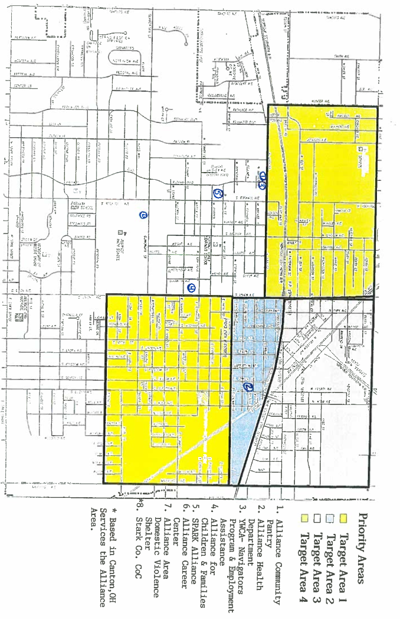
Actions taken to develop institutional structure. 91.220(k); 91.320(j)
The City of Alliance works directly with city departments, county and state agencies, local business partners, public service agencies and faith based organizations to carry out the objectives in the strategic plan. Below is the list of institutional structures that the city collaborates with.
- The Homeless CoC of Stark County
- The Stark County Regional Planning Commission
- The Planning & Development Committee
- Alliance for Children & Families
- The Alliance Area Domestic Violence Shelter
- The Prescription Access Network
- The YWCA of Alliance
- Ohio Means Jobs
- Stark County Board of Developmental Disabilities
- SARTA
- The Alliance Area Chamber of Commerce
- The Alliance Career Center
- Ohio Housing Finance Agency
- The Alliance Mission Encounter
- Hammer & Nails
A major strength for the FY-17 is joining the Stark County Network Board associated with Homeless CoC of Stark County. The City of Alliance’s Mayor has been an active member of the Homeless CoC of Stark County for the past four years. The Homeless CoC of Stark County has been in operation since 2013; however, a new board was formed less than one year ago. The Director of Planning & Development is on the Stark County Network Board which is a part of the Homeless CoC of Stark County. As the board is new, there have not been any major accomplishments, but there has been no interruption of services to the Homeless CoC of Stark County.
In the future, the City of Alliance and The Stark County Regional Planning Commission will look for efficient ways to acquire properties for low to moderate income family housing with less delays of time so that projects like the Alliance for Children and Families are completed within the fiscal program year.
Actions taken to enhance coordination between public and private housing and social service agencies. 91.220(k); 91.320(j)
In FY-16 the Alliance for Children and Families Acquisition of Vacant Single Family Homes for Affordable Housing for LMI Families Project was not completed because of the delay of the acquisition process. In the future, the City of Alliance and The Stark County Regional Planning Commission will look for efficient ways to acquire properties for low to moderate income family housing with less delays of time so that projects like the Alliance for Children and Families are completed within the fiscal program year. An extension was granted for this project and is to be completed by June 30, 2018. The project was completed in July 2018 and one low to moderate income family, who was at risk for homelessness and transitioned through the Alliance for Children and Families supportive housing program is now residing in this home.
Identify actions taken to overcome the effects of any impediments identified in the jurisdictions analysis of impediments to fair housing choice. 91.520(a)
Please note the section on action plans and subsequent actions undertaken for the City of Alliance for the response to 91.520(a).
See: Fair Housing Attachment

CR-40 - Monitoring 91.220 and 91.230
Describe the standards and procedures used to monitor activities carried out in furtherance of the plan and used to ensure long-term compliance with requirements of the programs involved, including minority business outreach and the comprehensive planning requirements.
Monitoring: Programs and projects have direct oversight by the Department of Planning and Development. Compliance with federal guidelines, achievement of goals and objectives and the collection of data is completed by the department.
To ensure compliance with timeliness for the CDBG program, the City of Alliance Department of Planning and Development followed these actions:
- Screening and selecting sub recipients and activities that will meet timeliness standards.
- Incorporating project mile stones and drawdown schedules into sub recipient contracts.
- Implementing sanctions for untimely sub recipients.
- Reallocating funds for untimely sub recipients.

Funding provided to sub-recipients require a per month based activity monitoring form. The activity monitoring form must report how CDBG funds were expended and how many clients benefited from the use of these funds. The Planning and Development Department does not release funding until it is verified that the expenditure meets all requirements included in the contract including the budget line items between the City of Alliance and the sub-recipient. The Department of Planning and Development’s Community Development Planner along with the City of Alliance Auditor, Deputy Auditor, or Planner’s assistant perform onsite visits to review work performed during the elapsed time period.
Informal and formal monitoring visits were conducted to ensure compliance with program requirements. Risk assessments and in-house desk audits were also performed for three funded agencies. These agencies included: The Stark County Mental Health Program and the YWCA Exterior Project and the Early Education program SPARK Alliance of which there were no findings. The agencies were in compliance with HUD regulations. Corrective actions were set in place for the Stark County Mental Health program as funding was not spent to its fullest. Initially, contact was challenging at first which drew concerns as to who specifically the City should be dealing. Also as a new sub recipient and a change of staff on the city’s side, the early program year was difficult. The sub recipient was unaware of the July 1 beginning date and did not utilize the CDBG funds to cover expenses that would have been allowed both by CDBG regulations and by the contract. Once an onsite visit with the financial manager and program manager took place, there was a good understanding of how the program should run.
The purpose of this monitoring plan is to provide an internal control mechanism to review performance over a period of time and to evaluate compliance of non-profit sub recipients funded with Community Development Block Grant (CDBG) funds pursuant to 24 CFR 570.502, Applicability of uniform administrative requirement, (a) (14) and with 24 CRF Section 5, Uniform Administrative Requirements for Grants and Cooperative Agreements to states and local governments, 24 CFR Section 85.40 “monitoring and reporting program performance”, and other laws and regulations based on the funding source.
The monitoring plan positions the City of Alliance, Planning & Development Department to make informed judgments about sub recipient’s program effectiveness, efficiency, ability to prevent fraud, and waste and abuse of public funds. Monitoring also allows the City of Alliance to provide technical assistance to help sub recipients comply with applicable laws and regulations, improve technical skills, increase and stay updated on regulations relevant to CDBG or other funding agencies. Additionally, monitoring helps to identify deficiencies, and highlight accomplishments and best practices that can be duplicated.
In addition, the housing inspector completes inspections on work being done by contractors who are contracted for homes for the Owner-Occupied Housing Rehab Program. A “Work Progress Report” is completed for each inspection visit. Communication is consistent with the homeowner and housing inspector.
Citizen Participation Plan 91.105(d); 91.115(d)
Describe the efforts to provide citizens with reasonable notice and an opportunity to comment on performance reports.
The Public Notice for the City of Alliance’s FY-16 C.A.P.E.R. was published in the Alliance Review on September 13, 2017 and September 20, 2017. A copy was made available at the Rodman Public Library, the Office of Planning and Development and on the city's website at www.cityofalliance.com. Currently, the City has not received any public comments on the FY-2016 C.A.P.E.R. In addition, the performance report provided to citizens must identify the federal funds made available for furthering the objectives of the Consolidated Plan. For each formula grant program, the grantee shall identify the total amount of funds available (including estimated program income), the total amount of funds committed during the reporting period, the total amount expended during the reporting period, and the geographic distribution and location of expenditures. Jurisdictions are encouraged to include maps in describing the geographic distribution and location of investment (including areas of minority concentration). The geographic distribution and expenditure requirement may also be satisfied by specifying the census tracts where expenditures were concentrated.
Citizen Participation Plan
PROPOSED CITIZEN PARTICIPATION PLAN
The Department of Planning & Development is the responsible entity in the City of Alliance to administer the HUD funded Community Block Grant Program (CDBG).
Citizen Participation Plan Development Process
Prior to the adoption of the Community Development Department’s Citizen Participation Plan, citizens are given the opportunity to comment. The draft plan is presented to the Community Development Committee at its March meeting at the same time as the CDBG proposed program. The plan is then made accessible to the residents of the City of Alliance through its website and a copy is available in the Rodman Public Library for a 30 day citizen comment period. As needed, the plan can be made into a format accessible to persons with disabilities, upon request. Any comments made by the public during the 30 comment period will be addressed by staff prior to the adoption of the final citizen participation plan. Furthermore, comments made may not always result in changes in the plan.
Community Development
Public Participation General Information
One of the main goals of the City of Alliance’s Planning & Development Department is to provide the community an opportunity to participate in an advisory role in the planning, implementation and assessment of its programs and projects. There are four main programs or plans that the Community Development Department undertakes and two main programs that the Stark County Regional Planning Commission’s Community Development Department administers for the City. These programs are the Community Development Block Grant Program, the Consolidated Plan (5- Year Plan), the Annual Action Plan, the Consolidated Annual Performance Plan (CAPER), and the HOME Investment Partnership Program (HOME), and the Assessment of Fair Housing (AFH), respectively. Please see the list below outlining basic practices and policies utilized by the City of Alliance to ensure the public has access and knowledge to programs in their community:

Holding a “public meeting” entails:
- Not being required by law.
- Not making the discussion between the interested parties and comments public record.
- Attendees being able to ask questions and make comments, with the aid of a moderator to keep the meeting focused.
All meetings held by the Community Development Department are normally during the day and held at the City Administration Office located at 504 E. Main Street, Alliance, Ohio 44601. If necessary, meetings may be held in the evening. By holding meetings or hearings at the City Administration office building, they are accessible to the community through the following ways:
- The City Administration Building is ADA accessible.
- The City Administration Building is accessible to public transportation, including the location of a SARTA bus stop directly in front of the Administration Building.
- Meetings or hearings being held are advertised in the local newspaper and the City of Alliance’s website, when applicable.
- Any documents created by the Department of Community Planning & Development that require public comment are made available on the City’s website as well as a copy being available at the office.
- If a non-English speaking community member attends a meeting, they are encouraged to bring a translator (1.08% non-English speaking households in Stark County, Ohio, according to the 2013 American Community Survey). If an interpreter is needed, advance arrangements will need to be made. The plan is intended to facilitate persons with mobility, visual or that are hearing impaired.
Community Development Programs / Plans
- Community Development Block Grant Program
The City of Alliance is the recipient of the federally funded CDBG program of the U.S. Department of Housing and Urban Development (HUD). The Department of Planning and Development does all of the overall planning and administration of the CDBG Program. The CDBG Program aims at developing viable communities by providing decent housing and a suitable living environment, along with expanding economic opportunities, for persons of low-and moderate incomes.
Citizen participation is a vital role in the CDBG Program process. As established by Section 104(a)(2) of the Housing and Community Development Act and by the regulations at 24 CFR 570.486, there are key actions that need to be taken to ensure that citizens of a community where CDBG funded activities will take place, have an opportunity to participate in an advisory role in the planning, implementation and assessment of the program and projects. Therefore, the City of Alliance’s Planning & Development Department includes the local community in the CDBG Program implementation by taking the following actions:
- Providing 2 public meetings, each at different stages of the program. The first being held for the CAPER to be presented, and the second during the 30 day public comment period of the Annual Action Plan.
- Providing citizens with reasonable advance notice of and opportunity to comment on proposed activities.
- Providing citizens contact information for submitting complaints and then responding to complaints in a timely manner.
Each program year the Planning & Development Department is responsible for:
- Publishing notices for the CDBG application workshop in the local newspaper.
- Sending invitations to non-profit agencies that have applied in the past, or expressed an interest in applying.
- Posting notices on the City of Alliance’s website.
A public meeting is held to present the upcoming proposed funding plan and encourage discussion with attendees. The funding plan is also presented at the March CDBG Committee meeting for voting approval and updates to the Citizen Participation Plan. Once the Plan is approved by the CDBG Committee the public comment period commences on the proposed program.
At the end of the comment period and after the comments have been reviewed and considered by the Department of Planning & Development staff, the Plan is presented to City Council for final approval. The final CDBG Funding Program is sent for submission to HUD no later than 45 days prior to the start of the City’s federal fiscal year (July 1).
CDBG Substantial Amendments:
An amendment is deemed “substantial” when:
- A program is added or cancelled; or
- A considerable amount of money is being reallocated from one project to another, as determined by the Community Development Department; or
- There is a change to the purpose, scope, location, or beneficiaries of an activity (24 CFR Part 91.505).
Public participation is required when a substantial amendment is needed. The proposed substantial amendment is presented to the Community Development Committee at an emergency meeting. A public notice of the proposed amendment is published allowing for a 30 comment period. If comments are received by citizens, they will be considered prior to finalizing the amendment. The Planning & Development Committee votes to approve the amendment which is then published as the final amendment. Then the amendment is presented to City Council for approval. In cases where urgency is a consideration, the comment period may be reduced to 15 days or less.
- Consolidated 5 Year Plan (CP) and Annual Action Plan (AAP)
The consolidated plan is a five year plan, updated every five years, in accordance with HUD regulations. The plan provides an assessment of needs in the community, including housing and homeless needs, a housing market analysis, and a strategic plan for the allocation of housing resources. The plan also includes the City’s priority community development needs that qualify under the CDBG program. Additionally, there is an assessment of the needs for infrastructure improvement, public facilities, public services, accessibility, economic development, fair housing and planning needs.
The submission of the CP also contains the first year AAP. During the next four years only the AAP is submitted.
The Citizen Participation for the AAP is as outlined in the CDBG section of this document. The AAP summarizes the activities that the City will undertake utilizing CDBG funding during the fiscal year.
Citizen participation is critical during the preparation of the CP. Residents are encouraged to participate through the following ways:
- Completing a survey that is made available to groups targeted as able to provide input in terms of homeless, housing, planning, and non-housing community development needs to gather information and comments.
- Attendance at public meetings.
- Public comments are received at public meetings held throughout the preparation of the CP.
- All comments and views are considered prior to submission of the CP.
As a result of the public meetings held, objectives and goals of the community are established and public comments are accepted. The CP is presented to the Community Development Committee and then there is a 30 day public comment period. Any comments or views taken into consideration by the staff and are made note of in the final CP. The Plan is then presented to City Council for approval and sent to HUD.
Consolidated Plan and Action Plan “Substantial” Amendments:
An amendment is deemed “substantial” when:
- There is a change to the allocation priorities or a change in the method of distribution of funds; or
- To carry out an activity, using funds from any program covered by the CP not previously described in the action plan; or
- To change the purpose, scope, location, or beneficiaries of an activity (24 CFR Part 91.505).
Public participation is required when a substantial amendment is needed. The proposed substantial amendment is presented to the Community Development Committee in a special meeting. A public notice of the proposed amendment is published allowing for a 30 day comment period. If comments are received by the citizens, they will be considered prior to finalizing the amendment. In cases where urgency is a consideration, the comment period may be reduced to 15 days or less. The Plan is then presented to City Council for approval and sent to HUD and published as the final Plan.
Consolidated Annual Performance Evaluation Report (CAPER)
The Consolidated Annual Performance Evaluation Report (CAPER), is completed annually by the Community Development Department staff and submitted to HUD within 90 days after the end of the City’s program year (June 30). Once the draft is completed the actions are as follows to encourage citizen participation:
- The draft CAPER is made available on the City’s website and the Rodman Public Library for a 15 day comment period.
- A copy is available at the Department of Planning & Development
- All comments are reviewed by the staff of Planning & Development and included in the final CAPER.
At the end of the comment period, the CAPER is submitted to HUD.
HOME Program and Fair Housing Program
The Home and Fair Housing Program are administrated by Stark County Regional Planning Commission for the City of Alliance. All public meetings and hearings for these programs are held by the County and information for these meetings is available on the Commissions website at http://www.starkcountyohio.gov/regional-planning. Information on both of these programs can be found on their website as well. For more information on the processes and procedures please visit their website or call the Stark County Community Development Department at (330) 451-7389.

CR-45 - CDBG 91.520(c)
Specify the nature of and reasons for, any changes in the jurisdiction’s program objectives and indications of how the jurisdiction would change its programs as a result of its experiences.
In FY-17 Historic Preservation as economic development was added as a high priority goal. This goal was not part of the 2014-2018 Consolidated Plan. The reason is unclear due to a change in staff. The city will monitor this goal through FY-17 as it is in that Annual Plan. The city is to determine if the outcomes reaches the goal of promoting comprehensive planning and development and preservation, rehabilitation, and the hiring of consultants to aid in; planning, data collection, studies, analysis, and implementation. At the end of FY-17, the city will determine if this will continue to be a high priority goal.
Additional changes in monitoring and reporting will continue to occur over the next couple of fiscal years. The City of Alliance is continuing to carry out the planned actions of the FY-16 Action Plan including demolitions, housing rehab, and historic preservation. In addition, during FY-17 all city administered programs and projects will monitored by the Planning Department/Housing Specialist and Code Enforcement Officer. Funds were not released unless verification showing expenditures met all requirements.
Does this Jurisdiction have any open Brownfields Economic Development Initiative (BEDI) grants?
No
[BEDI grantees] Describe accomplishments and program outcomes during the last year.

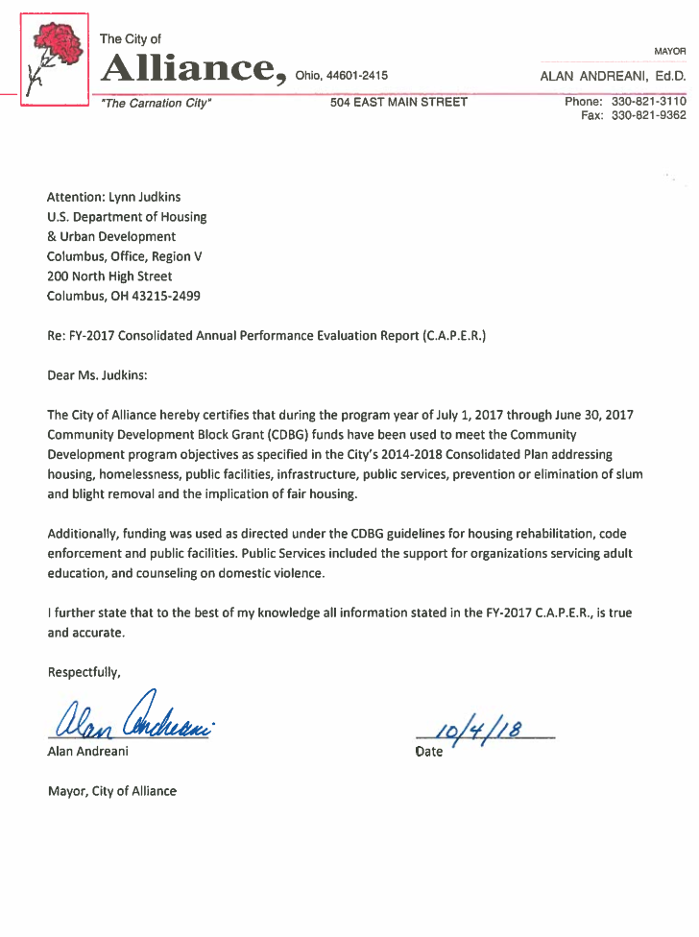

Affirmatively Furthering Fair Housing
City of Alliance
July 1, 2017 – June 30, 2018 (FY 2017)

Fifty years ago, the federal Fair Housing Act was passed in the wake of the assassination of Dr. Martin Luther King, Jr. This fiscal year, we celebrate the passage of the law and the thousands of legal victories that have provided housing choice for millions of Americans over the last 50 years. The goals of the Act is to eliminate housing discrimination and promote residential integration. During this fiscal period, civil rights organizations, affordable housing advocates, journalists, and others around the country have tried to paint a picture of how far we have come as a nation to achieving the goals of the Fair Housing Act. Most have reached the same conclusion…not far enough. With every step forward, there has been forces pushing us back. The struggle continues for African Americans, Latinos, women, people with disabilities, and other minorities.

The Stark County Regional Planning Commission’s Fair Housing Department serves to protect fair housing rights of residents in the city of Alliance. The City of Alliance entered into an agreement with the Stark County Regional Planning Commission to provide fair housing services in conjunction with the Community Development Block Grant Program for the residents of Alliance. Communities that are recipients of federal housing dollars are mandated to insure that access to fair housing choice is available to all. Since housing choice is critical, fair housing is a goal all must achieve if equality of opportunity is to become a reality. On April 11, 1968, President Lyndon Johnson signed into law Title VIII of the Civil Rights Act of 1968, commonly known as the Fair Housing Act. This law only covered discrimination based on race, color, religion, and national origin. Fair housing advocates fought for added protections making housing discrimination against women, families with children and persons with disabilities illegal in 1974 and 1988. In the 50 years since the passage of the Fair Housing Act, we have changed discriminatory behaviors in the housing, mortgage lending, and insurance industries and built more inclusive communities across America. However, we continue to lose ground as racists, bigots and others still try to limit or deny equal housing opportunity.

On July 16, 2015, HUD published its Affirmatively Furthering Fair Housing (AFFH) final rule. The AFFH rule provides that program participants must conduct an Assessment of Fair Housing (AFH) using an “Assessment Tool.” The AFH replaces the old requirement to conduct an Analysis of Impediments to Fair Housing Choice (AI). Then in January 2018, HUD published a notice extending the deadline for the AFH submissions by local government consolidated plan participants to their next AFH submission date that falls after October 31, 2020. HUD believes that program participants need additional time and technical assistance to adjust to the new AFFH process and complete AFH submissions that can be accepted. Consolidated plan program participants must continue to comply with existing, ongoing obligations to AFFH. Until a consolidated plan program participant is required to submit an AFH, it must provide the AFFH consolidated plan certification in accordance with the requirements that existed prior to August 2015 which means to conduct the Analysis of Impediments. Therefore, the cities of Alliance, Canton and Massillon, and the Stark County Fair Housing Department for the Board of Stark County Commissioners agreed to collaborate to conduct a Regional AI. The Regional AI will be completed by the end of year 2018.

In 2012, the cities and county joined forces to complete the latest Analysis of Impediments. This AI evaluates population, household income, and housing characteristics by protected classes in each of the jurisdictions; evaluates public and private sector policies that impact fair housing choice; identifies blatant impediments to fair housing choice, and recommends specific strategies to overcome the effects of any impediments identified.

Until the new AI is completed, the fair housing department will continue to address and reduce the potential impediments listed in the 2012 AI. Below are the potential impediments listed in the AI. HUD defines an impediment to fair housing choice as any actions, omissions, or decisions that restrict, or have the effect of restricting, the availability of housing choices, based on race, color, religion, sex, national origin, disability, or familial status.

The following are potential impediments listed in the latest AI for the city of Alliance:
- Due to the arrangement by which entitlement funds are allocated and the limited availability of resources, the city’s ability to use entitlement funds to create new housing opportunities in non-impacted areas is somewhat limited.
- There are an estimated 318 persons with limited English proficiency in Alliance. Among the Spanish speaking population in the city, 47.4% speak English less than “very well.” It is unclear whether this population has adequate access to city programs and services.
- The city has not established an Affirmative Marketing Policy.
- The city’s appointed public boards relating to housing issues are not demographically representative of the community at large.
- The Comprehensive Land Use Plan and the city’s zoning ordinance discourage the development of multi-family rental housing.
- The zoning ordinance places undue restrictions on the location of group homes for persons with disabilities, a policy that is inconsistent with the provisions of the Fair Housing Act.

Listed below are the action plans and subsequent actions undertaken for the city of Alliance:

- Action Plan – Allocate CDBG funding to enhance and revitalize LMI areas and improve the existing housing stock. Action Undertaken – The city allocated CDBG funding for the acquisition and rehabilitation of single-family housing for low-to-moderate income families. Funding is allocated to a local non-profit organization and over the period of one fiscal year, an eligible residence is selected and the unit is rehabbed in order to provide housing opportunities for an eligible Alliance resident. The city continued to allocate the funding to provide new housing opportunities to residents throughout the planned action years.

- Action Plan – Conduct the four-factor analysis to determine the extent to which the translation of vital documents is necessary to assist persons with limited English proficiency in accessing city programs and services. Action Undertaken – The department has worked on a Limited English Proficiency plan and procedure to examine and implement methods for providing meaningful access to our programs for the LEP population. The department has a draft form of the plan. Additional research is being accomplished to finalize the plan to see if printed documents are necessary so the foreign-language population could easily read and understand.
- Action Plan – Draft and adopt an Affirmative Marketing Policy per HUD regulations for all housing developments of five or more units that are assisted by any City funds. Action Undertaken – This action was completed. The city established an Affirmative Marketing Policy in which the staff monitors its progress. The policy is as follows: “Developers, owners, and grantees must market housing opportunities to all persons in the housing market, including groups that are not likely to apply without special outreach efforts, including the minority and LEP populations. All marketing efforts must be documented with sufficient records maintained by the issuer. The use of the Fair Housing logo or phrase must be included on all signage and marketing documents pertaining to rental and housing opportunities. Where there are five (5) or more units, developers, owners and grantees must adhere to Affirmative Marketing and Fair Housing practices in all marketing endeavors, eligibility determinations and other transactions. Failure to comply with the Affirmative Marketing Policy my result in the denial or dismissal of allocated CDBG funding.”
- Action Plan – Recruit and involve qualified members of the protected classes in community leadership as it relates to housing issues. Alternately, assemble an additional, more representative board to advise on matters related to housing policy. Action Undertaken – The City Administration is actively seeking qualified members of protected classes to sit on the Zoning Board and other housing-related boards and committees so they may be better equipped to serve the community at large.
- Action Plan – Initiate a review of the zoning ordinance and Comprehensive Land Use Plan with the goal of removing obstacles to the creation of affordable housing. Action Undertaken – The staff has reviewed part of the zoning ordinance and Comprehensive Land Use Plan to remove any barriers that are inconsistent to the Fair Housing Law.
- Action Plan – Amend the zoning ordinance to allow group homes for person with disabilities to locate and function under the same rules that govern single-family dwelling units. Action Undertaken – The staff will suggest amendments to the zoning ordinance so group homes will be permitted to locate in areas of the city as not to impede the housing choices for persons with disabilities and so they can function under the same rules that govern single-family dwelling units. Staff will work to remove any barriers that are inconsistent to the Fair Housing Act.
- Action Plan – Continue to provide fair housing education and outreach efforts to landlords, building owners, rental agents, and Realtors. Action Undertaken – The fair housing office continues to accomplish this goal by sponsoring trainings, presentations, and workshops. In addition, the staff continues to counsel tenants, landlords, students, and representatives from social service agencies to increase their knowledge on the fair housing and landlord-tenant laws.

Potential impediments and action plans were identified in the AI for the entire ACMS Consortium. They included the following:

Potential Impediments (Entire ACMS Jurisdictions)

- There is an undersupply of public housing units accessible to persons with disabilities.
- The Housing Authority’s policies could be improved from a fair housing perspective.
- The volume and outcomes of fair housing complaints filed at both the local and federal levels indicate that unlawful discrimination still occurs in Stark County, especially in the rental market.
- Preferences for particular family types were detected among the various real estate advertising outlets reviewed for the AI, suggesting that local newspapers could improve their screening processes related to potential housing discrimination.

Action Plan (Entire ACMS Jurisdictions)

- Action Plan – Proceed to create accessible public housing units in accordance with the voluntary compliance agreement, with UFAS thresholds serving as a minimum. Action Undertaken – Pursuant to the Voluntary Compliance Agreement, SMHA must complete the construction or conversion of 128 UFAS Accessible Units for individuals with mobility impairments and fifty-one (51) UFAS Accessible Units for individuals with hearing or vision impairments. SMHA has seventy-eight (78) remaining UFAS units to complete. HUD extended the term of the VCA for 3 years and 8 months from June 2015, allowing SMHA until February 2019 to satisfy the remaining provisions of the VCA.
- Action Plan – Add provisions to the SMHA affirmative marketing policy to reach traditionally underserved persons. Action Undertaken – The SMHA continues to work towards this goal.
- Action Plan – Add a formal statement to the Administrative Plan Policy that SMHA will seek exception rents of up to 130% FMR on a case-by-case basis to ensure that persons with disabilities can access decent, affordable housing. Action Undertaken – The SMHA revised the Administrative Plan to address this action plan.
- Action Plan – Continue to invest in landlord outreach, education and testing in order to broaden understanding of rights and responsibilities under the Fair Housing Act. These actions are potentially most effective executed on a regional basis. Action Undertaken – The staff continues to provide outreach, education, trainings, testing, presentations, and workshops in an effort to affirmatively further fair housing and to increase awareness of the fair housing law.

Strategies for Affirmatively Furthering Fair Housing

The following section addresses the efforts to further fair housing for all Alliance residents.

Housing Discrimination Highlights

Discrimination occurs in different housing transaction types, including rental, sales, lending, and homeowner’s insurance, as well as complaints related to advertising, harassment, homeowners and condo associations, zoning, and homeless shelters. Millions of complaints are still filed each year through HUD, the U.S. Department of Justice, private fair housing groups and state and local fair housing agencies. Together, these organization and government agencies serve as the national infrastructure to address housing discrimination complaints. According to the Housing Research and Advocacy Center, more than 33,000 instances of housing discrimination occur in Northeast Ohio annually, particularly against African Americans, Hispanics/Latinos, Asian Americans, and Pacific Islanders. On the national level, the National Fair Housing Alliance (NFHA) estimates that 4 million acts of housing discrimination occur per year in the rental market alone. The actual numbers reported are smaller because housing discrimination often goes undetected and unreported. It is estimated that less than one percent of housing discrimination complaints are reported. It is common for victims not to report discrimination because it is concealed and difficult to identify even if the suspicion is there. Some victims of housing discrimination also think nothing can or will be done about the discrimination they experience, or they fear retaliation from their landlord or they simply put up with the discriminatory act and decide not to report it. Housing discrimination affects us all, preventing our country from living up to equitable opportunities.

The SCFHD operates at the forefront of the housing crisis by educating the community and the housing industry and by enforcing the laws intended to protect all against housing discrimination. The SCFHD receives, processes, tests, investigates, and files complaints of housing discrimination with the Ohio Civil Rights Commission (OCRC). In Ohio, residential property is also covered by state law governing fair housing through the Ohio Revised Code, Section 4112.02(H). The Ohio statute is broader than the federal Fair Housing Act in several important respects. While Ohio law prohibits discrimination based on all of the classes protected by federal law, it also prohibits discrimination based on two additional grounds, ancestry and military status. Second, while federal law contains several provisions that exempt certain residential property from coverage, Ohio’s statute does not include these exemptions, making Ohio’s fair housing law applicable to almost all housing in the state. The SCFHD staff files administrative complaints, resolve complaints through conciliation, and/or litigate fair housing cases, where necessary.

Education, Workshops, Trainings and Outreach

The staff continues its ongoing process to educate the public on the fair housing law through workshops, presentations, and trainings in an attempt to increase the awareness of discrimination. The following events and activities were conducted by the SCFHD to educate and reach out to the community:

The staff attended the Stark County Bed Bug Prevention Task Force Meeting.
- The Fair Housing Coordinator provided news releases in the Alliance Review on discrimination.
- This April marked the 50th anniversary of the Civil Rights Act of 1968. To commemorate the passage of the law, the staff gave a presentation to Stark County Regional Planning Commission staff and RPC Commission. The city of Alliance Mayor and Community Development Director are members of the Commission.
- Staff counseled representatives from the Alliance for Children & Family, Alliance Towers, and Potters Creek on the landlord-tenant and fair housing laws.
- The Fair Housing Manager led a Government Roundtable Discussion on various issues about discrimination. The event was sponsored by Stark County Real Estate Investors Association and held at the Embassy Suites.
- The Department sponsored a Fair Housing Seminar at the Hampton Inn in the City of Alliance. Darlene Sweeney-Newbern, Ohio Civil Rights Commission, was the Keynote Speaker.

Educational materials were provided to all participants who attended the above listed presentations, workshops, trainings, etc.

SMHA Grievance Hearings

In addition to the above activities, the Fair Housing Coordinator conducted 52 Informal and Formal Grievance Hearings for the Stark Metropolitan Housing Authority. Of the 52 hearings, three (3) were residents of the city of Alliance. In January 2012, the SMHA entered into an agreement with Stark County Regional Planning Commission for the Fair Housing Manager to conduct hearings as the Hearing Appeals Officer. The purpose of the hearings is to resolve applicant or tenant disputes with the Housing Authority without legal action and to correct PHA errors that might have occurred in the decision-making process. The following lists the basic responsibilities of the Hearing Officer:

Assist with the coordination and the scheduling of all hearings.

Hear appeals by applicants of public housing and the housing choice voucher program regarding determination of ineligibility or denial of admission.

Hear appeals from housing choice voucher participants regarding adverse decisions regarding their Section 8 certification and/or tenancies.

Hear appeals from public housing tenants regarding adverse decision regarding termination of assistance, PHA requirements related to the tenancy of the resident, or PHA failure to act related to the tenancy of the resident.
- Research federal regulations and review SMHA’s Administrative Plan and Admissions and Continued Occupancy Policy.

Issue written decisions on each hearing.

Monitoring

During this period, three (3) housing providers were monitored. The owners and managers were monitored on a quarterly basis due to some questionable illegal rental practices in the past in regards to race, color, disability and familial status.

Advertising and Promotion

The staff continues to educate the public on the fair housing law in an attempt to increase the awareness of discrimination. Educational materials are distributed to various agencies and residents of Stark County. The staff distributed six hundred (550) brochures to property owners, managers, tenants, Alliance Municipal Court, City of Alliance Community Development Department, Realtors, Stark Metropolitan Housing Authority, and Stark County Mental Health & Addiction Recovery Board.

Landlord and Tenant Relations

In addition to counseling home seekers on the laws that govern discrimination, the staff counsels on landlord and tenant issues to the citizens of Alliance and Stark County. Property owners, managers, tenants and representatives from social service agencies are counseled on their rights, obligations, and responsibilities under the Ohio Landlord Tenant Law. The figures on housing discrimination does not reflect the numerous calls received from persons who feel they have grounds to charge someone with discrimination. However, many of the calls are the result of landlord-tenant problems and are resolved through counseling and mediation.

During this period, sixty (40) property owners, managers, Realtors, tenants and council persons were counseled on the landlord-tenant law in the city of Alliance. Specifically, they were counseled in areas regarding evictions, security deposits, rent withholding, lease termination, retaliation and other areas that deal with residential landlords and tenants. The following chart contains a breakdown on the number of households counseled by category and by fiscal years:

 | TOTAL LANDLORD-TENANT INQUIRIES
Category |  | FY 2014-2015 | FY 2015-2016 | FY 2016-2017 | FY 2017-2018
Evictions |  | 8 | 8 | 7 | 8
Escrow |  | 9 | 9 | 5 | 4
Rent Increase |  | 0 | 0 | 1 | 0
Utilities |  | 2 | 6 | 3 | 4
Miscellaneous |  | 17 | 12 | 10 | 15
Repairs |  | 15 | 9 | 6 | 8
Security Deposits |  | 3 | 3 | 5 | 6
Illegal Entry |  | 4 | 0 | 0 | 0
Lease Termination |  | 5 | 11 | 11 | 9
Referrals |  | 20 | 18 | 12 | 19
TOTAL INQUIRIES BY HOUSEHOLDS |  | 86 | 72 | 60 | 73

Note: The categories may not total the number of inquiries by households because some households are counseled in more than one category. The miscellaneous column includes counseling in an area that is not listed and cannot be checked in any other category. Miscellaneous may consist of complaints and/or inquiries on pets, noise, fire, snow removal, etc. On occasion some individuals are counseled by the staff and then referred to other agencies to further assist them. Clients are referred to agencies such as Stark Metropolitan Housing Authority, Code Enforcement, City of Alliance, Salvation Army, Community Legal Aid, United Way, Health Department and/or other housing service agencies.

Conclusion

Fifty years ago, the passage of the Fair Housing Act acknowledged the need to address housing discrimination. Through the fair housing enforcement efforts, there have been thousands of legal victories that have provided housing choice for millions of Americans. Doors of opportunity have unquestionably been opened, while other doors brutally closed due to discrimination. During this period, we celebrate the passage of the law, but we also grieve the staggering disparities that people of color endure regarding equal opportunity in jobs, transportation and homeownership. Racism, sexism and other forms of discrimination is still prevalent. In 2017, there were 115 complaints of housing discrimination filed in Northeast Ohio with the U.S. Department of Housing and Urban Development. The most common bases of discrimination alleged in the complaints were disability followed by familial status and race. Stark County Fair Housing Department work to secure the rights of individuals and to eliminate policies and practices that deny housing opportunity. The persistence of racial segregation, residential preferences in zoning, blatant discrimination against people of color, treating persons with disabilities differently, steering families with children to certain units, and sexual harassment continue to limit opportunities to fair and equal access to housing.

The Stark County Fair Housing Department will continue to root out discrimination and represent victims of housing discrimination. Necessary actions will be taken to ensure that the fair housing law is properly and fairly enforced throughout the city of Alliance. The department will continue to take the appropriate steps necessary to eliminate the potential impediments and work towards completing the AI to identify additional fair housing issues and to set goals for improving fair housing choice and access to opportunity.

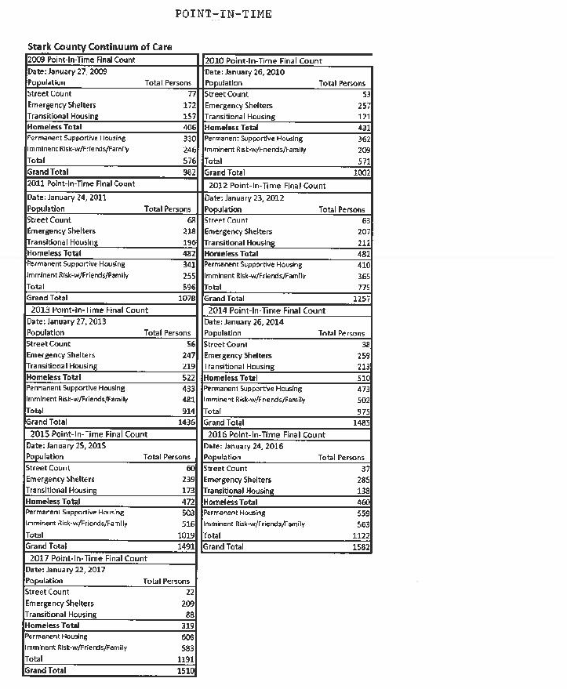
SELF EVALUATION

- Describe the effect programs have in solving neighborhood and community problems.
- Describe progress in meeting priority needs and specific objectives and help make community’s vision of the future a reality.
- Describe how you provided decent housing and a suitable living environment and expanded economic opportunity principally for low and moderate-income persons.
- Indicate any activities falling behind schedule.
- Describe how activities and strategies made an impact on identified needs.
- Identify indicators that would best describe the results.
- Identify the barriers that had a negative impact on fulfilling the strategies and overall vision.
- Identify whether major goals are on target and discuss reasons for those that are not on target.
- Identify any adjustments or improvements to strategies and activities that might meet your needs more effectively.

- FY-2017 projects had quantifiable effects on neighborhood and community issues. The City of Alliance returned 141 housing violations back to property maintenance code compliance. The City resolved 118 nuisance complaints for trash and/or tall grass. Code Enforcement restructured the City’s Mowing Program in 2013. The restructuring has decreased the number chronic violators and increased awareness of the potential health and safety issues high grass has on a neighborhood.
- All activities funded during FY-2017 made an impact on the needs and objectives identified in the Consolidated Plan as measured by the number of persons and households directly and indirectly benefitting from the activities.
- In FY-2017, the City provided decent, safe and affordable housing through a variety of housing rehab projects funded through CDBG as well as code enforcement initiatives. The City utilized HOME funds to assist three low-moderate income families by bringing their three homes up to code. CDBG funds were used to do emergency repairs for eight low to moderate income owner occupied homes.
- The Alliance for Children and Families Housing Rehab and Acquisition activity was granted an extension for the FY-2016. In June of FY-2017 this project was completed and now occupies one low to moderate family. This family progressed through the program to assist families in jeopardy of homelessness by participating in the transitional housing program and now has the wherewithal to be in their own home with ongoing guidance from the Alliance for Children and family staff.
The City of Alliance continues to do projects like this to meet the goals of the City and County Comprehensive Plans in order to establish affordable housing, address vacant structures, and tackle the federal goal of further affirming fair housing thru scattered-site housing in various neighborhoods, without despaired impact.
- The demolition of dilapidated and abandoned housing continues to be a priority for the City of Alliance. Demolition, the Neighborhood Initiative Program (NIP), housing rehab and aggressive code enforcement have produced noticeable, visual revitalization progress in the target neighborhoods. The City continues to aggressively pursue irresponsible home owners and landlords that contribute to the decay of the housing stock in the City of Alliance. The City has also utilized UDAG funds to assist in the demolition of vacant, dilapidated, commercial buildings in the downtown area that have jeopardized public health and safety.
- Success is measured by the number of properties inspected and found to have code violations compared to the number of violating properties inspected and found to have code violations compared to the number of violating properties that were resolved. Success is also measured by comparing the total number of blighted/vacant properties against the total number that were demolished and removed from the City’s housing stock.
- The largest barrier to meeting community needs is ongoing sufficient funding. Programs like NIP has helped significantly, more long-term sustainable funding is needed to ensure revitalization efforts keep moving forward. As of September 28, 2018 the City has demolished 68 blighted homes this year. The City of Alliance will have demolished over 100 blighted homes through the program by the end of the year.
- All but one of the City’s major goals is on target. Due to lack of applications and the rejection of non-qualifying applicants no progress was made by the City in its goal toward creating and preserving economic opportunities from the business sector using FY-2017 monies. This goal will be revisited to evaluate the need in the upcoming Five Year and Annual Plan.
- No improvements are needed at this time.

AA) Funds were not expended for acquisition, rehabilitation, or demolition of occupied real property in FY-2017.



Public Service Monitoring
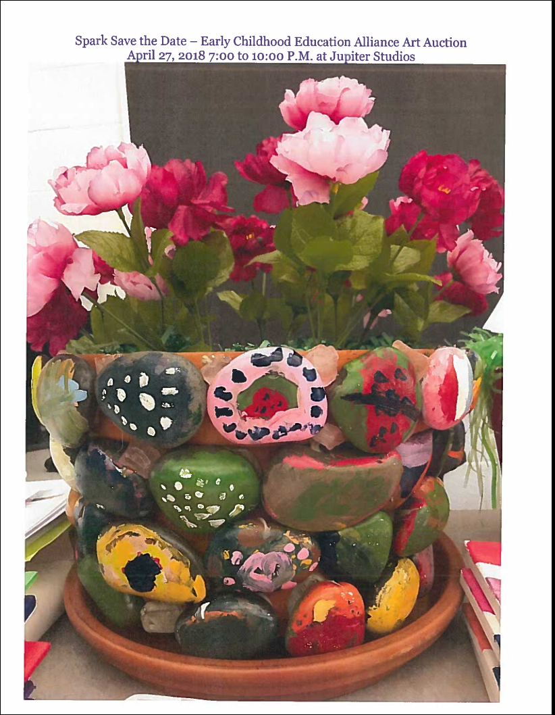
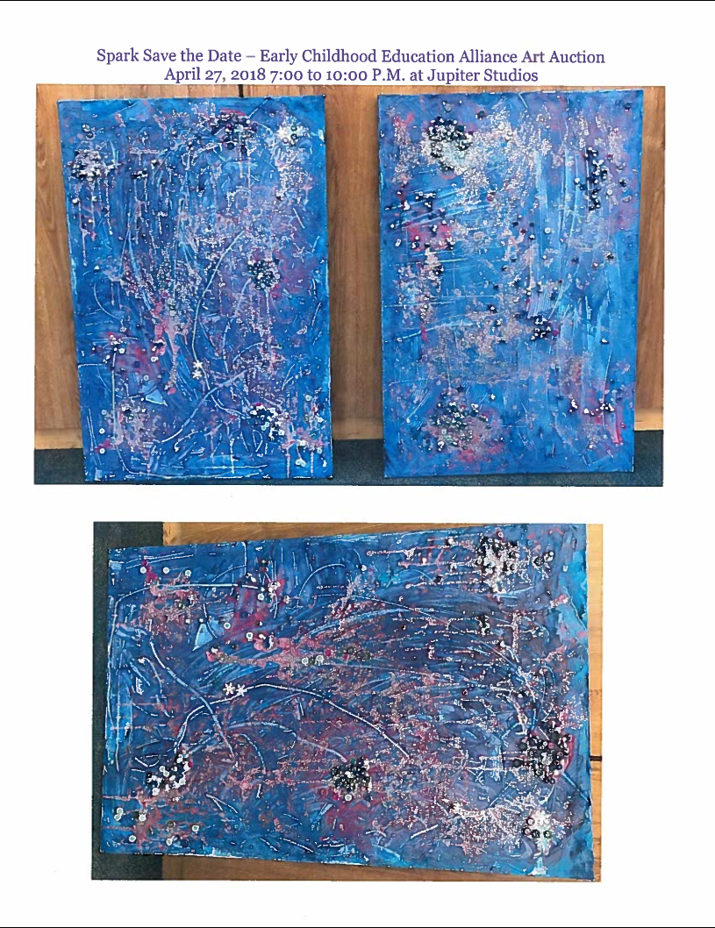

Public Service Monitoring
Fair Housing Seminar
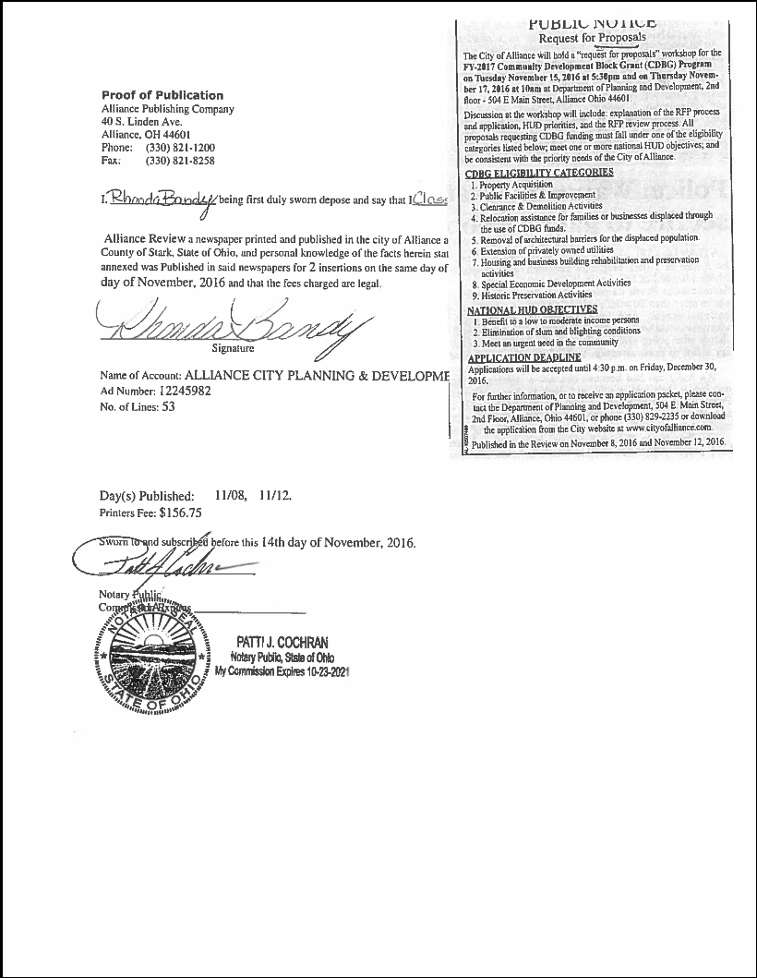
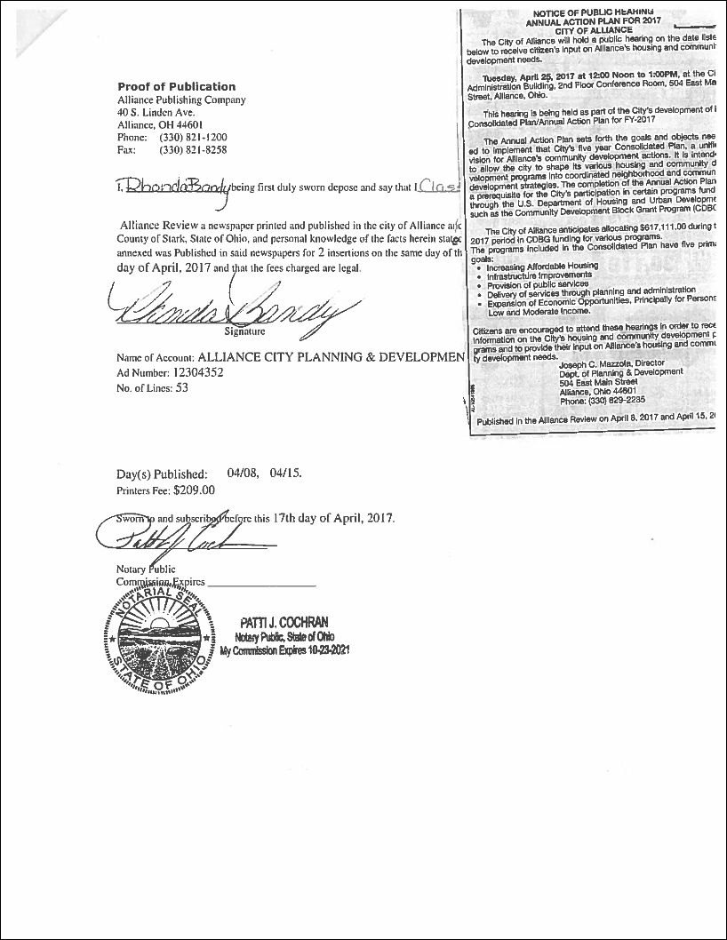

Public Notices

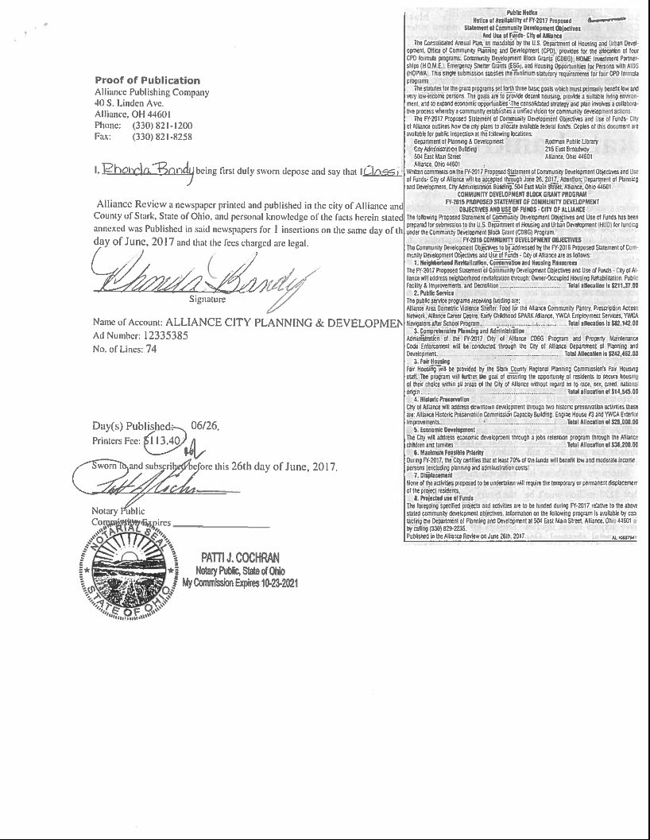
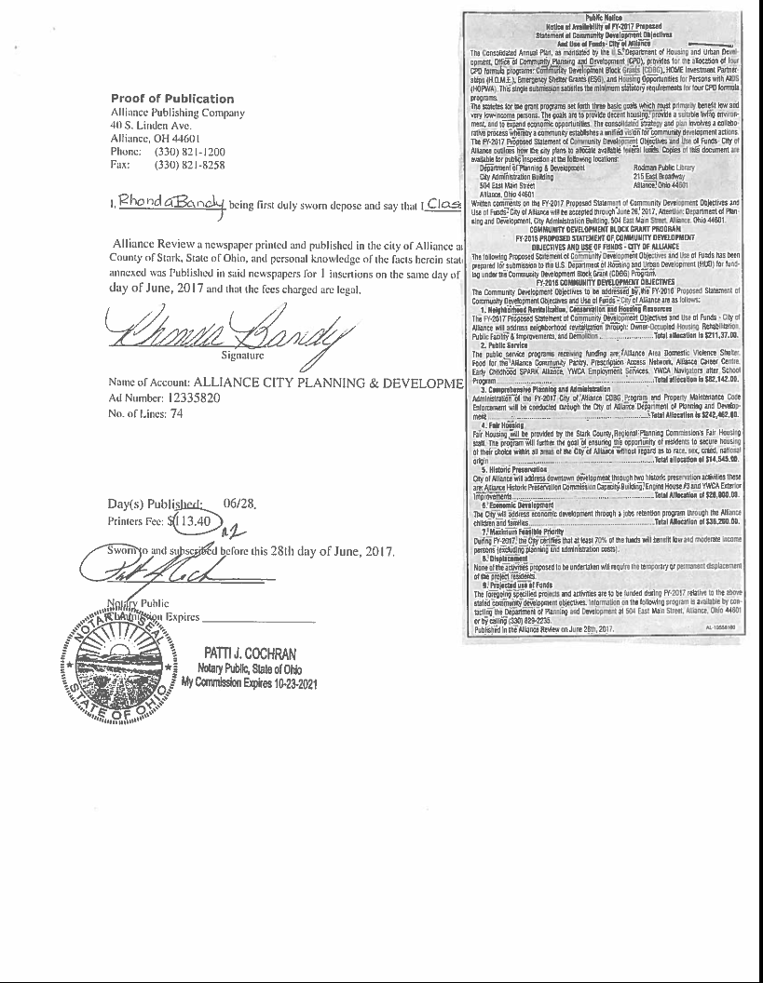
Public Notices
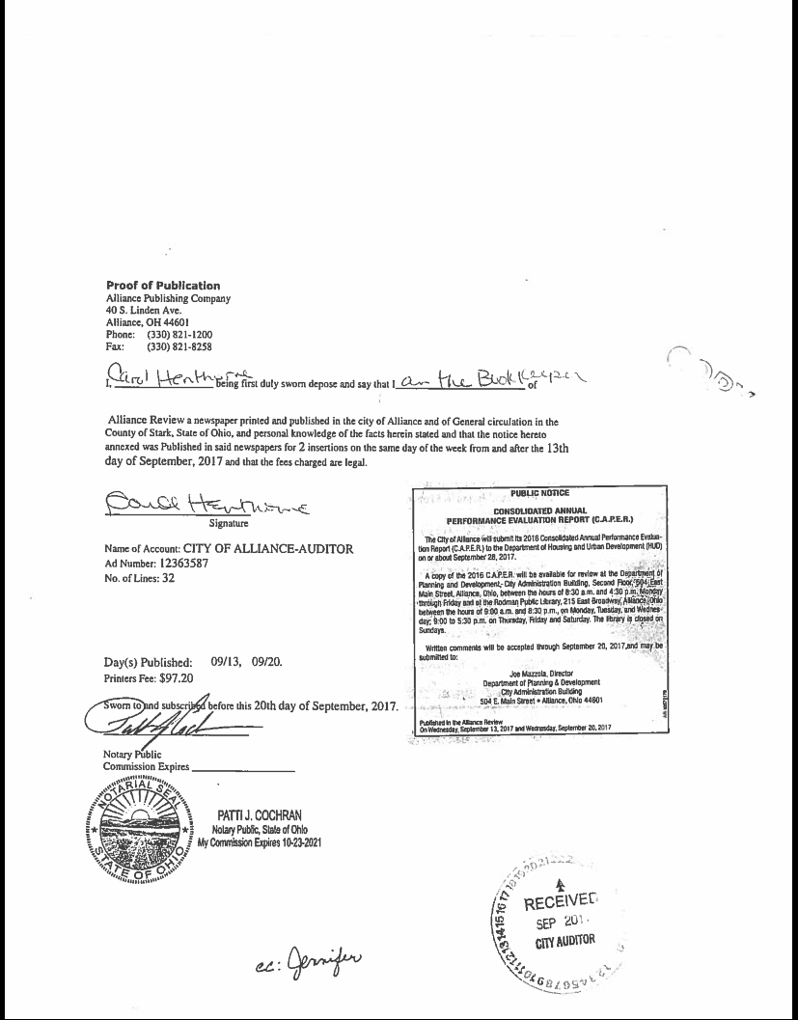
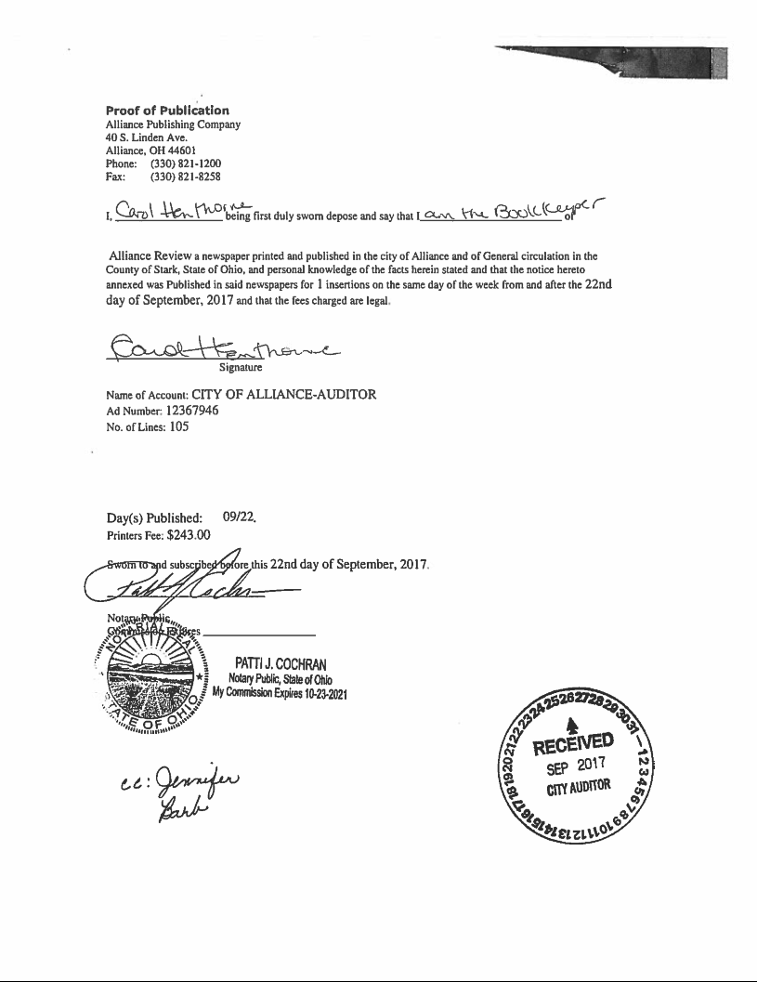
Public Notices
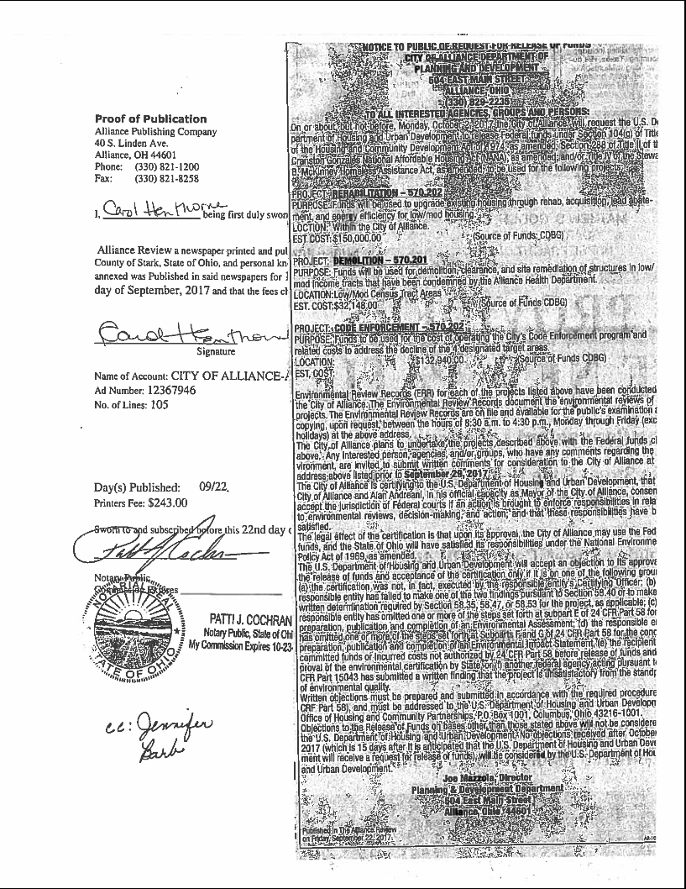
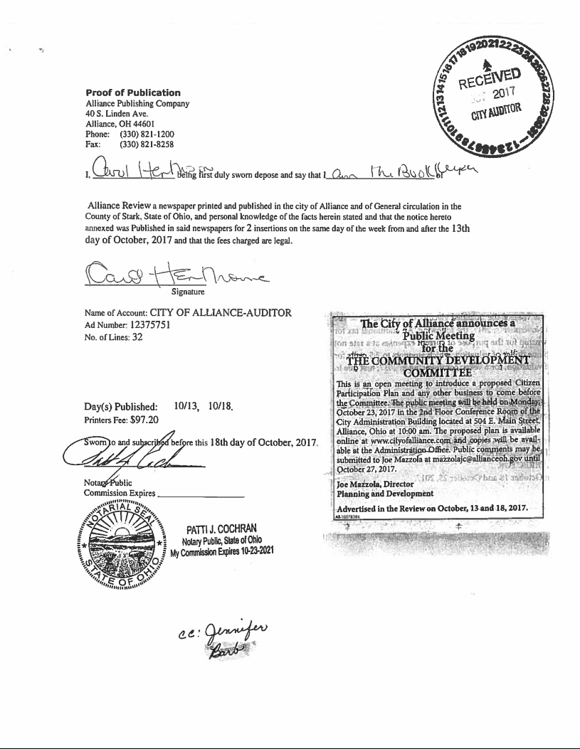
Public Notices
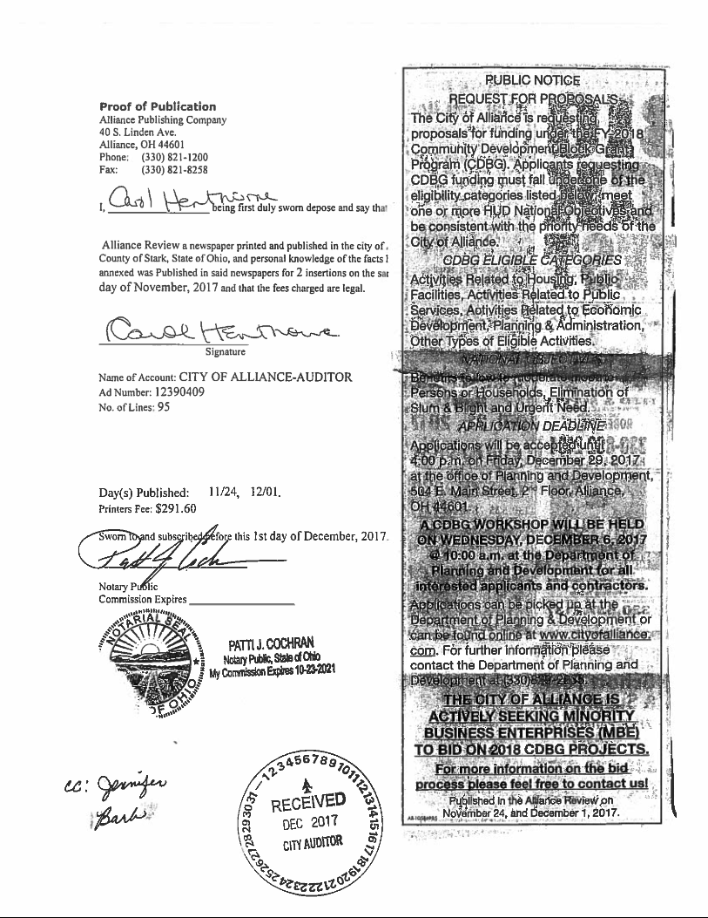
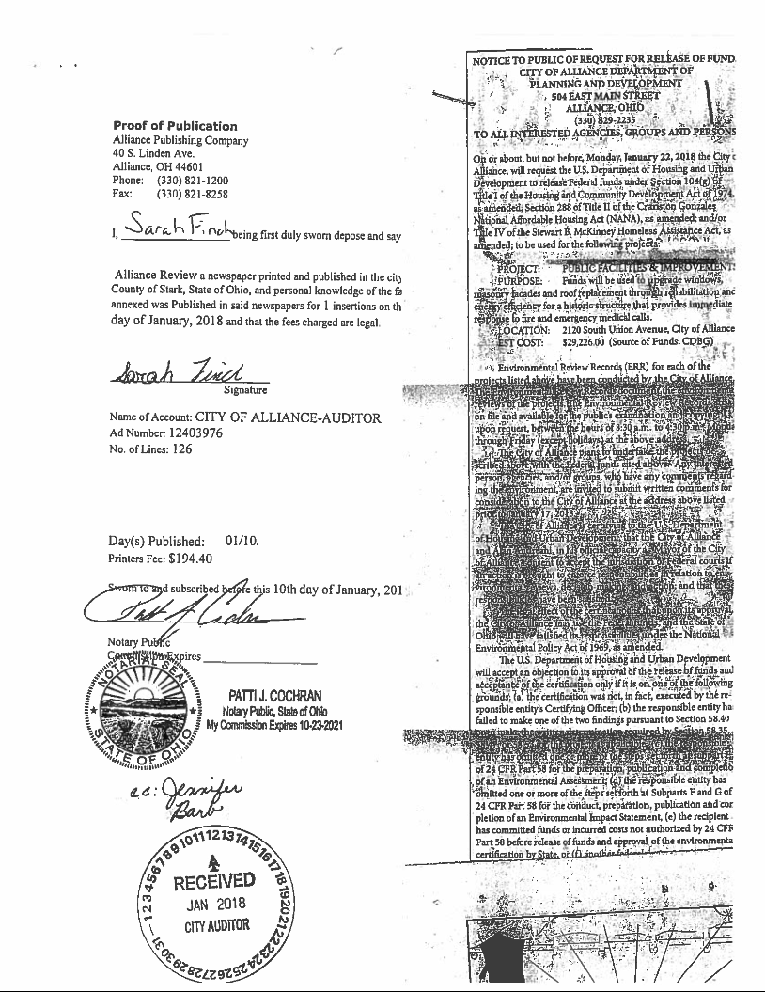
Public Notices
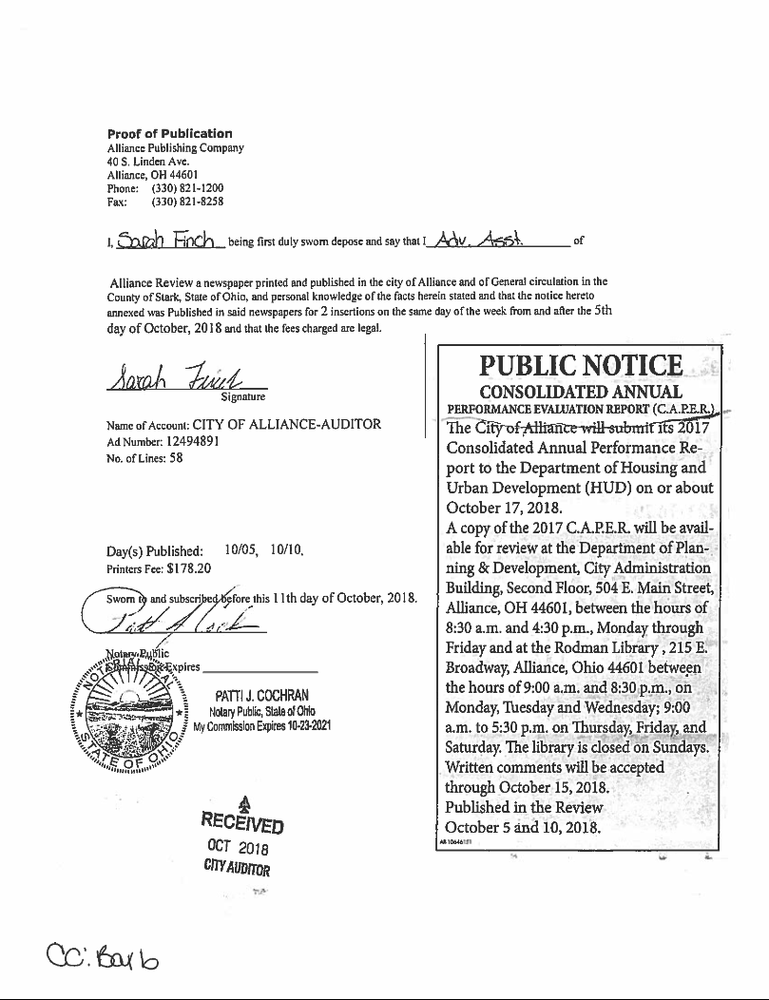
Public Notices

Public Notices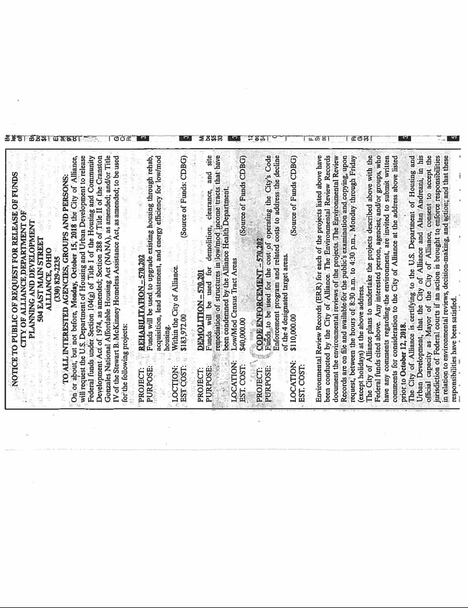
Public Notices